9/27/2021

Here we go again. Im gonna be responding to each individual paragraph/section of Darcys doc. If i dont respond to a part, its because i dont have anything to say, or it was addressed previously. Sorry if the timeline in this doc is all jumbled up, again im responding to each paragraph in Darcy’s doc as they wrote it, in the order they wrote it.

Once again, im not asking anyone to pick me over darcy or vice versa, im stating the facts and addressing allegations as unbiased as i possibly can. Dont harass darcy, or me pls, if anything here makes you uncomfortable with me, just block and move on.

TW: talk of grooming, sexual harassment, peh-dough-feel-leah accusations, CSA, basically all kinds of bad stuff along those lines

Im not admitting to grooming darcy because i didnt groom them! I admit that i, as a minor (16), talked to another minor, who had lied and told me they were 14, when they were actually 12. If this is enough for you to want to stop reading, then just block me and leave me alone! But i implore you to keep reading on if you have read Darcy’s doc so I can explain every specific situation they mentioned, because some things they said were misunderstandings, and maybe even straight up lies

Im sorry Darcy was groomed since they were 8. That should not happen to ANYONE. Darcy mentions this later on, but they speculated that i had been groomed too. Honestly, I have been groomed, but its kind of.. Gross of them to speculate on and bring up my past like that, completely uncalled for. I have been groomed LITERALLY for as long as i could remember, some of my earliest memories were of being groomed by my babysitter's older daughter. Ive never talked about that aspect of my life before, and I only realized i was groomed literally this year while trying to heal…. As I got older, i was exposed to a lot of NSFW shit on the internet, but my memories between the babysitter stuff and being around 12 (when i was Moe-Less-Ted too!! Great!!! /sarcasm) are extremely blurry, and not related. When I was 13/14, i met someone.. Who was literally 18/19 who also groomed me into thinking it was ok to talk to them about NSFW stuff. By 2016? i had stopped talking to them but the damage from them was done. So thats a little backstory on my own shit! I was an extremely fucked up child and teenager but ive moved on from this past.

I dont remember when i made my own NSFW tumblr blog, i think it was around 2014/2015? Ive lost the login to it since the tumblr NSFW purge. Anyway, this skype group chat darcy mentions? I have NO recollection of [redacted for their privacy] being in it. Back then, i never really talked to [redacted for their privacy] at all even. The only times i talked to [redacted for their privacy] was when I was first making the Original Callout Post (which i’ll talk about later) in 2015 I believe.

However, I do remember being in a group chat with Darcy at the time…. I have no receipts for this since I left that group chat soon after i joined it for reasons im about to talk about. There were other, really weird people in it. I have a distinct memory of another person in the group chat mention (TW FOR CP FANTASIES) how they wanted to “adopt a 12yo boy and force him to wear and pee in diapers”. Obviously i was fucking DISGUSTED by that. I remember saying “but thats illegal…” and they responded by saying “im a minor, so the police wouldnt do anything to me.” i was the only one that spoke out. obviously i fucking left that group chat afterwards. Again, this is the ONLY group chat I can remember being in with darcy.

Heres the thing about that nudes tumblr account.. Yes i had one that i shared with a partner at the time (again being a groomed teenager that thought it was a good idea to share nudes led to some stupid choices.) However. Darcy asked me for nudes and thats when i mentioned having that blog. Never gave them access to it either. Plus, Darcy has a history!! of asking people/friends (MINORS) for nudes, and acting sexual towards people, even if they barely met. After I made the Original Callout Post, at LEAST 2 people came to me, telling me how darcy would ask them for nudes + audios of the person involving piss. [redacted for their privacy] was one of these people. I specifically remember darcy talking about getting off to an audio involving them. Heres another person who came to me about Darcy lying about their age and grooming them recently. As seen by the time stamp, they came to me way before i ever though id have to make this doc.
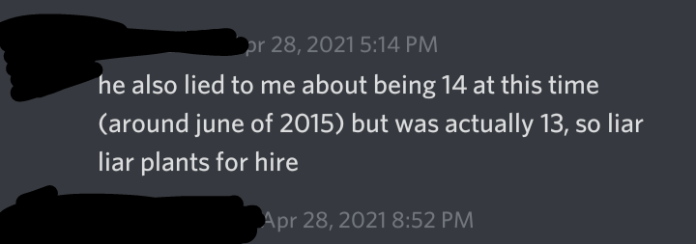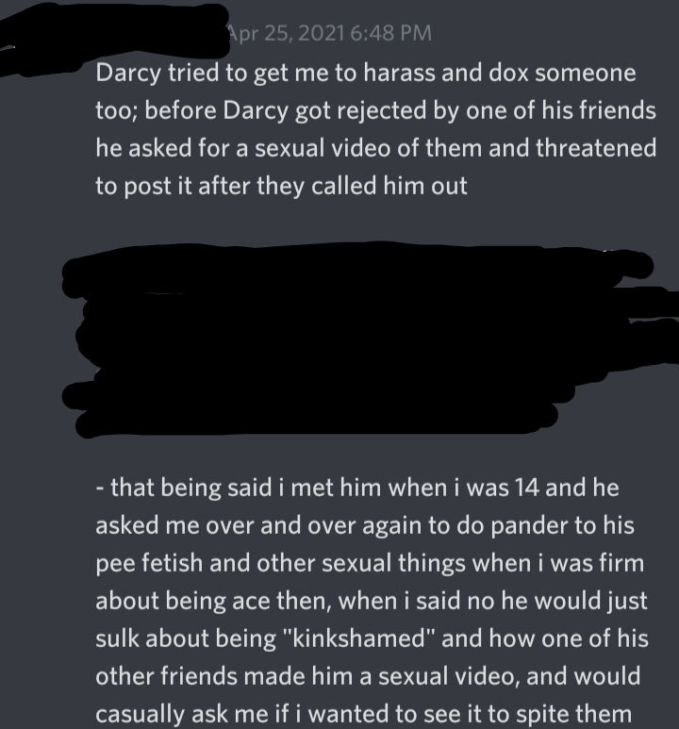
Transcript: Apr 28, 2021 5:14 PM
He also lied to me about being 14 at this time (around june of 2015 [which aligns with my claims in my first doc…]) but was actually 13, so liar liar plants for hire

Apr 25, 2021 6:48 PM
Darcy tried to get me to harass and dox someone too; before Darcy got rejected by one of his friends he asked for a sexual video of them and threatened to post it after they called him out
[Blacked out identifying info]
- that being said i met him when i was 14 and he asked me over and over again to do pander to his pee fetish and other sexual things when i was firm about being ave them, when i said no he would just sulk about being “kinkshamed” and how one of his other friends made him a sexual video, and would casually ask me if i wanted to see it to spite them

This is literally owning and attempting to distribute CP.

Another person who contacted me YEARS ago.
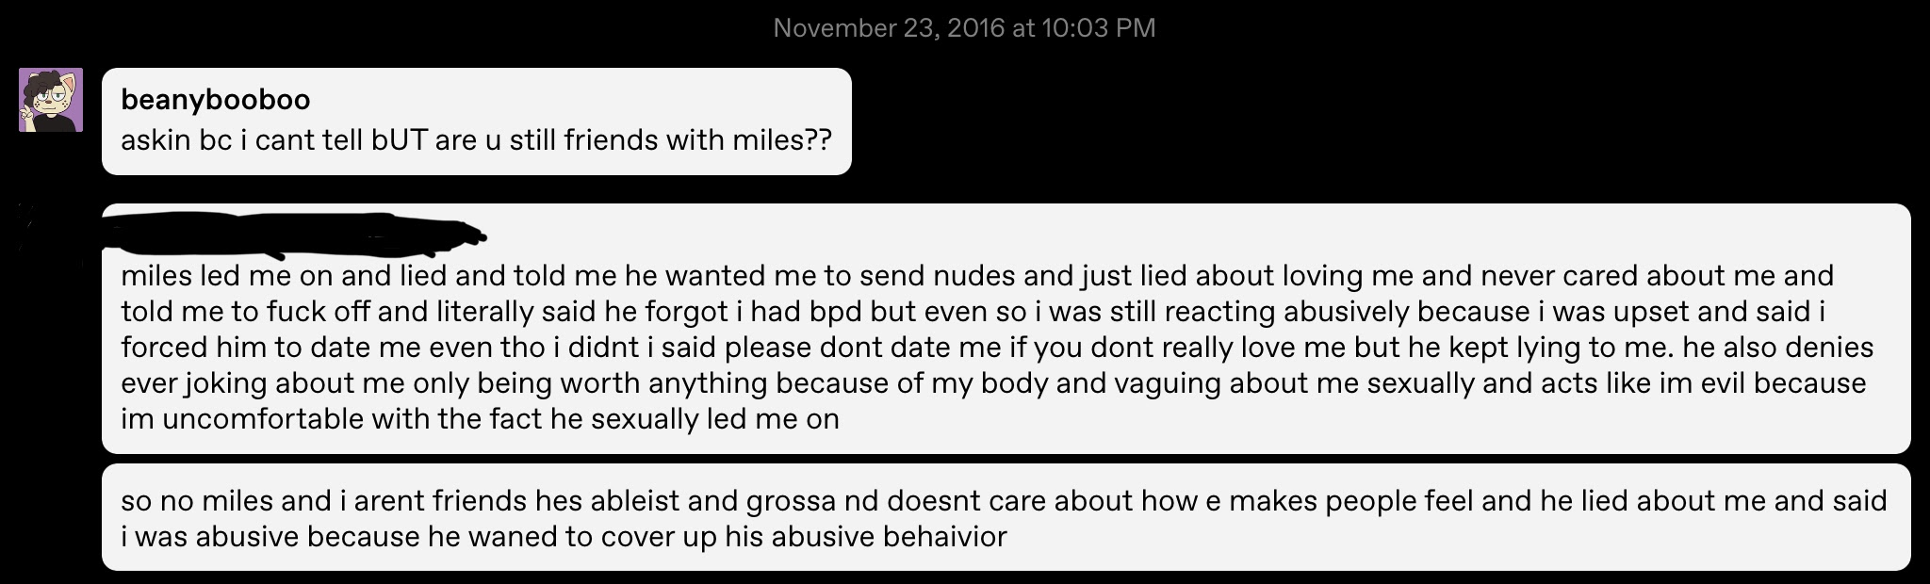
Transcript: November 23, 2016 at 10:03 PM
Beanybooboo
Askin bc i cant tell bUT are u still friends with miles?? [one of Darcy’s old names]

[blacked out]
Miles led me on and lied and told me he wanted me to send nudes and just lied about loving me and never cared about me and told me to fuck off and literally said he forgot i had bpd but even so i was still reactive abusively because i was upset and said i forced him to date me even tho i didnt i said please dont date me if you dont really love me but he kept lying to me. He also denies ever joking about me only being worth anything because of my body and vaguing about me sexually and acts like im evil because im uncomfortable with the face that he sexually led me on
So no miles and i arent friends hes ableist and grossa nd doesnt care about how e makes people feel and lied about me and said i was abusive because he wanted to cover up his abusive behaivior

Another example of Darcy asking for nudes from minors. By the same logic theyre using with me, I guess this makes the other minors he asked for nudes and fetish content from are groomers too, right? /sarcasm

Again, Darcy lied about their age. They told me they were 14. My first doc has screenshot proof of them lying. And again, I was mutuals with [redacted for their privacy], but never really talked to them except in regards to the Original Callout Post.
Like Darcy said, they were very unstable and unmedicated, its an explanation but not an excuse. I saw their decline from when we first met to them becoming obsessed firsthand.

I made the Original Callout Post in Feb 2016. In my first doc, I have a screenshot of Darcy saying in June 2015 that they were 14. I assumed they had just turned 15 by the time i posted it. They keep claiming i called them out when they were 13 on purpose. Like i said, I did NOT know they were actually 13 because of their previous lies.

I dont???? Reblog the OG Callout post bimonthly???? This is a straight up lie. I checked my tumblr, the last time i reblogged the post was around 840 days ago, which would be the summer of 2019, obviously BEFORE december 2019 (more on this later). The last time i even used my tumblr was around 238 days ago, in January of 2021. And even before that, my posts were sporadic.

Darcy claims they abused [redacted for their privacy] “in a way”. It was straight up abuse. I included the suicidal postings in the OG callout specifically because a lot of the posts also included evidence of Darcy making death threats, mocking/insulting [redacted for their privacy], trying to guilt trip them, and about Darcys fake DID which….. idek if im gonna get into as of this point in my writing (spoiler, i do)

TW Fictional R*pe Discussion
Darcy claims they “thought rape was when [the victim] explicitly said no and intercouse was forced upon the victim anyways.” ← I dont remember if intercourse was in the fanfic, but I DO remember the victim in their fanfic explicitly saying no and begging to be left alone. I understand Darcy might not have understood the full implications of rape back then, but make of this what you will.

I can confirm the doxxing, and the transphobia, and Darcy wanting to visit them in person.

Good on Darcy for apologizing, and for being open with friends and trying to change. However… im kind of skeptical about the therapist part. More on this later.

My intent with the OG post wasnt to traumatize Darcy. It was because they lied so much, publicly and probably privately, about what really happened between them and [redacted for their privacy]. There was no way for me to possibly track down every individual person Darcy had told his twisted version of the story to, so i thought a public post would reach out the most. And remember, this was 2016 tumblr. Callout posts were common back then, as a 17yo i seriously thought a public post was the best course of action. OBVIOUSLY i know its not now. And before you say “THEN WHY DID YOU MAKE YOUR DOC” i made it cuz darcy has been publicly slandering my name without telling the facts of what happened between us, and calling me a groomer publicly. Its not intended to be a callout post, it was intended to tell specifically my followers what i had taken a part of in my past. It was for my followers to come up with their own conclusions, and to unfollow/block if my past made them too uncomfortable to want to associate with me.

Yes i apologized to darcy in 2016, but i stopped thinking like that because of the fact that multiple other people have come forward to me with their own stories involving Darcy, including things that happened as recent as 2018.

Yeah, Darcy apologized for wishing i went homeless. That point of my life really fucked sucked, but its unrelated.

Ok…… heres the part where im walking on eggshells when i say this but. Darcy has a history of lying about things therapists say, or lying to therapists about the true situation. In like late 2015/2016, Darcy faked having DID (dissociative identity disorder, previously known as multiple personality disorder). They claimed that they told their therapist about it, and their therapist confirmed that Darcy had DID. Im not an expert on DID but i know for a fact that a diagnosis for DID involves a lot of testing, and the way darcy talked about their DID online.. Was not anywhere close to what a person with DID actually experiences. So either Darcy lied to their therapist, or lied online about what their therapist said regarding this DID situation. Im not going to include screenshots of this situation in this doc, but i do have them. I really hope Darcy didnt actually lie to their therapist this time about this though, they need serious help, and healing cant happen without the truth.

This is unrelated to therapy, but Darcy also just has a history of twisting peoples words around in general. Recently, darcy mentioned something about having their art insulted in a discord server? Someone from that server contacted me and this is what actually happened.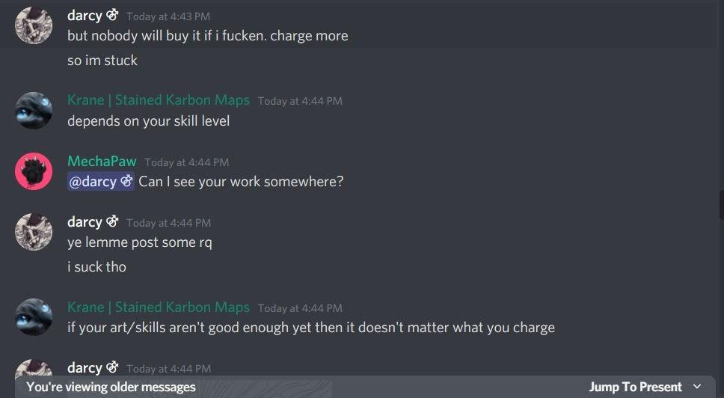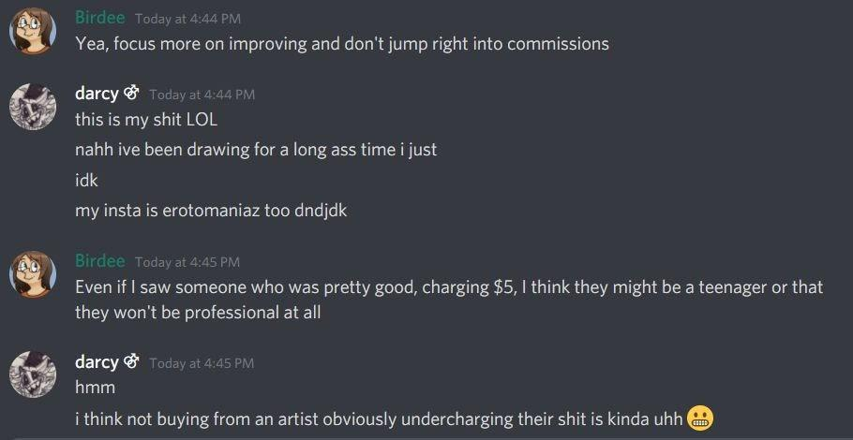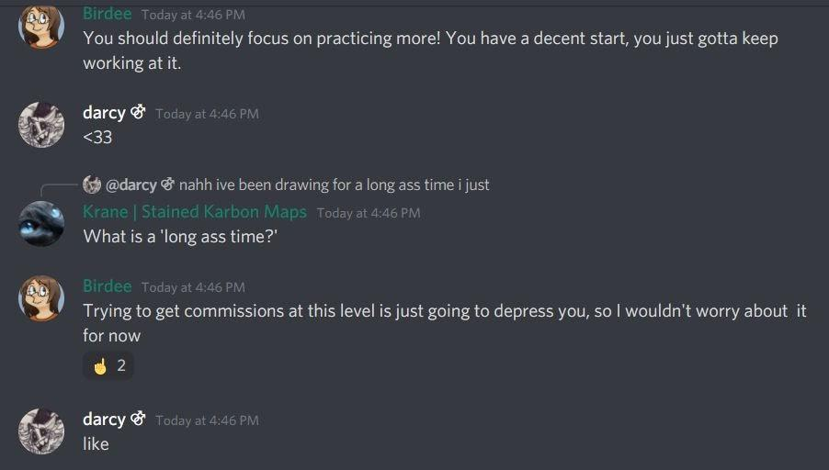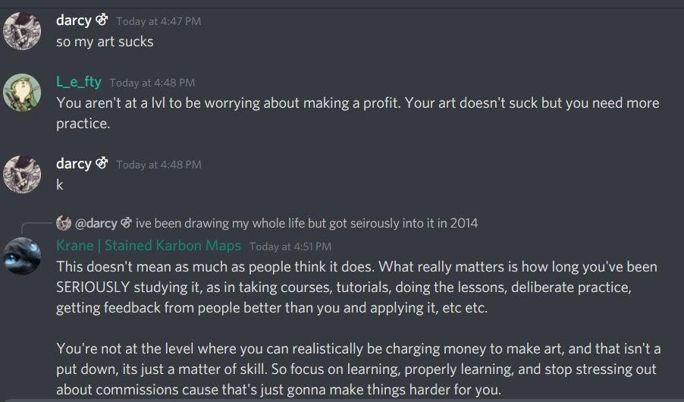
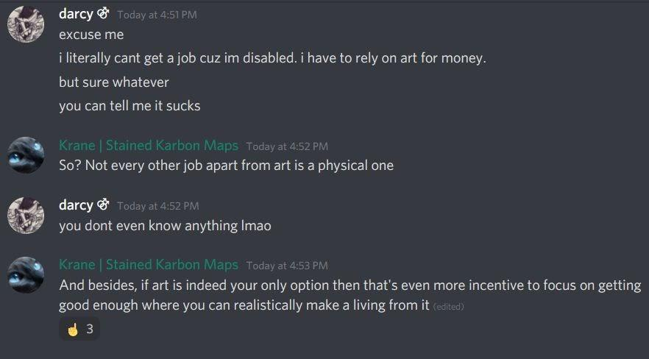
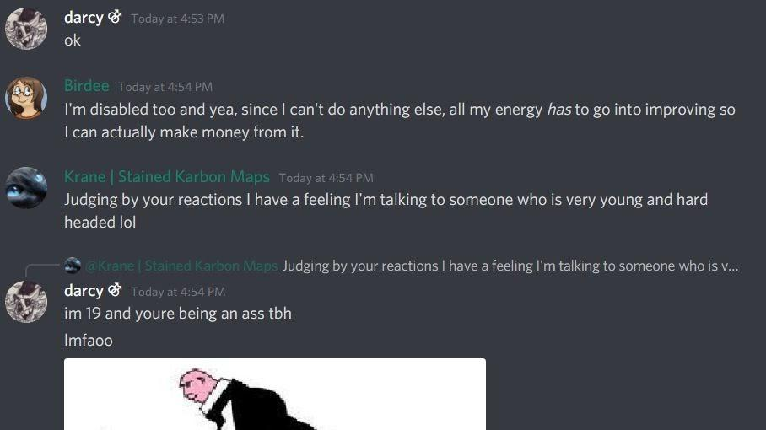
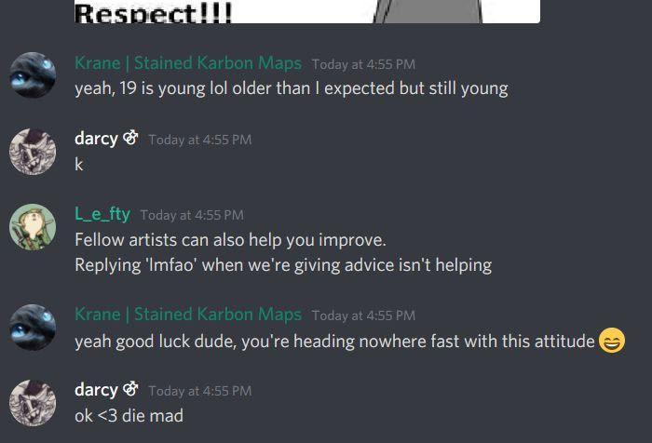
Transcription:
#1 darcy:
But nobody will buy it if i fucken. Charge more
So im stuck

Krane:
Depends on your skill level

MechaPaw:
@darcy Can I see your work somewhere?

Darcy:
Ye lemme post some rq
I suck tho

Krane:
If your art/skills aren’t good enough yet then it doesn’t matter what you charge
#2 Birdee:
Yea, focus more on improving and don’t jump right into commissions

Darcy:
This is my shit LOL
Nahh ive been drawing for a long ass time i just
Idk
My insta is erotomaniaz too dndjdk

Birdee: Even if i saw someone who was pretty good, charging $5, i think they might be a teenager or that they won’t be professional at all

Darcy:
Hmm
I think not buying from an artist obviously undercharging their shit is kinda uhh :grimacing:

#3 Birdee:
You should definitely focus on practicing more! You have a decent start, you just gotta keep working at it.

Darcy:
<33

Krane:
-replying to an earlier message from darcy-
What is a ‘long ass time?’

Birdee:
Trying to get commissions at this level is just going to depress you, so i wouldn’t worry about it for now

Darcy:
Like

#4 darcy:
So my art sucks

L_e_fty:
You aren’t at a lvl to be worrying about making a profit. Your art doesn’t suck but you need more practice.

Darcy:
K

Kraner:
-replying to Darcys earlier message about how long theyve been drawing-
This doesn’t mean as much as people think it does. What really matters is how long you’ve been SERIOUSLY studying it, as in taking courses, tutorials, doing the lessons, deliberate practice, getting feedback from people better than you and applying it, etc etc.

You’re not at the level where you can realistically be charging money yo make art, and that isnt a put down, its just a matter of skill. So focus on learning, properly learning, and stop stressing out about commissions cause thats just gonna make things harder for you.

#5 Darcy:
Excuse me
I literally cant get a job cuz im disabled. I have to rely on art for money.
But sure whatever
You can tell me it sucks

Krane:
So? Not every other job apart from art is a physical one

Darcy:
you dont even know anything lmao

Krane:
And besides, if art is indeed your only option then thats even more incentive to focus on getting good enough where you can realistically make a living from it

#6 Darcy:
Ok

Birdee:
I’m disabled too and yea, since i cant do anything else, all my energy has to go into improving so i can actually make money from it

Krane:
Judging by your reactions i have a feeling i’m talking to someone who is very young and hard headed lol

Darcy:
-replying to Krane’s last message-
Im 19 and youre being an ass tbh
Lmfaoo
-image-

#6 Krane:
Yeah, 19 is young lol older than i expected but still young

Darcy:
K

L_e_fty:
Fellow artists can also help you improve.
Replying ‘lmfao’ when we’re giving advice isnt helping

Krane:
Yeah good luck dude, youre heading nowhere fast with that attitude :D

Darcy:
Ok <3 die mad

….. Please tell me how what these people said is an insult? They gave good advice, i literally dont know how to interpret any of what they said as insults. So yeah, Darcy twisting up someones words isnt anything new.

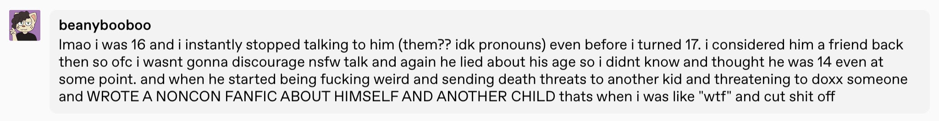
Ok, this situation regarding Darcys friend colin…. Darcys lying. I never said I was 14/15 when i talked to Darcy. I think Darcy might be mixing up the numbers (on purpose or not, im not sure). i said i THOUGHT Darcy was 14/15 when we were talking/when i posted the callout post. In the OG Callout post, i said i met Darcy around late 2014/early 2015. Heres a part of what i said regarding my age in that conversation with Colin

Transcript: lmao i was 16 and i instantly stopped talking to him (them?? Idk pronouns) even before i turned 17. I considered him a friend back then so ofc i wasnt gonna discourage nsfw talk and again he lied about his age so i didnt know and thought he was 14 even at some point. And when he started being fucking weird and sending death threats to another kid and threatening to docc someone and WROTE A NONCON FANFIC ABOUT HIMSELF AND ANOTHER CHILD thats when i was like “wtf” and cut shit off

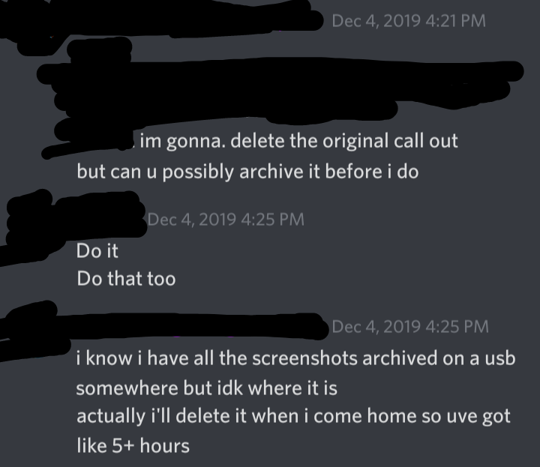
Regarding taking the callout down. This was genuinely my mistake. I remember the night i got Colins message, I was at my work building about to start my shift at 5. I told Colin i would take it down after i got off work and got home, which would be at around 11 since i had a 40 minute commute back then. I very much wanted to take it down, I remember specifically asking someone if they could archive it for me because i was a mobile-only user, so archiving it would have been hard for me at that moment. Receipts for this convo (with blocked out personal info) including timestamp V

Transcript: Dec 4, 2019 4:21PM
Im gonna. Delete the original call out
But can u possibly archive it before i do

[Blacked out]
Do it
Do that too

I know i have all the screenshots archived on a usb somewhere but idk where it is
Actually i’ll delete it when i come home so uve got like 5+ hours

When i left work, i thought to myself “fuck it” and i tried deleting it using the tumblr app before i got home, cuz i just wanted to be done with it, i didnt care about archiving it cuz i wanted that shit gone. And i deleted it!... at least, i genuinely thought i did. I think what happened was that i deleted a previous reblog of it, OR the tumblr app just fucked up and didnt delete it because we all know tumblr is 100% functional all the time.

By the time i post this doc, the Original Callout Post should be deleted. Im done with it existing. The usb drive with screenshots i mentioned is still nowhere to be found, but like i said, i dont care about having it archived. If its not deleted off my tumblr blog someone pls let me know, i dont trust the tumblr app to work as its supposed to.

Im glad Darcy is healing and getting sober, i genuinely am. No one should deserve to feel so fucked up.

However, Darcy needs to accept this past part of themself. Darcy WAS an abuser, and sexual abuse can happen without physical contact. I understand they were an unstable abused child, but what they did was NOT right, and they need to accept that past. And I dont think its right to tell someone to kill themself either, no one deserves that.

…. Heres the thing though. I DONT think im innocent. I dont believe ANY minor should be talking to people sexually on the internet. It WAS wrong of me. Again, thats why i made the doc, to let people know that i, as a 16 minor, talked sexually to someone who lied to me about being 14. But i genuinely do not believe that i groomed Darcy. Again, I DID NOT KNOW our age difference was that drastic. I WOULD NOT have talked to them if i knew they were actually 12.

Reiterating what i said in my first doc, we talked about characters pissing themselves, we talked about US pissing ourselves/pissing into containers. What i didnt mention in my first doc was how Darcy asked me to make an audio of myself pissing into a container so they could hear it. I agreed to do it but never went through with it, because i was uncomfortable to do that but i didnt want to make Darcy upset. Same situation with the nudes. I NEVER sent them anything of myself. Darcy would also talk about having audio of their other friends pissing and moaning, and of having their nudes, and getting off to it. I was uncomfortable AF because i knew that was CP, but again i didnt want to make darcy upset so i didnt voice my concerns. Thats when my IRL started changing, and when darcy became obsessed with [redacted for their privacy], so i talked to darcy less because i was more preoccupied IRL and because Darcy made me more and more uncomfortable. And we know the story from then on.

Also I added the screenshot in my first doc because of the part where Darcy said they were 14, and the “fronting” part (which has to do with their faked DID). Though i should have cropped out the suicidal bit, i will agree with that.

HERES WHERE IT GETS INTERESTING, EVERYBODY. This part involves talk of NSFW art. If youre uncomfortable reading ahead, feel free to stop, but it involves Darcy accusing me of being a p3h-dough, WHICH WE ALL KNOW IS A PRETTY SERIOUS ACCUSATION, with bottom-of-the-barrel evidence that I cleared up.

I didnt draw CP. Yes i RT porn of cartoon characters who are all canonly adults. You all do know undertale/deltarune is childrens media too, right?

Also…. WALDEN FROM WOW WOW WUBBZY IS NOT 12. The idea that Walden is 12 is a headcanon the fandom agreed upon for dumb, shoddy reasons. I’ll explain as briefly as possible. In an episode, the characters mention how they take a photo together every year, showing a wall with pictures on it, and theres 12 pictures. If they took a picture together at least once a year, that would signify that the characters are AT LEAST 12. BUT if walden was a 12yo, he would be a fucking baby in half of those pictues, but he literally looks the same in all of them???? Plus, he drives a car, owns a museum, is literally wubbzys school teacher, and is in general a father-figure to wubbzy. Hes not 12.

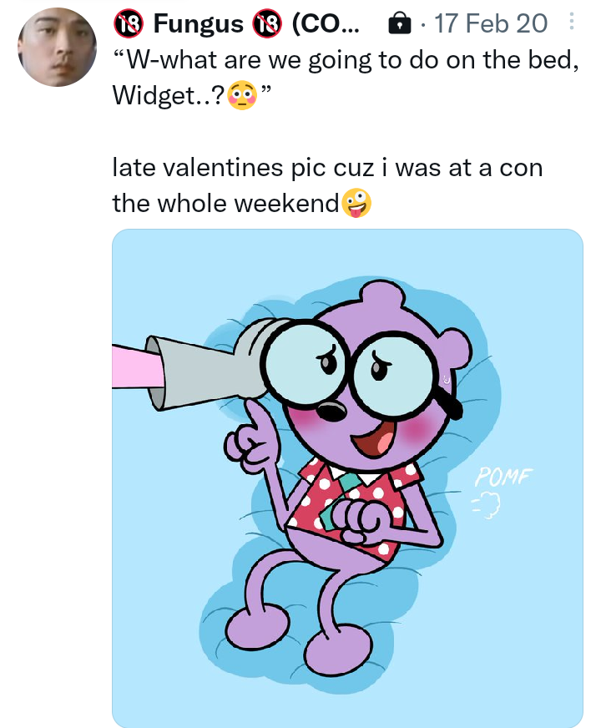
Also, the picture i drew of walden…. ISNT EVEN EXPLICIT. Darcy purposefully cropped it to make it seem more explicit than it actually is. Hes pantsless because thats just his design in the show. Theres no genitals in the picture i drew. HOWEVER, i will admit. I captioned it with him saying “what are we gonna do on the bed?” which, darcy is right, is a reference to a lol* manga. The only reason i drew/added that caption was because that format was a meme at the time, and i captioned it that as a joke. Its a shitty joke in poor taste and i admit that. But i DID NOT have any gross intentions behind that, other than it being a bad joke. Im gonna post a screenshot here to prove that the pic isnt even explicit if you want to see it, before i delete it off my twitter because again, i agree that the format and the caption are gross.

Moving on to my F-list kinks. I picked the age-difference kink, and the description of it on the website explicitly says that this kink DOES NOT involve minors. I just like older men characters! And im 23! Theres a big age difference there, which is why i picked that kink. Hatefucking has a custom description by me, which says I like when characters just have a lot of unsolved sexual tension between each other. And the tsunderes kink is also a custom kink i put in, but i didnt put a proper description. It just means i like characters who are embarrassed to admit their feelings.

Darcy is calling me p3h-dough for owning Super Sonico and Super Pochaco figures. Originally they literally had no backstory, they were just mascots for a music festival, but got an anime where theyre college students who work as models to pay off their loans. They have big tits because theyre supposed to be chubby. I just think the figures are cute!

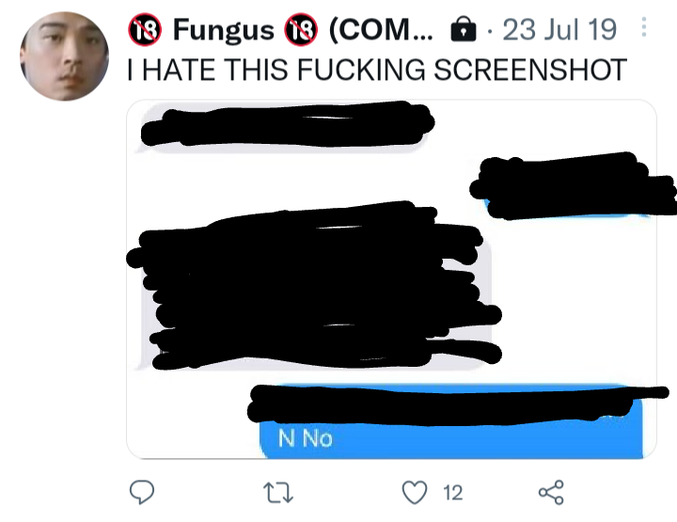
Yes I posted a screenshot of something embarrassing Darcy said, but i? Did not encourage harassment. Also the timestamp is different from when Darcy said I posted anything. Pictured below, blocking out the embarrassing part. The tweet will be deleted though. Unless Darcy means another tweet? If so someone LMK so i can delete it too.

Transcript: Fungus - 23 Jul 19
I HATE THIS FUCKING SCREENSHOT
-blacked out screenshot-
“N No”

About RT from problematic artists, i try my best to be careful and check peoples twitters, and if i see something even vaguely sus, i DONT rt. IDEK who popthesnowman is, i checked their profile and nothing about their art is familiar, and i didnt see that i had RT anything from them. Please direct me to the specific thing i supposedly RT.

I didnt reply to darcys friend cuz they have me blocked so i obviously cant see their reply. But yeah, no, im still not a groomer. Talking to a minor sexually is wrong, but remember, i was also a fucked up minor. It doesnt make it right from either side because it should have never happened to begin with. Also, I????? Never mentioned Colin or *zzy, or ANYONE other than Darcy by name, and [redacted for their privacy] indirectly when i talked about the callout post, in my doc. i really dont know where thats coming from???? Unless Darcy is actually mistaking the situation about [redacted for their privacy] with whatever the hell they went through with Colin or *zzy???? If so, i think the fact that theyve had multiple similar situations with different people enough to mix them up, says a lot more about darcy than it does about me

Yeah, im done with this entire situation. Im not gonna respond to anything else after this. I politely ask that anyone reading this, and then sees Darcy say something, to not show me what they say, i really dont care. If people want to block me, go ahead, just dont talk to me or harass me or Darcy.

