From what I saw and read. Don’t @ me if I missed something.

Sheep’s Comprehensive Guide to the Pull 3.0 Drama

How it started:
- Best Dressed channel. Someone called her new man ugly. They got warned, or muted, or banned or something. Pissed everyone off.
  - It was Glitzy the transphobe who was modding a different section that she was assigned and then a different mod came in and handled the situation the same way (read: poorly) as Glitzy did
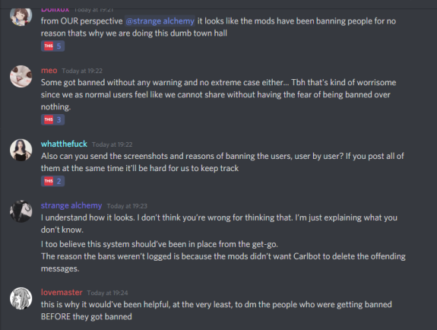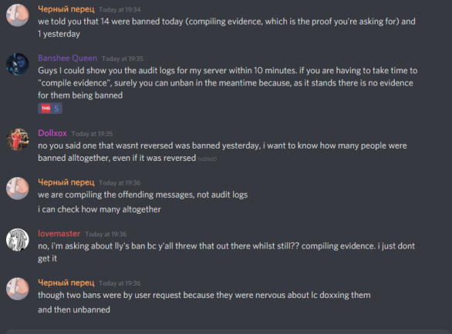
- People start going off on the mods with valid criticism about having a terf (glitzy) mod and the abuse of power by administration in general. The mods start muting people and banning/kicking them.
  - More rage.

Townhall opens: Hell
- 2 hours late to opening up for the general public to use, after stating that there was going to be a townhall
- People call for the modding of Buruberi to have someone more representative of the community in power
- People call for a total revamp of mods and admins, this time selected by voting
- Many mods step down.
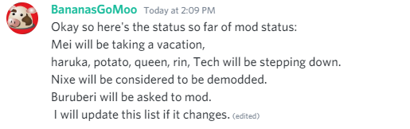
- Two mods apologize for their abuse of power. SS by Catphrase.
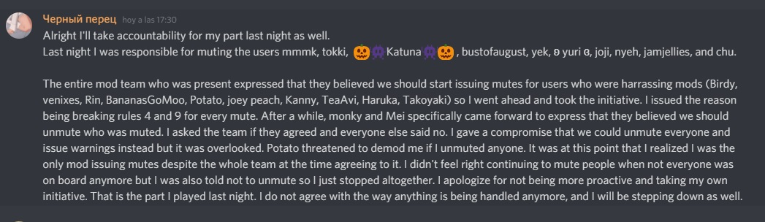
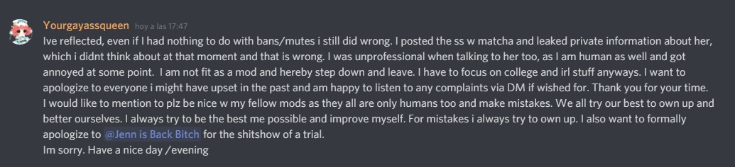
- Buruberi modded after he came back online
- Many whistles blown. Listed below in no order:

WhistleBlow 1: Matcha
- Match was a former user of Pull 3.0
- Would spy on people from other servers and then alter screenshots and give them to Pull 3 mods
  - This resulted in many people being banned or muted for voicing any negative opinion about moderation
  - Also lead to a very close relationship between Matcha and the mods
- Has a vendetta against Jenn
  - Mods got a ticket telling them that they need to moderate their friends who derail threads too, implying that mods need to stop letting Match derail threads and feel invisible because they are feed the mods info
  - Jenn complied and told Matcha to stop derailing a KPop thread.
    - Matcha got pissed and started a campaign against Jenn. Screenshots are the “evidence” Matcha collected against Jen
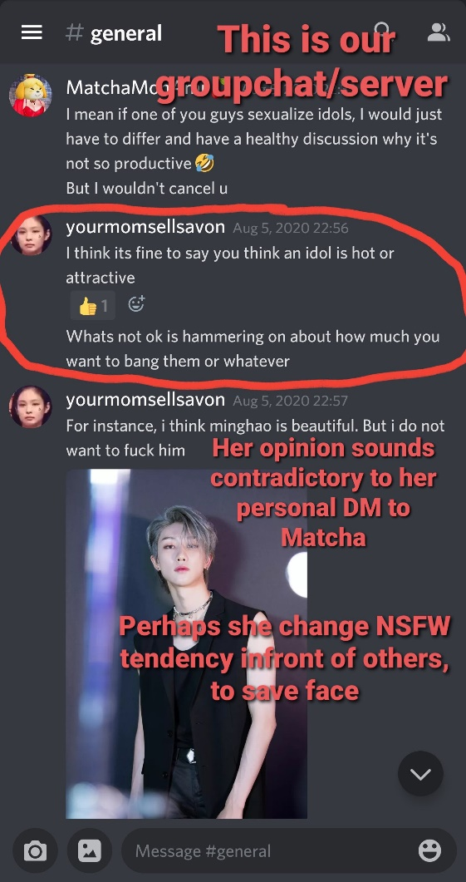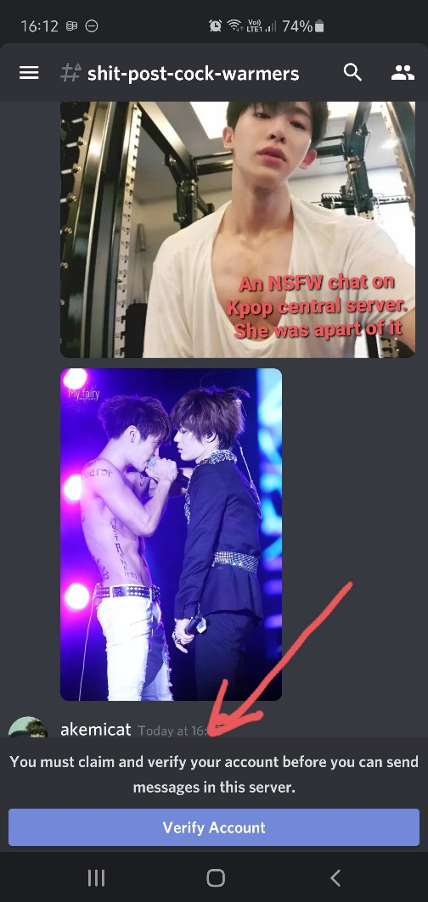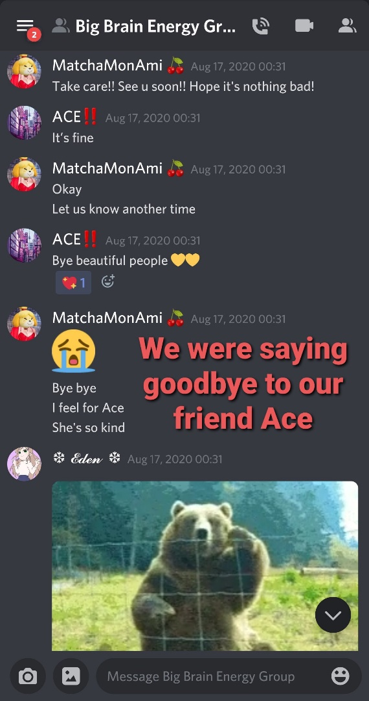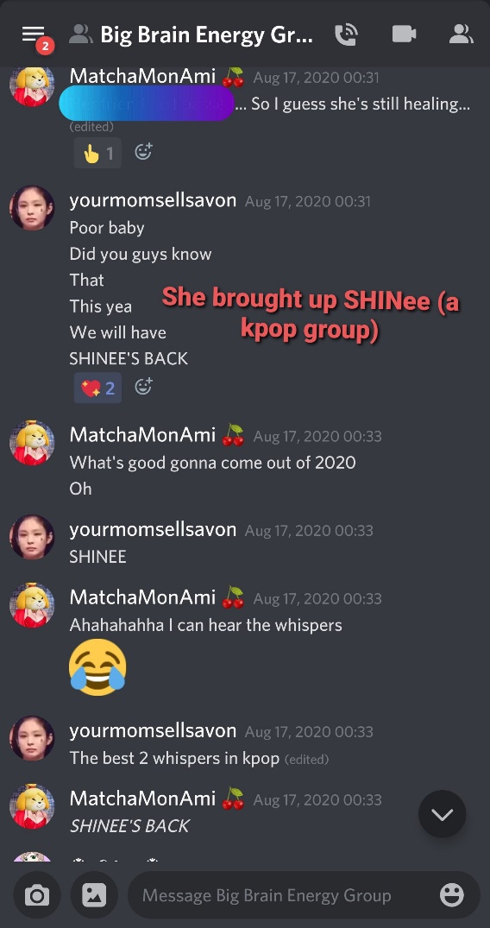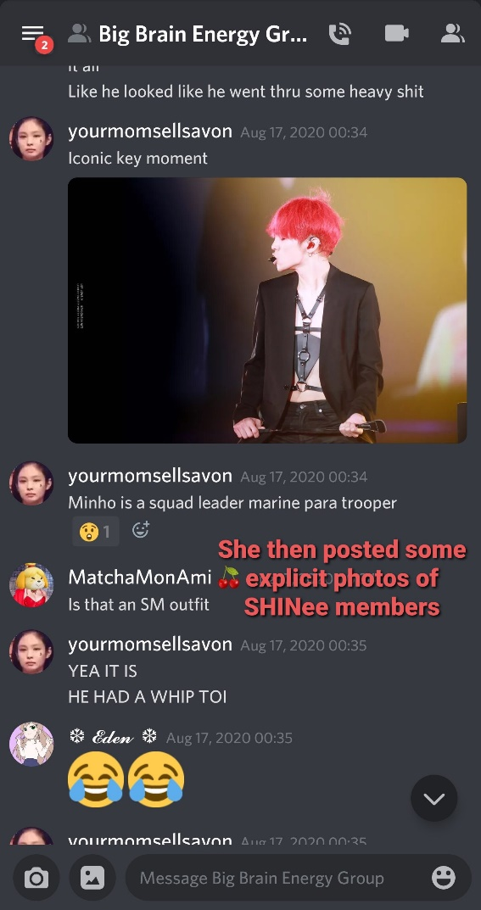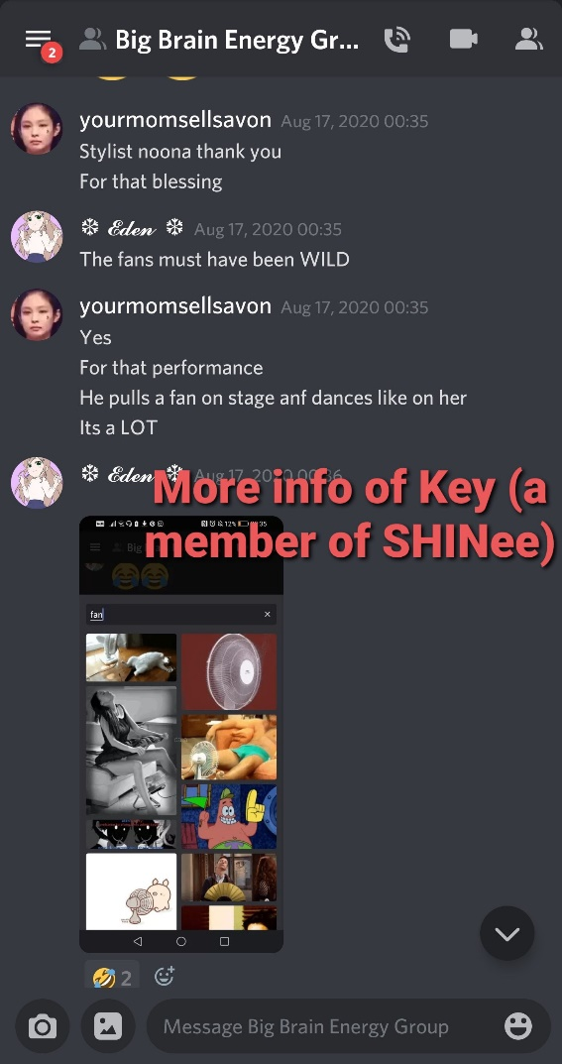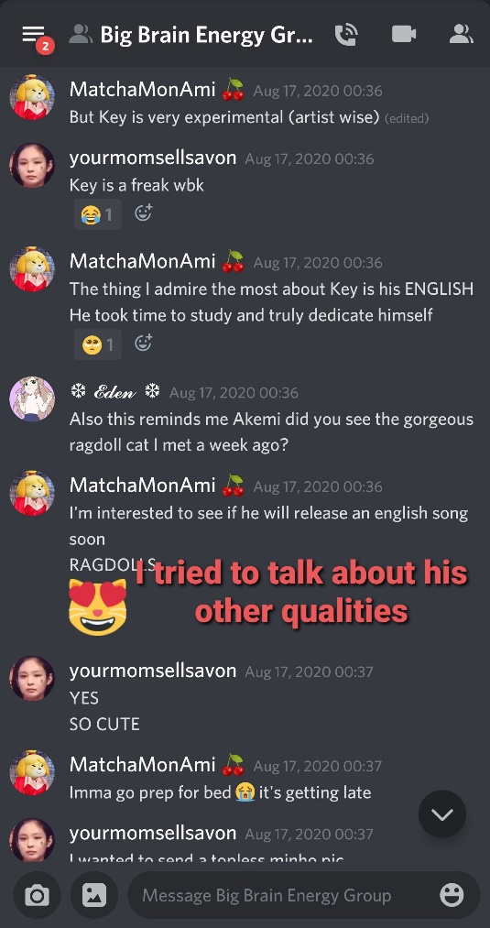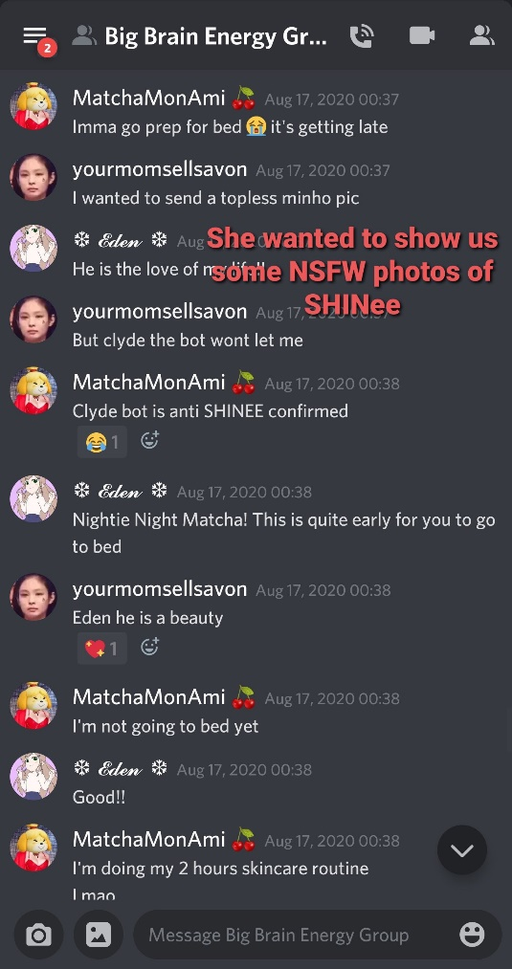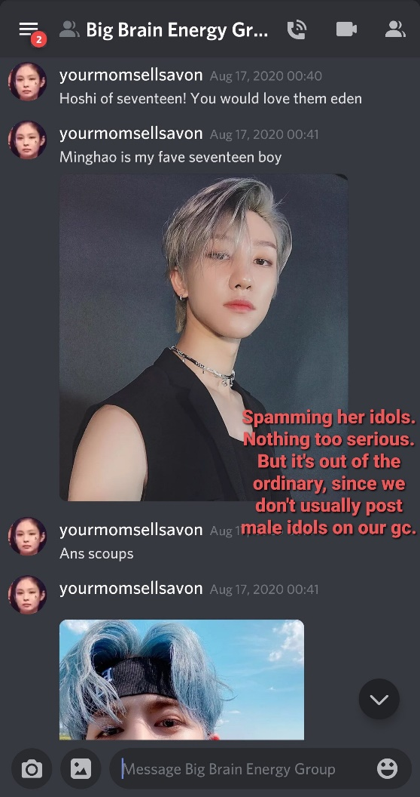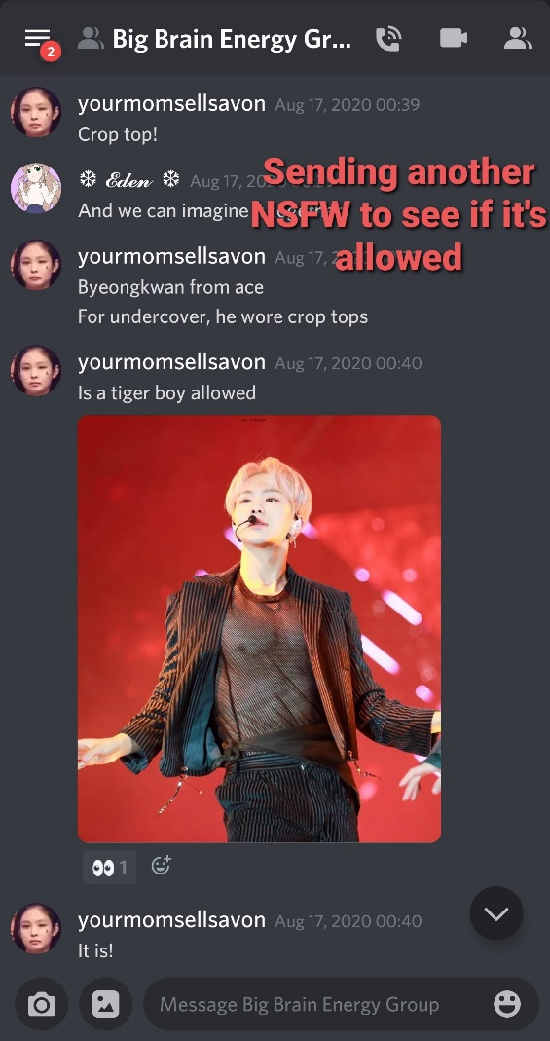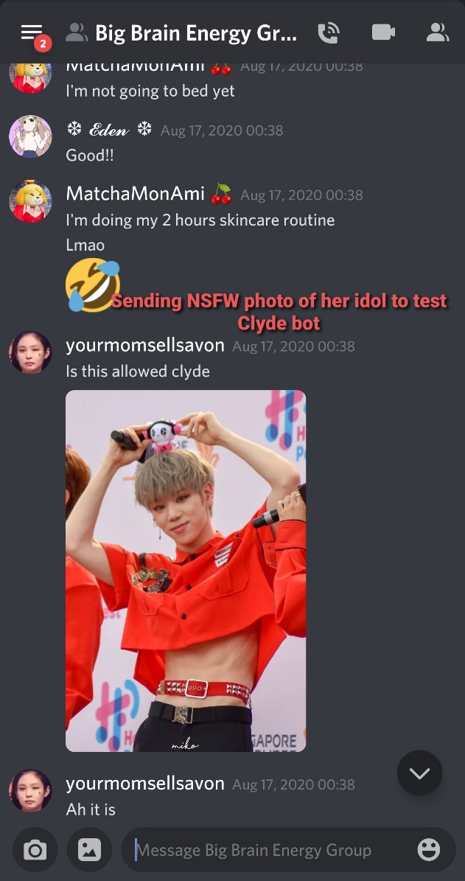

- More of Matcha’s shitty behavior leaked by sleepydoll
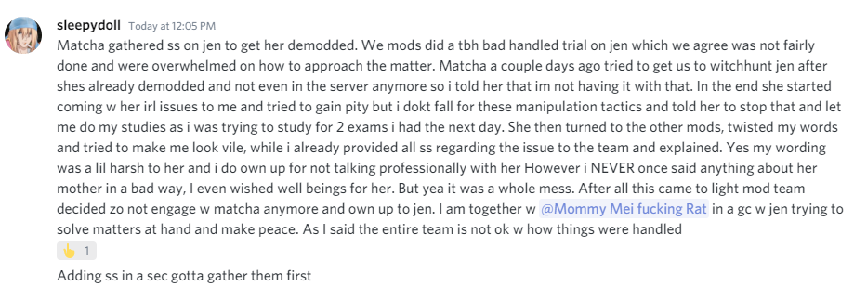
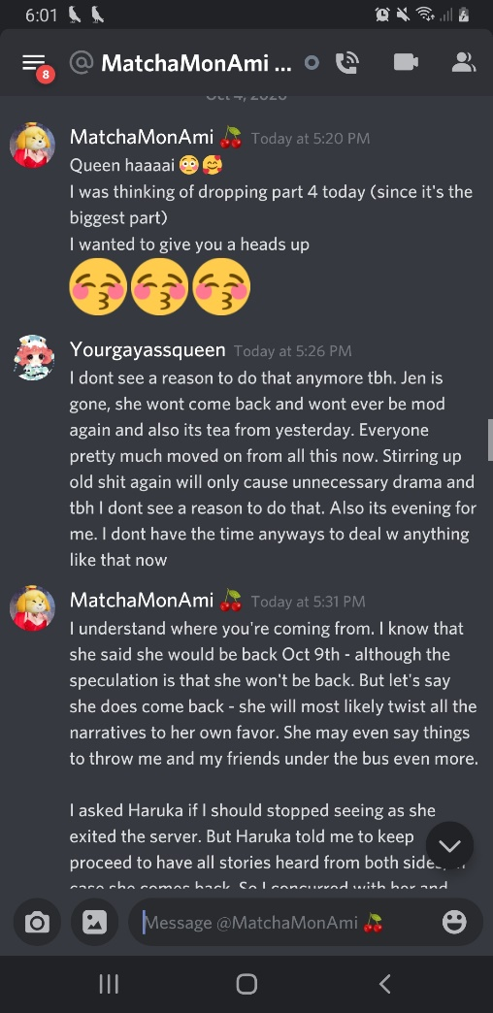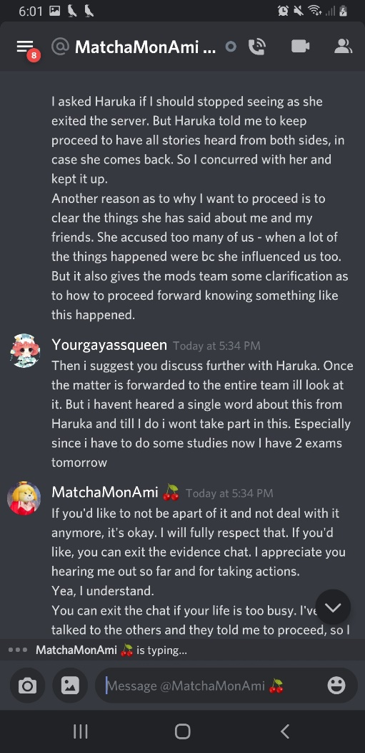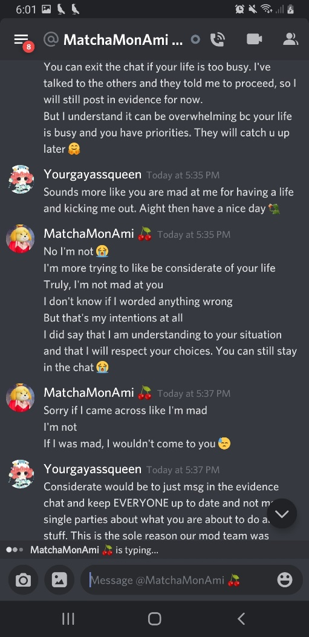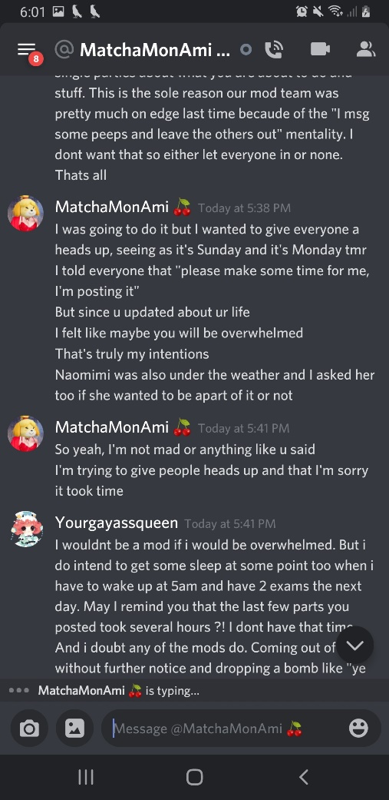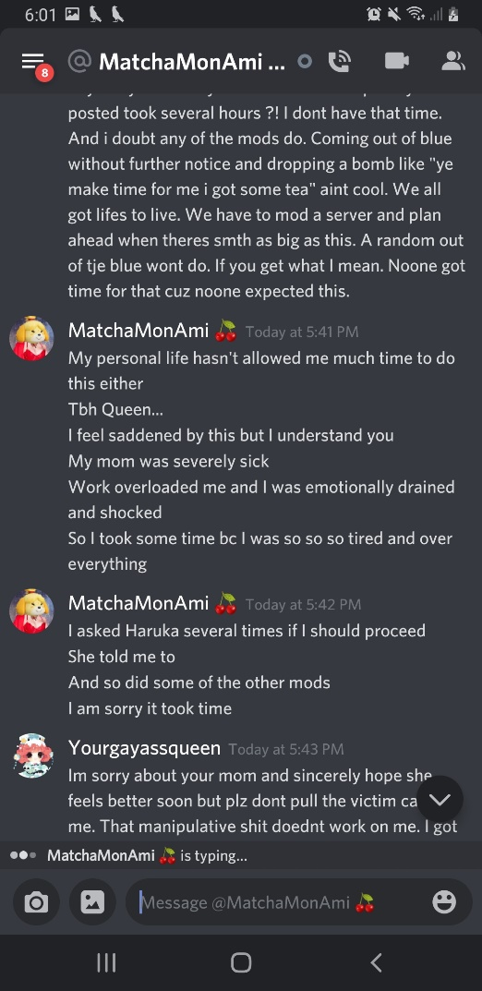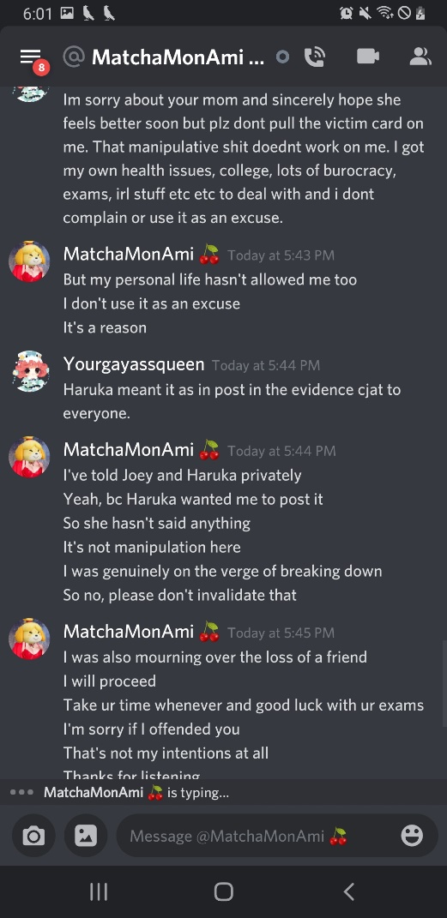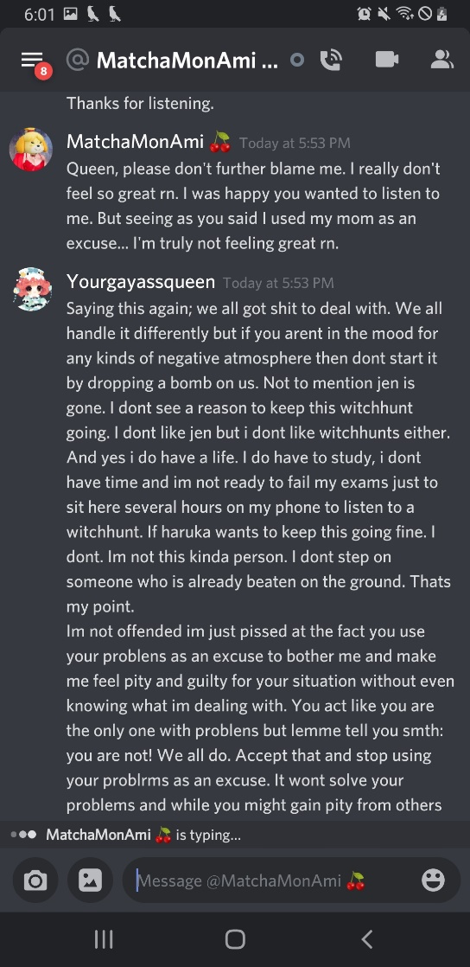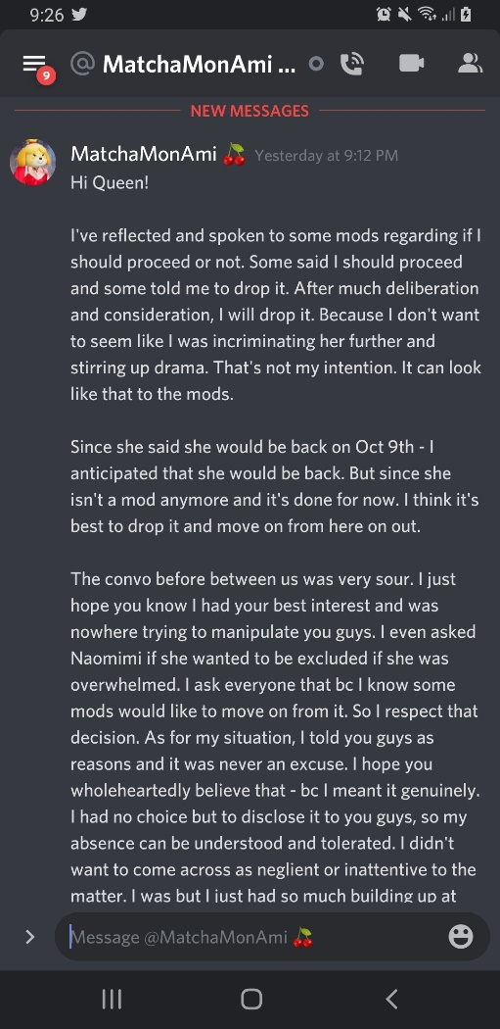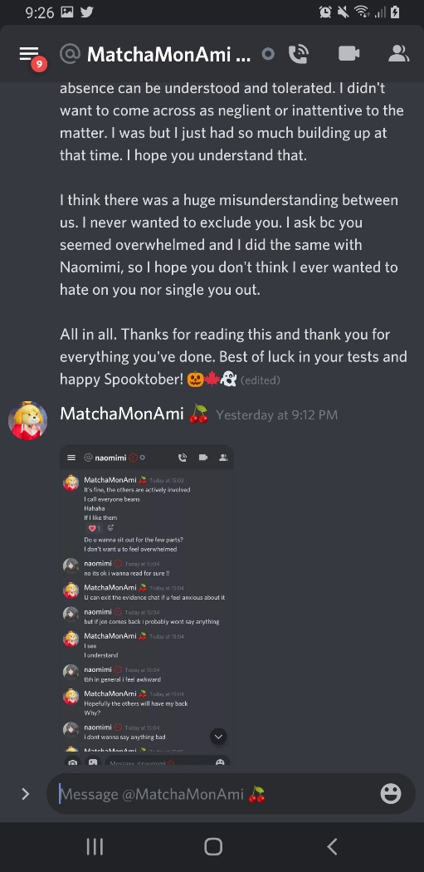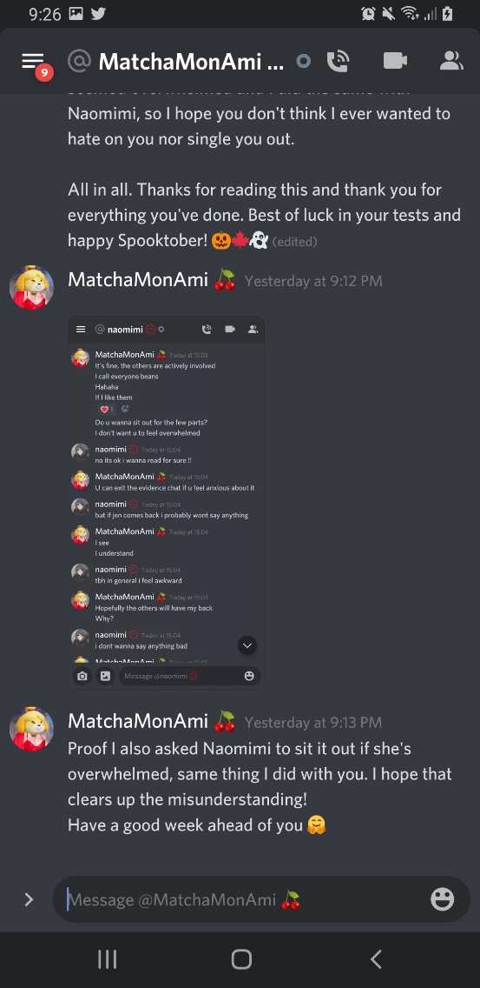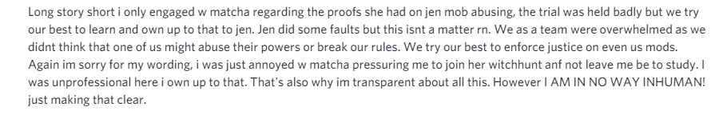

- Matcha, not getting the reaction she wanted from Queen, cries to the other mods.
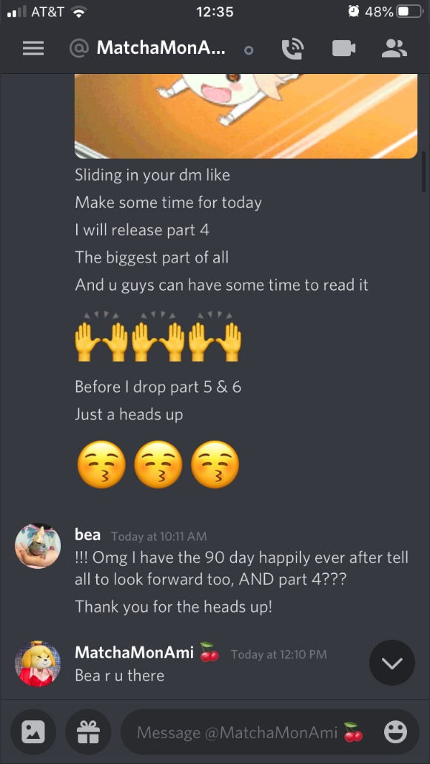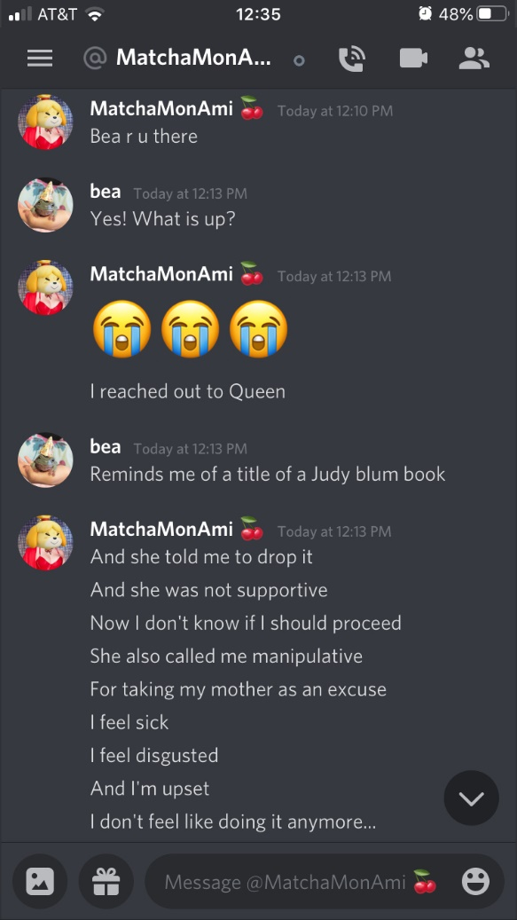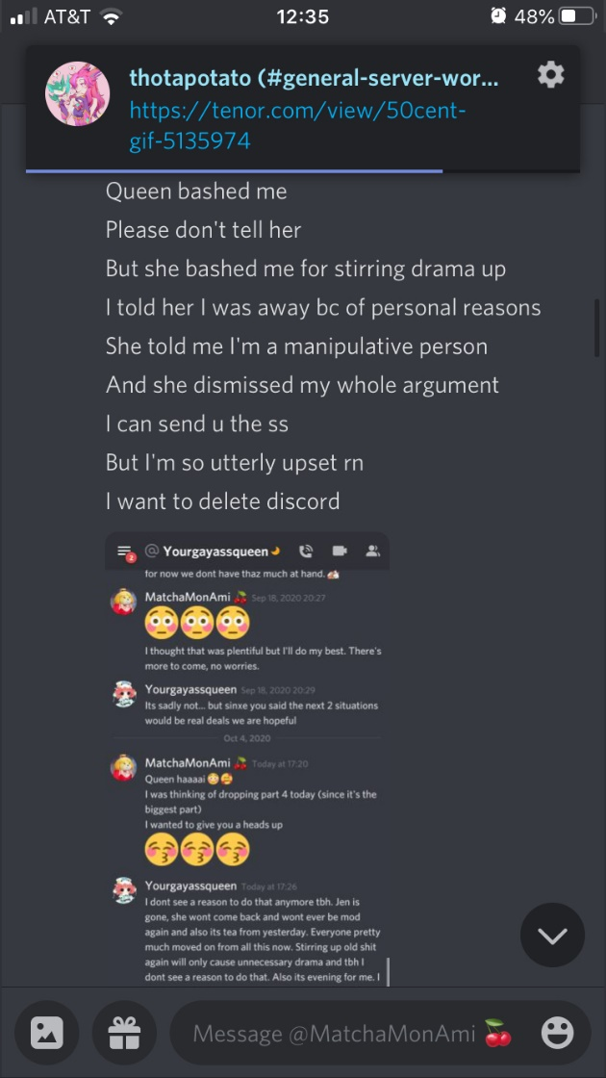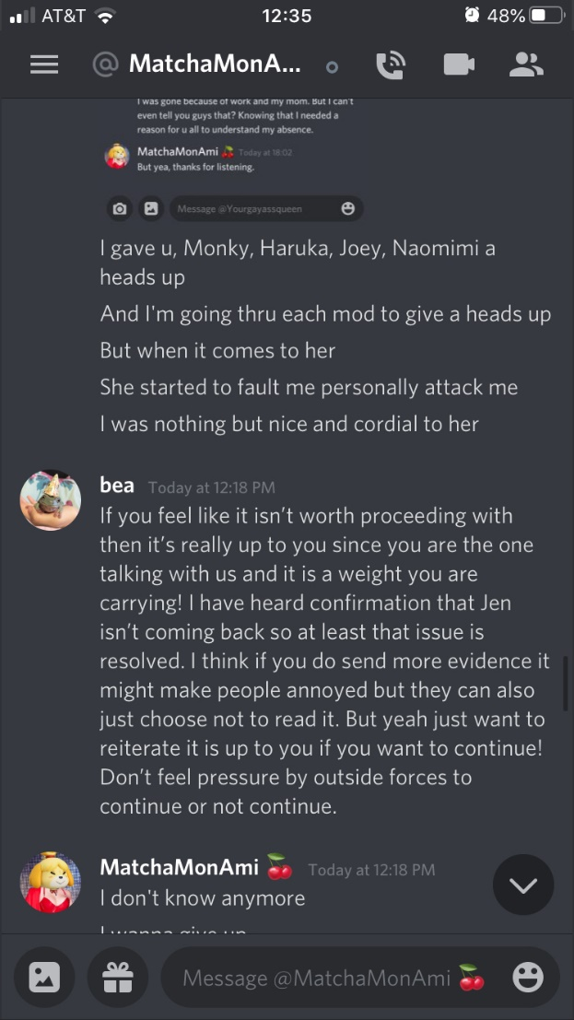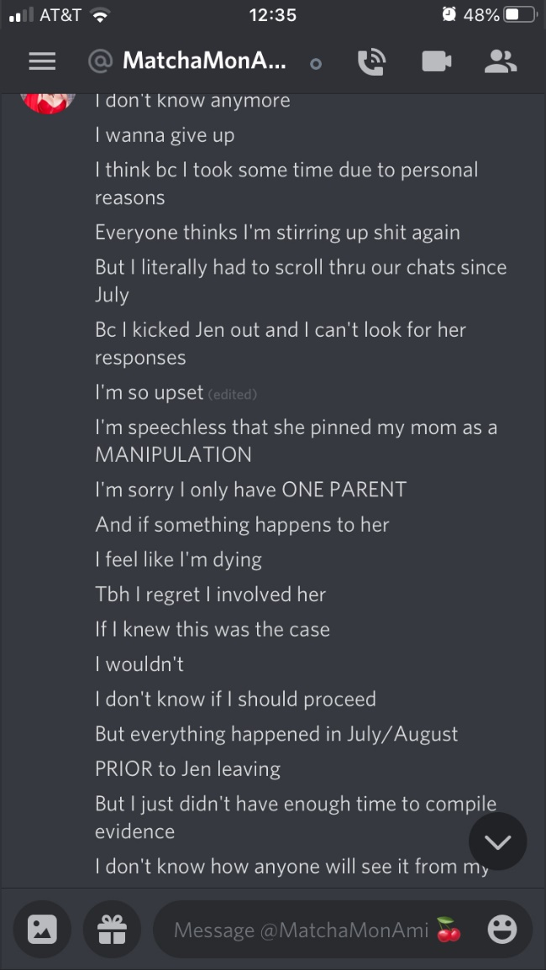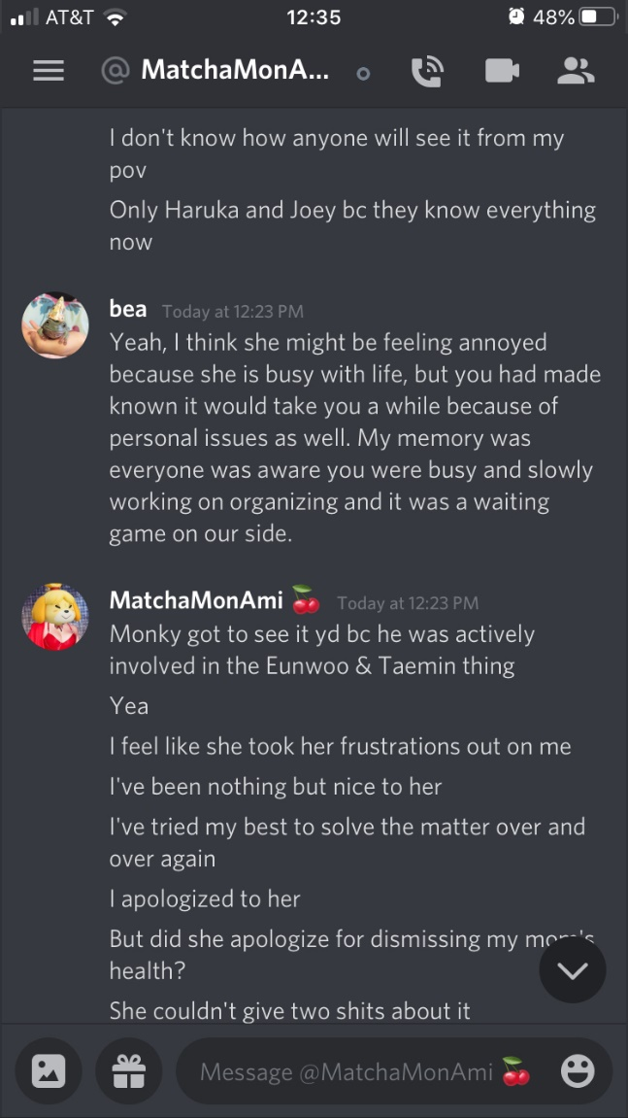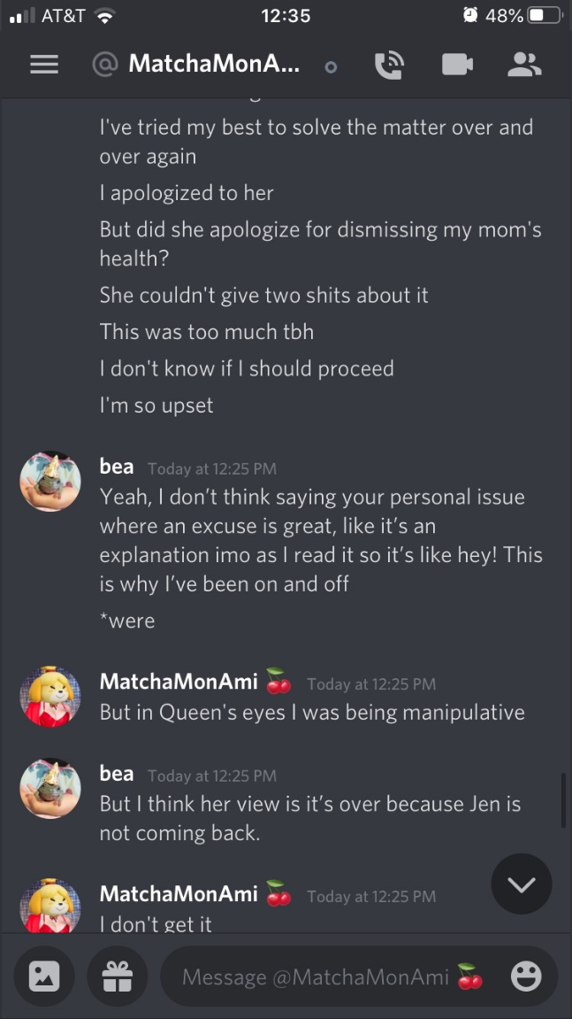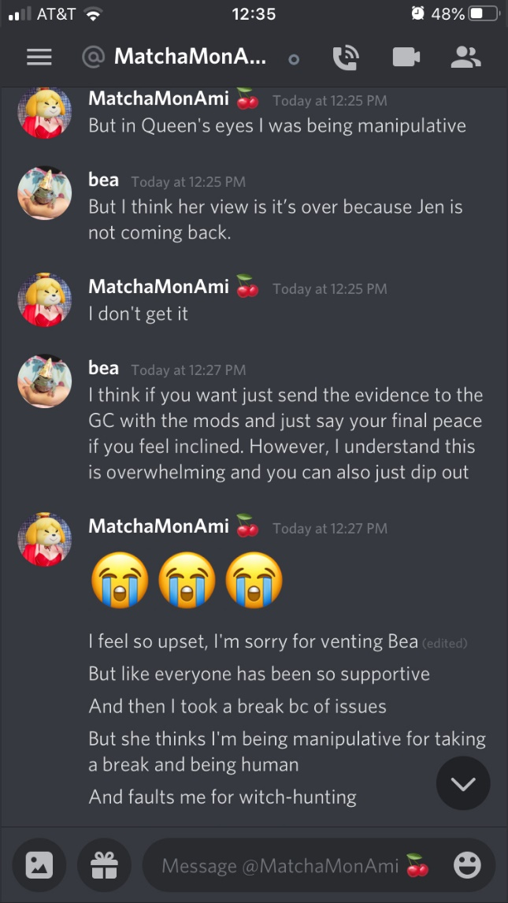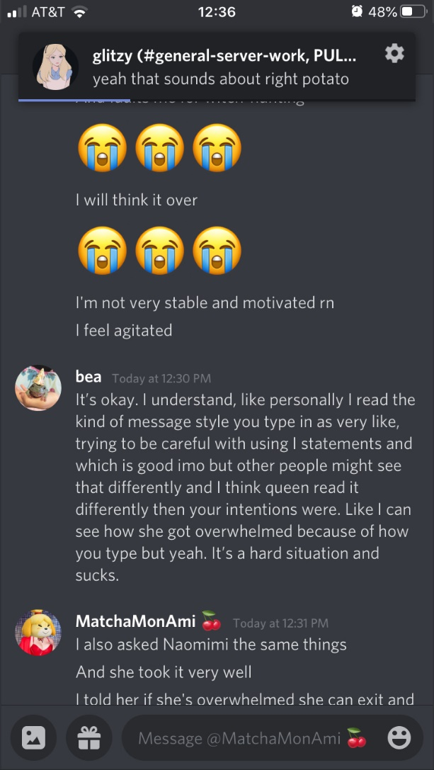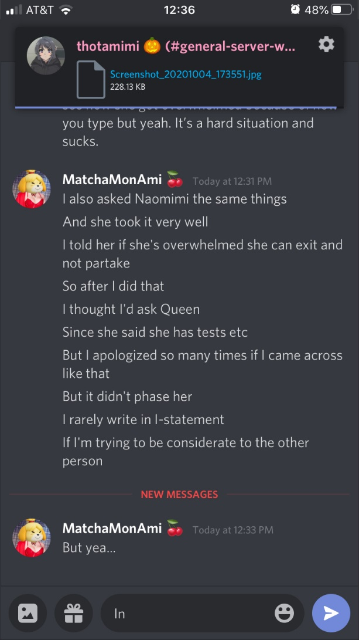

WhistleBlow 2: Glitzy
- Glitzy was a transphobe. People didn’t like that and wanted Glitzy to be demoded and/or banned.
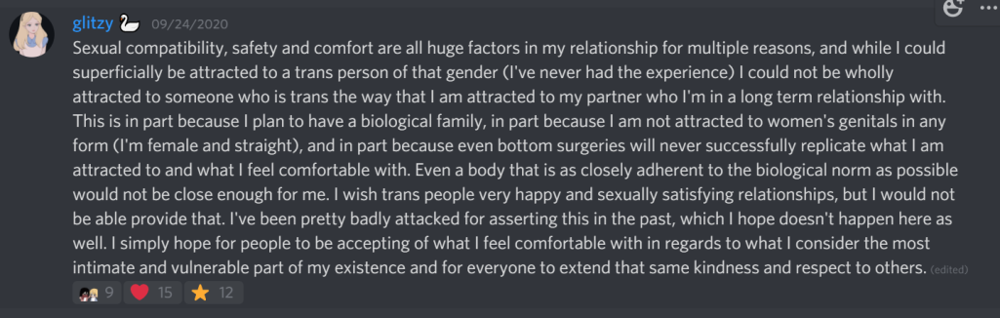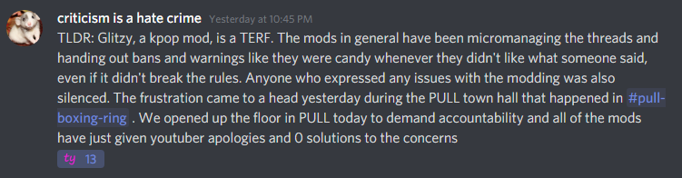
- Mods and admins wanted to protect Glitzy and give her another chance

WhistleBlow 3: BananasGoMoo is a nasty mother fucker (literally, it’s a pregnancy fetish and more.)
- BananasgoMoo uses the same username everywhere. Foolish.
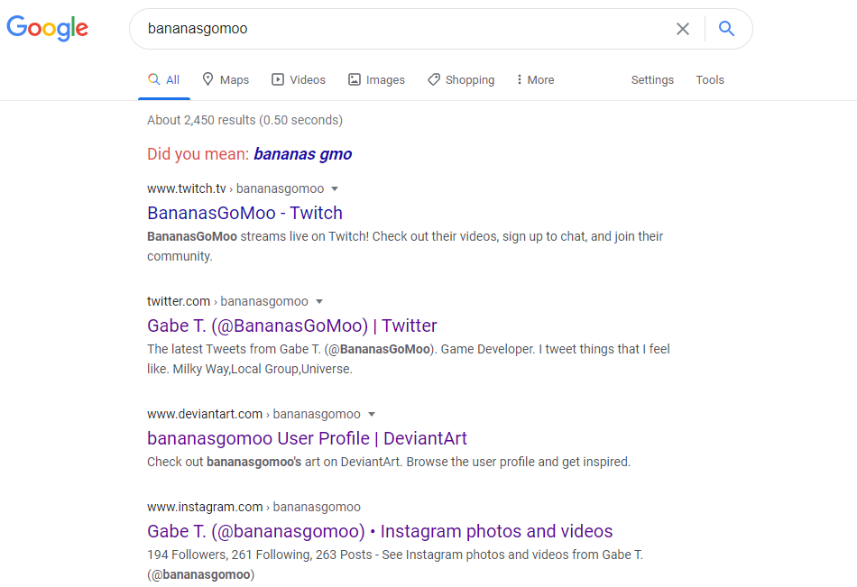
- He has since wiped his accounts or made them private. Too little too late.
- Reddit shows him on r/PornID, not too damning but shows a trend.
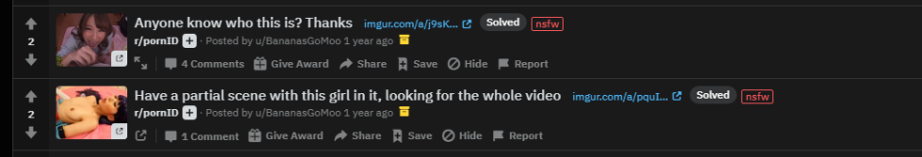
- Namely that he has an unhealthy sexuality
  - Fetishizing Japanese women
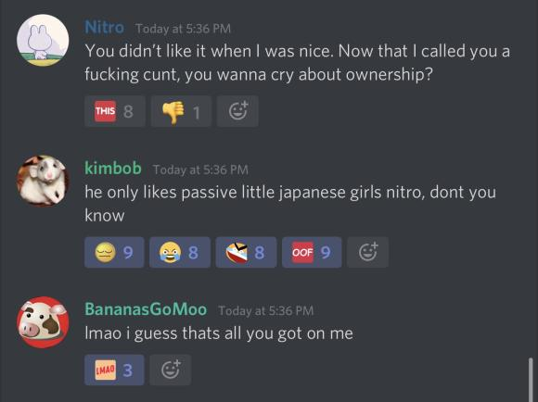
  - Pregnant women fetish
    - Reblogging non fetish pictures of pregnant women onto his fetish tumblr
  - Piss fetish
  - Is a nasty lolicon, pedo ass
  - Incel
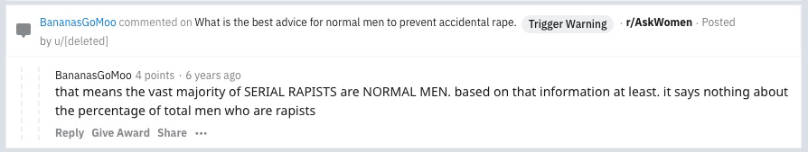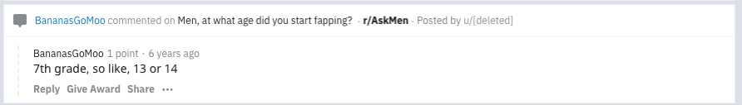
- This was all found out on his now deleted tumblr. And leaked by lolcow (thank u lc)
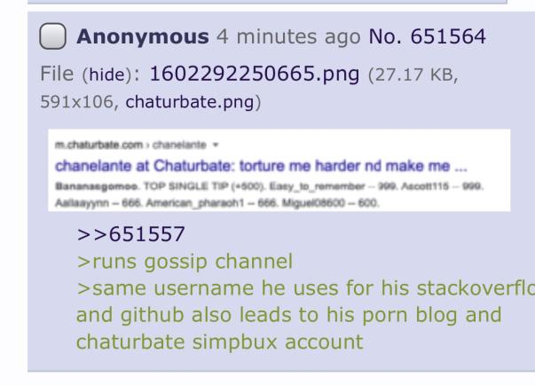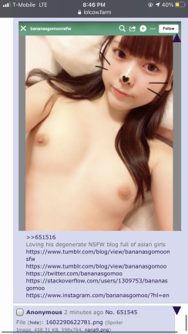

Stringing it all Together: aka TLDR



