I take the allegations against me seriously. The allegations that claim that I harassed four women are unequivocally false. I have plentiful evidence that will prove my innocence. I admit that I made mistakes in text messaging communication, but it was never in a way that was indicative of harassment or excessive advancements.

My messages were never intended to cause distress or discomfort. No one in this entire situation has any chance of filing a successful legal claim.

The purpose of this document is to reference the claims against me and show that this is a personal issue that has been pushed too far into a public light. While I do regret that those involved may have been unintentionally hurt, I do not stand for these circumstances leading to these individuals taking actions against me meant to discredit and slander my character.

This is a situation where many disagreements and incompatibilities between me and my exes have surfaced. I made mistakes, and they made mistakes. These types of situations happen in most relationships except that in most relationships one of the people doesn't have a large online community filled with people interested in reading intimate details of their relationships. This type of thing happens all the time, goes unnoticed, and is dealt with on a personal level. Unfortunately I don’t have the opportunity to keep the more embarrassing and unfortunate parts of my relationships private. However, the mistakes that me and my exes made don't make us evil, nor do any of the actions involved classify as harassment.

The four women I was accused of harassing are Lexy*, Sienna, Cats4ever, and Jen.
Lexy is not the actual name of the individual, it’s a name I made up to avoid confusion and to censor her identity. I can uncensor these screenshots if I absolutely must, but she requested to not be involved in this situation so I will respect that.

I will display everyone’s forgiveness in the first 4 pages, and then go into great detail about everything after that.
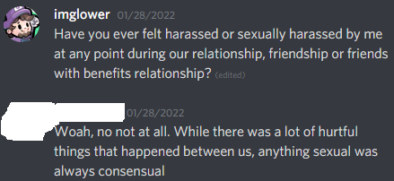
I never “harassed” Lexy.
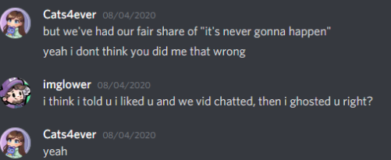
Cats4ever: “Yeah I don’t think you did me that wrong”.
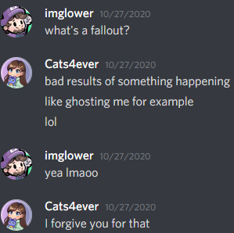
Cats4ever forgives me on her own terms for “ghosting” her. Cats laughs at the situation with the “lol”.

There was never a situation when I was in communication where Cats4ever told me to stop with my advances or flirting. I will admit that I did say many things that I now regret, but she welcomed it, or thought it was funny. We remained on good terms and were very close friends after the events of “ghosting”.

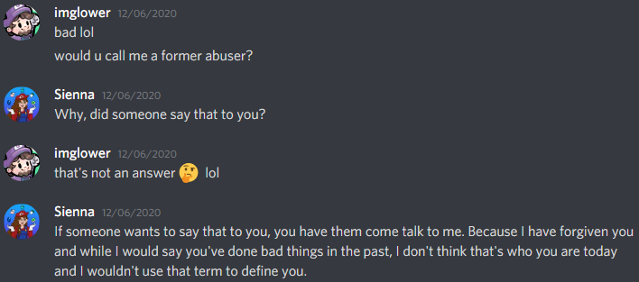
Me: “Would you call me an abuser?”
Sienna: “I have forgiven you.”
Sienna: “While I would say you’ve done bad things in the past, I don’t think that’s who you are today and I wouldn’t use that term to define you.”
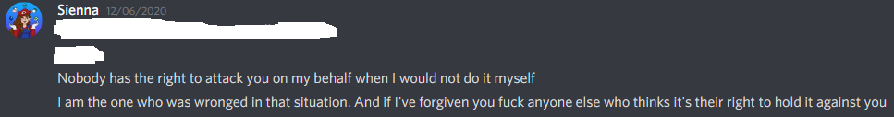
Sienna: “I’ve forgiven you”.

Much of what Sienna has said in the twitlonger is manipulated, falsifiable and incorrect. I will prove it below. I admit I did make many mistakes in our encounters, however she forgave me, and we remained on good terms long after because she knew I had good intentions.
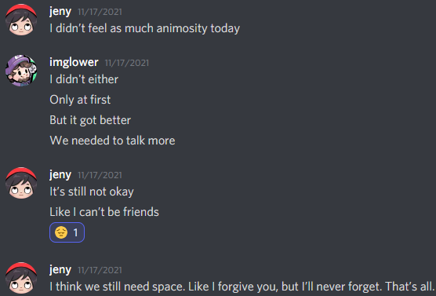
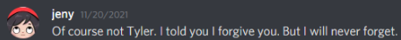
Jen forgave me on her own terms the first two times.
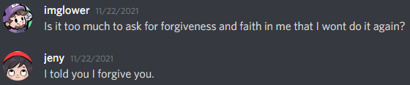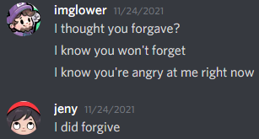
The next two displays of forgiveness.

I admit that I did make Jen uncomfortable, but days after, she did want to remain on good terms and she did remain friendly with me. She later turned her back on me because I kept contacting our mutual friends about our breakup against her wishes.

Now I will go into great detail about everything to prove my innocence.
I was forced to contact Lexy after 9 months of not talking to her to disprove the claims of harassment. She does not belong in Sienna’s twitlonger.

I never “harassed” Lexy. Sienna believed false rumors that came from people who know nothing about my relationship with Lexy, and she reported that false information in her twitlonger. Sienna’s twitlonger is libel because Lexy was never harassed.

Many relationships have many hurtful things that happen and the pain was felt on both sides.
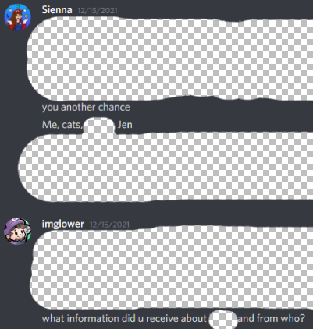
Sienna specifically named this person in a DM, and spoke on her behalf without her permission.
Sienna falsely accused me of harassing Lexy.

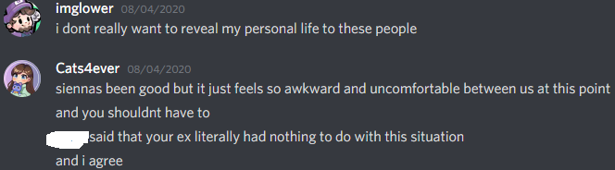
Individuals who know nothing about Lexy, tried to bring my relationship with her up in a discussion, Cats and I talked about it. Lexy has nothing to do with the accusations according to Cats4ever. Cats has since changed her mind.
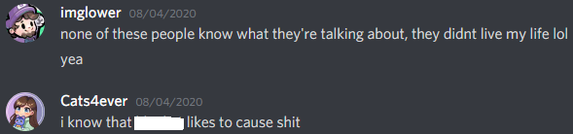
Cats4ever admits that ____ likes to create drama, and that’s where Sienna got her information.
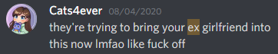
Cats knew that there were people that like to cause unnecessary drama and now she stands with them.
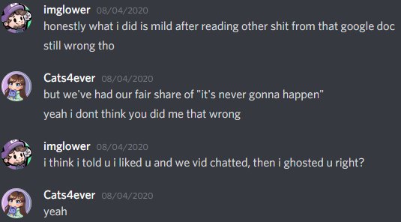
Cats4ever: “Yeah I don’t think you did me that wrong”.
I told Cats4ever that I liked her, and after I learned more information about her after doing a video call with her I “ghosted” her. Ghosting is when you stop responding to messages. I don’t think it was a complete shut down from all communication, but I stopped being as talkative as I was before. After the events of ghosting, we made amends and became very close friends. That is not harassment.
Cats4ever forgives me for “ghosting” her on her own terms. Cats laughs at the situation with the “lol”.

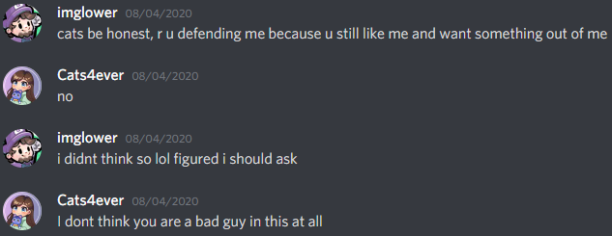
Cats4ever: “I don’t think you’re a bad guy in this at all”. When referring to the actions that took place between me and her, and me and Sienna.
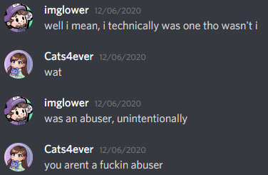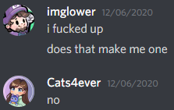
After I try to convince Cats4ever that I am an “abuser” twice for my actions towards Sienna and herself, she disagrees and tells me that I am not an abuser both times.
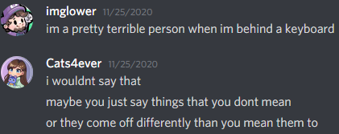
I believe that Cats is correct. A lot of the time, what I say over a keyboard does not come out in the way I intended it to.
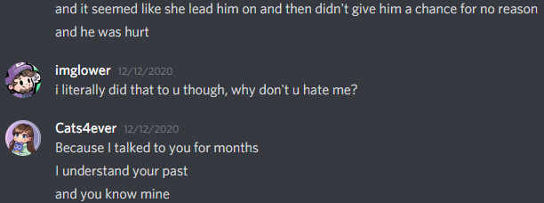
Context, and understanding a person's past is massively important when it comes to understanding their behavior and why they do what they do, and did what they did.

Cats4ever wants to remain my friend after knowing everything that had happened with everyone (Herself, Sienna and Jen).

There was never a situation when I was in communication where Cats4ever told me to stop with my advances or flirting. I will admit that I did say many things that can look bad out of context, but she welcomed it, or thought it was funny.

The situations with Sienna and Jen are much more complicated and I will have to go into great detail to falsify the claims of “harassment” with them.

The women in all of these situations, if uncomfortable, had the opportunity to tell me and to space themselves away from me by blocking me; that action was never taken by any of them. All context of remaining friendship and forgiveness was left out of their stories. Lexy was never harassed and we have always been on good terms. I was very good friends with Sienna and Cats4ever long after we stopped being romantically involved. Jen did not initially disapprove of me after our incident, we talked civilly many times and she even came back to my Twitch stream to watch, lurk, wish me luck and compliment me. Jen only started to dislike me after she believed that I was trash talking about her to our friends. My intentions in talking to those friends was to seek therapy due to how I was feeling due to the unexpected circumstances I will reveal below.

Now I am going to directly address Sienna’s twitlonger and respond to most of the important information. I will take accountability and apologize in areas where I believe I made mistakes. I will disprove misinformation and show that much of what Sienna stated is over-exaggerated. The snapchat interactions that happened between Sienna and I fall between the dates of roughly October 2019 and July 2020. I have learned my lessons from all these situations and do not deserve further punishment.

Everything I take from her original twitlonger ( https://www.twitlonger.com/show/n_1srulb2 ) will be “highlighted with quotations”. Anything else below those quotes is my response to it.
“I don’t want to speak on behalf of others”
This is hypocrisy, she says “I don’t want to speak on behalf of others”, but then speaks on behalf of Lexy without her, or anyone she talked to ever contacting her. 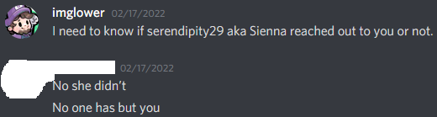
Sienna knows nothing about Lexy, nor does she know about any of my experiences with her. Sienna falsely accused me of harassing Lexy. Any screenshots, rumors, and discussions that she may have had from people who don’t know anything about the relationship I had with Lexy are discredited. The censored screenshots of Lexy outsource all of the out of context, or misinformation that was spread about us by individuals for years.

The claims of harassment with one of the four women that Sienna claims, is undeniably false.

“However, I know that including myself there are at least four women that Glower has harassed.”
In the first paragraph, she said numerous statements that are blatantly false. One of the very first things she writes about is assumed and incorrect information based on rumors from people that know nothing about my life. They have no evidence of anything that happened between Lexy and I and Sienna chose to believe it. She made assumptions about my relationship with Lexy and reported incorrect information in her twitlonger to make me look as bad as possible. The foundation of her twitlonger is her words, and she is already telling you multiple pieces of false information in the first paragraph. This is not to say that you shouldn’t believe victims on the grand scale, but in this specific case, not everything that Sienna is saying is true.

“I was not the first, and I was not the last.”
This statement is false. If she has the opinion that everyone was harassed, then she can believe it if she wants to. The statement “I was not the first, and I was not the last” is one of the many examples of manipulative literature to make it appear as if I am a serial abuser.

“I know there are people who think that I’m posting this for clout or to “cancel” someone.”
If people don’t feel that I am safe, they have every right to leave my community, and ban me from theirs. People are allowed to share their opinions about me, but it is calumny to spread Sienna's twitlonger around as if it is nothing but the truth. Much of what has been reported is provably manipulated and false. With that said, I have made mistakes in my text messaging with her specifically. Since that time, I have learned from those experiences and have improved my communication skills.

“However, after finding out in November that Glower had once again harassed another one of my friends, I was filled with regret for not saying anything earlier.”
I am denying the claims, and Sienna’s opinion, that what I did to anyone, is harassment. Now that I have my act together and have stopped crying, I am composed and can properly defend myself. Jen knew what had happened between us, yet chose to get into a relationship anyway.

“Honestly, I had never been DMed by a “bigger streamer” before, and I was really surprised by his name in my DM list. It’s hard to explain, but when you’re a fan of someone’s content and they all of a sudden reach out to you so personally, you feel sorta awestruck, a “He’s actually talking to me?!” kinda feeling. It’s a weird dynamic, and I really felt like I was meeting someone famous, as stupid as that is. He held all those world records, had hundreds of viewers, and I was a big fan. I was flattered that he bothered to talk to me at all. This obviously led to a pretty unhealthy friendship/relationship with him in the first place, but that was compounded by other factors.”
I never knew that you viewed me in this way. Personally, I see celebrities, streamers, YouTubers, everyone considered to have any fame, as people because that is what they are. I can see the perspective that people look up to streamers and potentially idolize them, I can also see the perspective as seeing them as people. I did not in any way use my position to intentionally manipulate you, or anybody into liking me. She did not give the full context of what actually happened, so I will do so below.

“I initiated most of the conversations that led to us getting romantically involved from then on out.”
She admits that she was the initiator here.

We have reached the point in the twitlonger where Sienna has started to add, subtract, and alter some information so that I look much worse in these situations, and she looks much better.

In 2022, I was contacted by a friend that Sienna and I had in common during 2020. His name is Shaggaliciouss. Sienna and Shagg were close friends when the events between her and I took place. When Shagg first found out what happened between us, he hated me. Sienna then decided to send Shagg a letter to explain her perspective of the situation to him so that it could ease the situation and his hatred towards me. Later on, in 2022, Shagg saw the tweets from Jen and Sienna about me through mutual friends, he noticed that much of what Sienna said in the twitlonger was inconsistent with what she personally wrote to him 17 months prior.
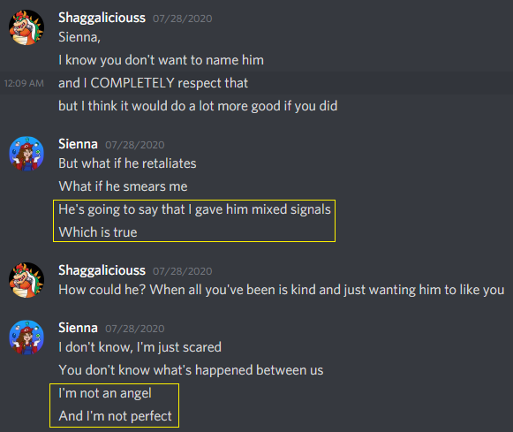
Sienna admits to giving me mixed signals throughout our entire relationship to Shagg. Sienna admits that she was not a perfect angel in our situation.
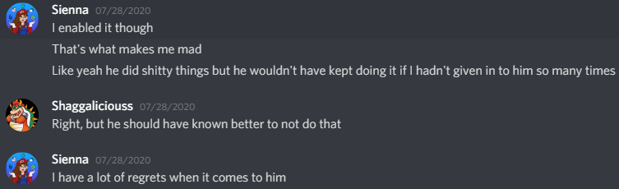
I should have known better in some of the situations, but Sienna gave me mixed signals and allowed my behavior because she wanted what we did too. She has a lot of regrets, and so do I.
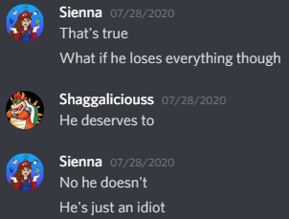
Sienna did not believe that I deserved to lose everything that I worked for over the years because of my actions towards her.

The majority of Sienna's twitlonger is copy and pasted from the letter that she sent to Shagg. The memories of what happened between Sienna and I, were much more fresh in Sienna’s memory when she wrote the letter to Shagg. When Sienna copy and pasted most of the material from the letter she wrote to Shagg to make her twitlonger, she decided to also extract anything that might put her at fault. Sienna also created fabrications and lies to dig me a deeper hole. I will now expose all of the lies Sienna is telling and falsify everything she made up, with her very own words.

Note: Some of the information in both stories seems to be incorrect and I will attempt to piece together what actually happened.

Note: In 2023 I have removed the note she wrote to Shagg since it contains too much personal information. There will be many portions below that are censored or removed as a result.

To Shagg:“When you messaged glower and told him what you thought about him, I realized that your thoughts about him were so much worse than what I thought. And I was wracked with guilt about not presenting you with the full picture.”
Initially, Sienna did not tell the full story to Shagg, so she wrote him the “For_Corey”, letter exposing her perspective of what happened. Sienna did not provide Shagg with any context before writing For_Corey, and as a result, Shagg hated me more than Sienna did. Similarly, Sienna left a lot of very important context out of her twitlonger, and added many fabrications, so the result is many people who read her twitlonger hate me more than she does herself.

To Shagg:“I also did things I regret in my interactions with him. I was done giving him chances and making excuses for him, but I still didn’t really hate him. I hated what he did, but not who he was. I realized that by talking to you and having emotional reactions to what he was saying, I was presenting him as an irredeemable abuser.”
The events that took place are not as bad as she is presenting them to be today. After our romantic relations had ended, Sienna was nowhere close to hating me, and she never viewed me as a malicious, abusive person. Sienna remained my friend for 1.5 years after the events that happened. There was redemption and forgiveness after our many miscommunications.

To Shagg:“That while he was in the wrong at many points in time, I did not do what I could have to prevent it from happening. And I sent him mixed messages, which potentially led him to do what he did.”
Sienna admits to Shagg that she was sending many mixed messages. As much as she claims how bad the situation was, Sienna did welcome my advances. She took me in and accepted me when she had needs to fulfill. Sienna also initiated many of our sexual encounters at random points during our entire relationship, even at the times that she now views as inappropriate or uncomfortable. This piece of important context was removed from her twitlonger.

To Shagg:“In August of last year, Glower slid into my DM’s.”
I didn’t “slide into her DMs”, I told her to stop flirting in my chat because my girlfriend was getting upset, then she was the one who was “sliding into my DMs”. (I removed this proof as it was mostly irrelevant and took many pages)
To Shagg:“Somewhere into the conversation, glower tells me that while he’s flattered by my comments, he wasn’t “exactly single” at the moment.“
I never told her that I was flattered by her comments on our first day of DMing.
To Shagg:“The next day he messaged me telling me that he had told his girlfriend about our conversation and she was pissed.”
I did not message her the next day, she messaged me 2 days later.

The three above quotes that she wrote to Shagg are not what actually happened.

These two quotes below were absent from the letter that she sent to Shagg. She added it later, to state a personal opinion and to make it look like I was taking advantage of her.

To Twitter: “With that being said, I had disclosed to him very early on that I was a virgin and that I was inexperienced. This was something he latched onto, and something he used, I now believe, to manipulate me into doing things I wasn’t entirely comfortable with.”
I did not latch onto and then use the fact that you were a virgin to gain any sort of advantage or edge over you. I saw it as a situation I have never dealt with before, and wanted to talk about it so that we could iron out the kinks. This is what adults do in adult relationships; they talk about things to avoid potential issues. After you told me about your background, I tried to get a better understanding of how to navigate the situation by communicating with you. Having open communication is the foundation for keeping a relationship healthy. Why would I try to manipulate you to do something you’re not comfortable with? Nothing about that is appealing. That’s gross.

To Twitter:“He became hyperfixated on certain things; asking me if I masturbated to him, pressuring me to do it after I told him I hadn’t ever done it and wasn’t comfortable with doing it, asking for videos of me doing it. I really wanted to please him, so I tried to give him whatever he asked for. I didn’t want him to stop messaging me, so I ignored a lot of my own personal discomforts to do what he wanted. However, I acknowledge that I did do these things willingly.
”
I don’t remember specific situations, but because of the fact that she told me she was a virgin, in general, I was trying to learn about what she was comfortable with and what she had and hadn’t done sexually. I do not recall ever “pressuring” her to do anything, nor did she mention the fact that she felt pressured by me. She never told me she felt uncomfortable, in fact, she was very excited to do everything that we did, especially early on. I do not recall specifically asking for that type of video, that isn’t something I have a particular interest in seeing. She admits to doing these things willingly, so if these events happened, she was just as interested as I was and therefore I’m not at fault.

I am now going to directly compare the letter she sent to Shaggaliciouss, to what she said in her twitlonger to expose her manipulations, cover-ups and lies. Notice how much of the text is copy and pasted. Sienna intentionally altered it to make herself look better, and to make me look worse. I will properly apologize in areas that I believe I messed up in. As a reminder, these events took place 1.5-2 years ago and I have learned my lessons. Since this time, I have not made the same mistakes because I learned from these situations after it was discussed and forgiven in privacy.

To Shagg: “And at the beginning, I wasn’t as emotionally invested in him. But I am human, and I get horny, and when he solicited me for nudes over Christmas break, I didn’t turn him down. I didn’t feel pressured at all. In fact, I found it really satisfying that he wanted me to help him get off.”
To Twitter: “At the beginning, I wasn’t as emotionally invested in him, but when he solicited me for nudes over Christmas break, I didn’t turn him down. I didn’t feel pressured at all. In fact, I found it really satisfying that he wanted to get off to me.”
Sienna cut the part where she said “But I am human, and I get horny”, out of her twitlonger. She wanted to present herself as professional rather than animalistic. At this point, she admits that she wanted these sexual encounters to Shagg, so the manipulative paragraph above, that was written exclusively to Twitter, where she claims “I really wanted to please him, so I tried to give him whatever he asked for.” is completely discredited. If you were reading carefully, above she also said “pressuring me to do it after I told him I hadn’t ever done it and wasn’t comfortable with doing it”, then she says here, “I didn’t feel pressured at all.” The story does not add up, she later added this information to make me look bad in order to manipulate the audience that read it.

She reported that these events happened over Christmas break. None of our messages in snapchat were ever saved, and our discord DMs have a gigantic 5 month gap so there will be no evidence of any of her claims up to this point.
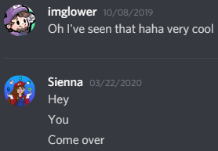
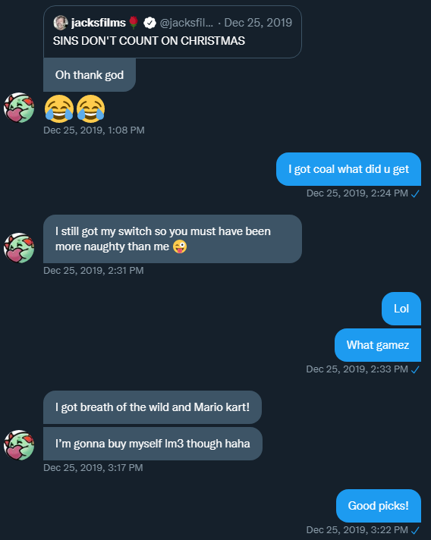
On Christmas, she sent me this DM on Twitter because we were on Santa’s naughty list that year. The claim “he solicited me for nudes over Christmas break”, as if it was something she didn’t want, is discredited with this added context because the content of these messages points in the direction of her liking it and getting a laugh from it.

To Shagg: “But after a couple weeks of this, I started to get feelings again. A lot of my old feelings came back, but he just wanted to focus on the sexting. This started to bother me. I ended up getting drunk for the first time in my life just after New Year’s and texted him, asking if he cared about me at all or if he just liked getting off to me. He responded saying, “I don’t know, I don’t even really know you.” And at that point I knew he would never see me as anything more than a friend with benefits. So that’s when I decided I was completely done with him.”
To Twitter: “However, after a couple weeks of this, a lot of my old feelings came back, while he just wanted to sext. This started to bother me. I ended up getting drunk and texted him, asking if he cared about me at all or if he just liked getting off to me. He responded saying, “I don’t know, I don’t even really know you.” At that point I knew he would never see me as anything more than someone to jerk off to. So that’s when I decided I was done with him.”
To Shagg: “he would never see me as anything more than a friend with benefits.”
To Twitter: “he would never see me as anything more than someone to jerk off to.”

She intentionally changed the wording here to make it look worse than it actually was. We agreed upon a friend with benefits relationship at this time (proven below).

We agreed upon this, early on in our relationship: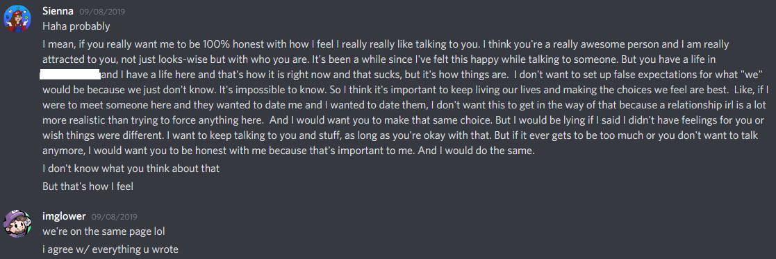

To clarify the meaning of “I don’t know, I don’t even really know you.”. What I was trying to say was, I am interested in her, but since this is a long distance connection, I find it difficult to imagine what it would be like if we were together, in person, with body language included in the mix. An online connection is hard to navigate, especially when you don’t know what the other person is like in real life.

To Shagg: “I told him I was dating someone and at first, he seemed confused and asked a lot of questions, but then he congratulated me. He seemed happy for me. I told him we could still be friends, but obviously that’s all we could be. He said he understood, and we left it at that. But then he started messaging me pretty frequently. Overall, it was innocent, but I did notice it was more often than it had been before. I didn’t mind, as long as it stayed friendly. I went to visit [said boyfriend] the first time, things went perfectly.”
To Twitter: “I told him I was dating someone and at first, he seemed confused, but then he congratulated me. He seemed happy for me. I told him we could still be friends, but obviously that’s all we could be. He said he understood, and we left it at that. Right after this, he started messaging me pretty frequently and it began to get uncomfortable quickly. Glower started asking really invasive questions about my relationship. He began to ask things about whether or not my boyfriend and I were physically involved, if I sent him pics, if we had sex, etc. When I declined to answer, he kept pushing me for details. When I told him I wasn’t comfortable with his questions, he apologized and backed off. I think he was still hyperfixated on my virginity and wanted to know if I’d lost it. Regardless, it was extremely inappropriate for him to be asking me those things. After this, I went to visit my boyfriend for the first time and things went perfectly.”

To Shagg: “Overall, it was innocent, but I did notice it was more often than it had been before. I didn’t mind, as long as it stayed friendly.”
To Twitter: “Glower starting asking really invasive questions, etc”.
These are not compatible. She is including fabrications as well as an obsession on her virginity to make me look terrible. I really don’t know why. She tells Shagg that my questions were innocent and friendly, but then reports to Twitter that my questions were invasive and sexual in nature. She also tries to sell me being “hyperfixated” on her virginity again, I don’t know why.

To Shagg: “But then the second time I flew out there, things were different. Things were going downhill in the relationship and we were both unhappy. While this was going on, glower and I talked occasionally but just as friends. We played AC together, I participated in his streams, and we talked about life. On occasion he would flirt with me, but I would have to remind him that I was unavailable, to which he would apologize. It never got further than that.”
To Twitter: “However, a month later, when I flew out there the second time, things were different. Things were going downhill in the relationship, and we were both unhappy. While this was going on, Glower and I talked occasionally but just as friends and mostly in groups. We had a group of friends that VCed pretty much every night called “comfy chat”, where we would just chill or play games together.”
To Shagg: “On occasion he would flirt with me, it never got further than that.”
To Twitter: She lied about the very specific information that she did not include in her writing to Shagg in the above and below paragraphs.

This is all conflicting information. She tells two different stories, these are her words, not mine. I apologize for occasionally flirting with you at this time for humor, it was not appropriate.
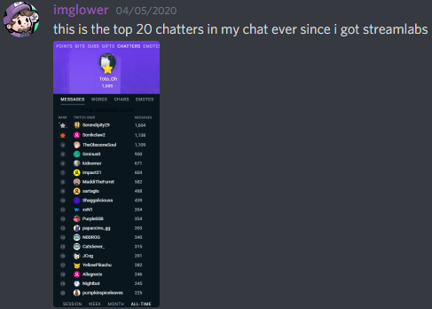
Serendipity29 is the #2 chatter of all time
If I made her as uncomfortable as she claims, why was she so active in my chat? The reason is because she liked our interactions and wanted friendship too. I can not exactly pinpoint the timeline of the claims that Sienna writes in the above paragraphs, but this chat log should approximately come after everything that has been said so far.
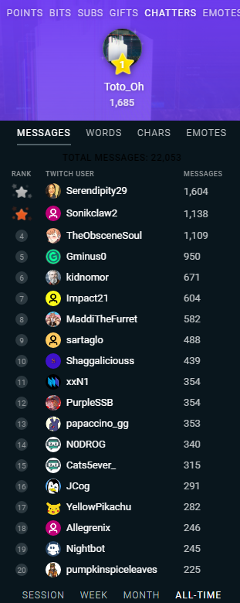
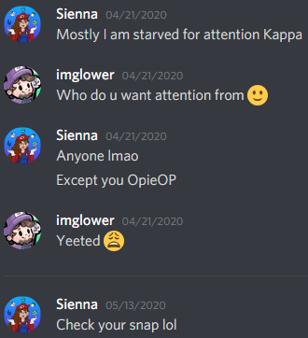
This picture approximately fits the timelines of these events.
Additionally she joined voice calls in Comfy-Call and texted in #comfy-chat.
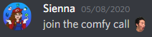
This is the first message that I can find in #comfy-chat from Sienna.
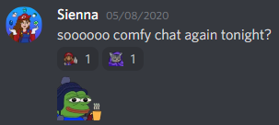

To Shagg: “At one point, glower disclosed to me that he had been talking to one of our mutual friends. I asked him if anything had happened, he said nothing like with him and me, but that they’d been talking a lot.“
To Twitter: “At one point, Glower disclosed to me that he had been talking to one of our mutual friends. He said that things weren’t sexual between them, but that they’d been talking a lot.”
“One of our mutual friends'”, is Cats4ever.

Sienna may have edited this part just for clarification. However, since before this point she painted most of the sexual interactions between the two of us as a strictly bad thing (which is not true), this could be a manipulation tactic to make it seem like I was doing the exact same things with Cats4ever (which is also not true).

Would I be embarrassed if what I said to Cats were to resurface? Absolutely, I said a lot of things that I regret and I’m sure that she did too.
Do I think what I said to her is considered harassment? No, she consented to everything and was never pressured.

To Shagg & Twitter: “He made a comment about wishing I was available.”
I think I said “I wish you were available” to stroke her ego so she could feel good about herself as her relationship was failing. I wanted her to feel desired and good about herself. I admit that I was way too reckless with what I texted to people 1.5-2 years ago and for that I’m sorry. I have since corrected my texting recklessness.

To Shagg: “I made a mistake in breaking down to him. I told him all the details of everything that had been going on with [boyfriend], all the ways it was hurting me, how I didn’t know what I should do, and how I wasn’t happy. He was very supportive through all of this. He told me he was sorry and he hoped I would be happy, that I deserved more. He also made a few comments that made me a bit uncomfortable, referring to some of the lewd pictures I had sent him in the past and how he couldn’t stop thinking about them. But I just blew them off and overall, it was a positive interaction.”
To Twitter: “I made a mistake in breaking down to him. I told him all the details of everything that had been going on with my boyfriend, all the ways it was hurting me, how I didn’t know what I should do, and how I wasn’t happy. He told me he was sorry, and he hoped I would be happy, that I deserved more. Then he made a few comments that made me uncomfortable, referring to some of the lewd pictures I had sent him in the past and how he couldn’t stop thinking about them. I just blew those comments off, and I thanked him for listening, apologized for venting to him”
Sienna intentionally removed the part where she said I was “very supportive through all of this” from the twitlonger to make me look bad. She describes this experience as “a positive interaction” to Shagg but omitted that information in the twitlonger. It’s possible that at the time she was receiving these compliments, she liked it and felt the same way when she remembered what I said when she wrote this to Shagg. When she wrote the twitlonger, she deleted her real feelings in the writing. You can see the mixed messaging in what she said to Shagg. “I just blew them off and overall, it was a positive interaction.” Without a doubt, she was giving me mixed messages when we would text on snapchat. I admit that saying these compliments near the end of her failing relationship was a mistake. I’m sorry and I have learned my lesson.

To Shagg: “He would insinuate that I should dump [her boyfriend]. He also sent me messages that alluded to him thinking about me sexually and wishing I could send him things. I probably told him to stop messages like that at least 5 or 6 times, which is something he downplayed in his account of things. It was often and it was frustrating, and it put me in such an awkward situation.”
To Twitter: “He would insinuate that I should dump my boyfriend. He constantly sent me messages that alluded to him thinking about me sexually and wishing I could send him more pictures. I probably told him to stop at least 5 or 6 times, which is something he downplayed in his account of things. His behavior put me in such an awkward situation.”
At this point, she told me how unhappy she was with her boyfriend. I knew their relationship was coming to a close based on what she told me, neither of them were happy. If the report of her saying that I should stop 5 or 6 times is true, I agree that it was very inappropriate to continue pushing and I apologize. I do not remember the exact wording of her requests in asking me to stop, if there were a few eye roll emojis, or the message was something along the lines of “stop lol” I may have misinterpreted the message as her laughing at the situation rather than being uncomfortable. In any case, I am sorry. I have learned my lesson from this situation.
This is the type of context I am talking about. She uses emojis a fair amount in texting.
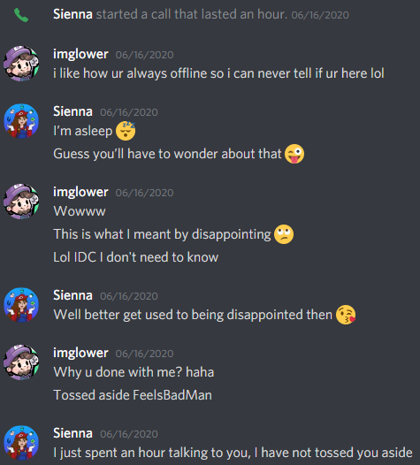
We bonded over being very sarcastic and very flirty. It is likely that I misinterpreted what she wanted. This screenshot happened after the claimed events.

To Shagg: “I wasn’t happy with [boyfriend], I already felt internal pressure to break things off, and then all the pressure was coming from glower.”
To Twitter: “His behavior put me in such an awkward situation. He was being so pushy, and I felt overwhelmed with everything that was going on.”
She tells Shagg that she had an internal conflict about her boyfriend, she told me this conflict about him to me, and I advised that she should break up with him mainly because of that. In this situation, I was only partially responsible for the pressure she was feeling.

For her to be having problems this early on in a relationship, is not a good sign, which is why later on I advised that she end it with him. It seemed to me that the problems in that relationship were because of him, not because of her. It is very painful and unhealthy to force a relationship to work, it can’t happen, I've tried it and experienced it for years before. These reasons, along with my desire to be with her, are the reasons I recommended her to break up with him.
I acknowledge that my desire for Sienna at this moment had a negative influence on what I was saying to her during this time period. I admit that these actions are wrong. I am more mature and self aware compared to 1.5-2 years ago and I have made corrections to my poor behavior.

To Shagg: “I realized that by keeping quiet like glower had wanted, I had failed to warn other people what he was like. That while he was a good person, he had hurt me. So, I disclosed to her.”
To Twitter: “I realized that by keeping quiet like Glower had wanted, I had failed to warn other people what he was like. So, I disclosed to her.”
She intentionally deleted the part where she says I’m a good person to twist the reader's perception of me, again.

To Shagg: “I told her everything about our relationship, aside from the secrets he had told me that I promised I wouldn’t ever disclose. I even told her our fling had escalated to a sexual thing, to which she was surprised because he hadn’t solicited her for things like that. We also discovered that the night he left her on read was the night that he was talking to me about her and about my relationship with [boyfriend]. And that now that he was ghosting her, he was trying to hit me back up. We were both pissed about that.”
To Twitter: “I told her everything about our relationship, even that our fling had escalated to a sexual thing. We discovered that the night he ghosted her was the night that he was talking to me about her and about my relationship. Now that he was ignoring her, he was trying to hit me back up. We were both pissed about that.”

To Shagg: “He hadn’t solicited her for things like that”
To Twitter: She later reports that I solicited sexual things from Cats4ever.
There was never a point where I was seriously trying to solicit anything sexual in nature from Cats4ever. At points, I would suggest things as a joke for laughs, and she thought it was funny, and then the topic would quickly turn into something else because nothing was ever serious. She and I would often joke about many topics, sex being just one of them. We would discuss things of the same nature in a snapchat group called “Kreygasm” with two other Twitch friends. That group had two males and two females and we have all said many embarrassing things there. The main purpose was for humor and laughs. Cats has told me on many occasions that she isn’t proud of the things she has said. Neither am I. I would rather we just shake hands and leave it in the past where it belongs because we’ve both learned what’s appropriate. We’re both better today than we were yesterday.
There is no evidence that I stopped talking to Cats to talk to Sienna, but if that claim is true, I agree that that would be in poor taste. There is a possibility that Sienna needed relationship advice as her relationship was ending and I was trying to prioritize that to help her. Above in her writing to Shagg, Sienna wrote “He was very supportive through all of this”.

After all these reported events, she posted selfies of herself in my #selfies channel in my discord server. These public images of Sienna that she herself sent in my public discord server are undeniable proof that she was not scared, threatened, or traumatized by me. She very much wanted to be involved in my life and friend group after everything that has been claimed so far.
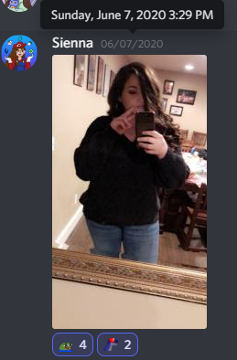
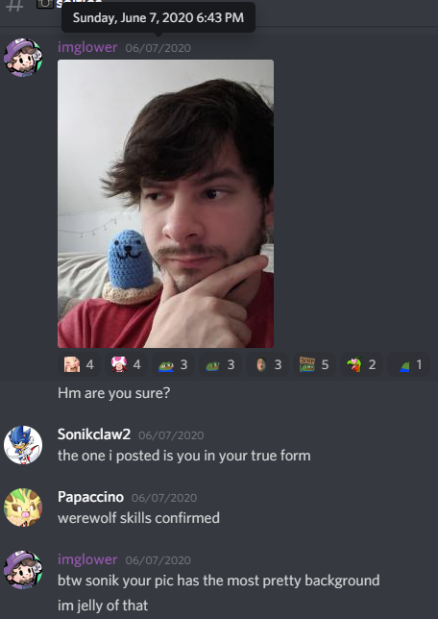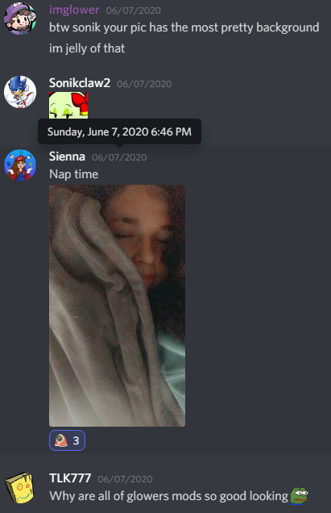
After I posted my one selfie, she posted one 3 minutes later.
Disclaimer: This day was the first time the selfie channel was opened and at least 11 others posted their first selfies, however Sienna was one of the few to post multiple selfies of herself, one of them being 3 minutes after I posted, and then the next day she posted a 3rd.

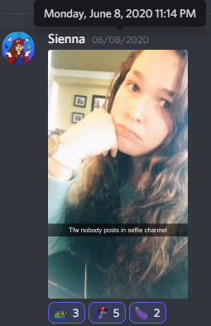
Sienna posts a picture of herself, with the text on the screen saying “That feel when nobody posts to the selfies channel” even though there were 11+ people posting selfies the day before. It may have been a post to get my attention, I can’t really know.
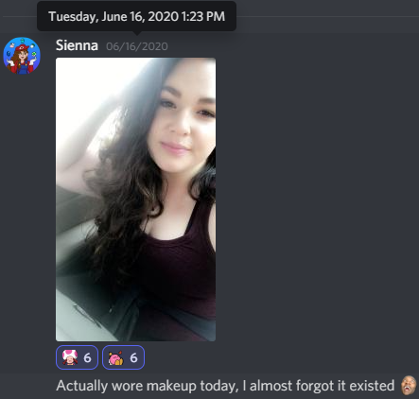
This does not prove my innocence, but it does show that Sienna was not at all afraid of, or made uncomfortable beyond repair by our interactions up to this point. In fact these selfies may have been attempts to gain my attention, even after the above claims.

To Shagg: “We conversed often about the messages that he sent to us. It was kind of how we supported each other through his poor behavior. I would vent to her when he’d try and flirt with me, she’d tell me jokes about the messages he sent her. Overall, we both decided- and I remember telling her on multiple occasions- that glower was a good guy but who was super emotionally immature. This is why, despite his shitty actions, we decided to keep supporting him and his stream.”
To Twitter: “Over the course of many months, we conversed often about the messages that he sent to us. It was how we supported each other through his poor behavior. I would vent to her when he’d try and flirt with me, she’d tell me jokes about the messages he sent her. Even though he told me their interactions weren’t sexual, she disclosed to me that he did send her sexual things and she ultimately told him she would never send him pictures. After that we discovered he was sending us the same sexual pictures/messages. Even with all of this, we both were under the deluded impression that Glower was a good guy who was just super emotionally immature and desperate. This is why, despite his shitty actions, we decided to keep supporting him and his stream.”
During this period of time, Sienna reported that she and her boyfriend were still together. The next paragraph after this one says that they break up. If the information that she reported to Twitter is correct, specifically “he was sending us the same sexual picture/messages” then Sienna is admitting that she cheated on him. This part of the story must be fabricated because it was not reported to Shagg, and would be an admission of cheating on her boyfriend. The timeline seems wrong regardless of the added information however.
I am going to deny the claim that I sent “sexual things” to Cats4ever. I am also going to deny that I was sending the same pictures/messages to both of them. None of this information was reported to Shagg. I may have jokingly flirted with both of them at the same time over snapchat but I can not confirm that, nor is there any evidence, I often use flirting as a humor technique and sometimes I even flirted with my male friends too because we all thought it was funny. Even when I stream, I sometimes flirt with viewers for the laugh of it. During this period in my life, I was definitely way too reckless with my flirting and what I sent over text, but since then, I have calmed my flirtatiousness and recklessness down. I learned my lesson on everything from this situation long ago and have corrected my behavior where necessary. There is no need to continue to attack me about it.
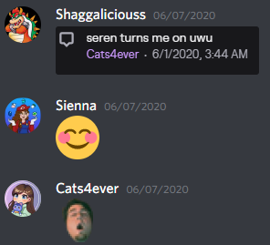
Whited out name is a man.
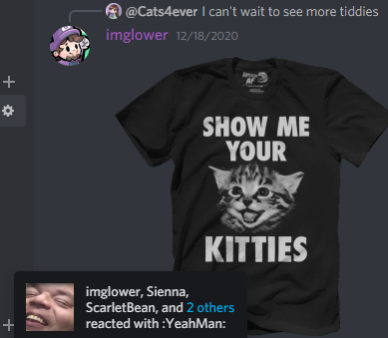
I believe that everyone as a whole was very reckless with what they said over text, me likely being the most reckless unfortunately. Lots of the time, it was purely for humor.

The next line “Not too long after this, my boyfriend and I broke up.”
So she admits to cheating? This part of the story seems inconsistent with what actually happened.

To Shagg: “Shortly after this, [boyfriend] and I broke up.”
To Twitter: “Not too long after this, my boyfriend and I broke up.”
The above statement in the twitlonger is false unless she admits to cheating on her boyfriend, or her timeline is wrong.

To Shagg: “That even though things were hard, that I didn’t do anything that would make him question my loyalty. I was not going to cheat on him.”
To Twitter: “After that we discovered he was sending us the same sexual pictures/messages.”
If the information reported to Shagg is correct, I never had sexual relations with Cats4ever.
If the information reported to Twitter is correct, Sienna admits to cheating on [boyfriend].
The story reported to Twitter must be incorrect.

To Shagg: “I knew he would ask for them. But I told him anyway. Because I felt so undesirable, so unwanted, so alone after the breakup. And I knew that he would want and desire me.”
To Twitter: “I knew Glower and his pattern of behavior, and I anticipated exactly what happened next- rather than being supportive, he immediately sent flirty/sexual messages soliciting nudes now that I was single.”
To Shagg: She blamed herself because she felt unwanted and as a result, initiated sexting with me.
To Twitter: She changed the story, blamed me for everything, and then said I solicited nudes from her. (FALSE, see below)

To Shagg: “I told him no at first, that it was too soon. But a few days later, I initiated sexting with him. For the same reasons as why I told him I had broken up with [boyfriend]. I was hurting, I felt unloved and I just wanted to be desired.”
To Twitter: “I told him no at first, that it was too soon. But a few days later, I gave in and gave him what he wanted. I knew it was stupid, but I was hurting, and it felt good to be desired.”
To Shagg: “I initiated sexting with him.”
To Twitter: “I gave in and gave him what he wanted.”
This may be the most deliberate manipulation in the entire twitlonger.
Sienna on multiple occasions throughout her entire twitlonger has manipulated her initial writing to Shagg, to make it look like I am a disgusting person who was pressuring her at all times to get what I wanted. That is far from the truth. She wanted to sext too and initiated it a lot of the time. She has manipulated the truth to make me look much worse in the twitlonger many, many times. These edits were intentionally made in January of 2022, what does that say about her credibility? What does that say about her goal of writing the twitlonger?

To Shagg: “Which is why the next day I apologized to him, I told him I wasn’t ready to get involved emotionally with anyone else. I told him exactly why I had initiated things, he said it was fine. He asked where we went from here, and we considered having a friends with benefits type of thing. But after a few days of that, I could just tell he wanted more. He kept asking me if he could come visit me when I moved to Virginia. That made me super uncomfortable and finally I told him that we just needed to stop completely. I didn’t want to hurt him emotionally, I didn’t want anything with him except for satisfying my physical desires, and even if he was okay with that, I wasn’t. I didn’t want to use him, I didn’t want him to be secretly hoping that we would be something more..”
To Twitter: “Which is why the next day I apologized to him, I told him I wasn’t ready to get involved emotionally with anyone else. He asked where we went from here, and we considered having a friends with benefits type of thing, but after a few days, I could just tell he wanted more. He kept asking me if he could come visit me when I moved. That made me super uncomfortable.”
She leaves the part where she “initiated things”, out of her twitlonger TWICE. It was intentional manipulation of her initial writing to Shagg to cover up her mixed messages and sexual interest in me. Without the writing that she sent to Shagg, I was ready to apologize for all of that. How much else of this never happened that I’ve been apologizing for?

The above statement “I could just tell he wanted more” proves that I did want a relationship with her after she and her boyfriend broke up. When I did want a relationship, she was not emotionally available for it, which disappointed me and kept our relationship as “friends with benefits”. She admits to Shagg that she “didn’t want anything with him except for satisfying my physical desires”, but cuts that out in her twitlonger because it made it look like she was using me for sexting.

I have never in my life pressured a girl into doing sexual things with me in person. I am not interested in anything physical with a woman unless she gives me full consent and really desires me. It is a turn on when she really wants me.

To Twitter & Shagg: “From then on, he continually tried to solicit things from me. I told him no. I stuck to my guns for a while. But he kept mentioning how he was disappointed, how it was lame I wouldn’t send anything, how he was masturbating to me and couldn’t stop thinking about me. I felt so pressured. One night when I was feeling really low, and when I was intoxicated, I sent him more photos. This pattern continued for a bit. I would say no, I would be firm about it, and he would just push and push and push. Then when I couldn’t take it anymore, I would concede. I always followed it up with, “We are done, this is the last time, I don’t want this.” However, because I had given in in the past, I think he thought that if he just kept pushing me, eventually I would give in.”
When I said that it was “lame” it was a joke to try and spark humor out of the situation. It was in no way an attempt to pressure her to send anything. I am sorry for trying to create humor in this situation, it was not appropriate if you were internally feeling that uncomfortable. If she was firm about saying no, but then got drunk and initiated things with me, that is not responsible, that is sending further invitations to me saying “come back for more”. When she toyed around with the yes and no, I was really confused about what she really wanted. I never knew she was intoxicated in any situation.
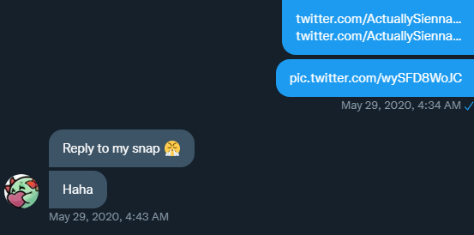
I sent her pictures of herself that I told her I found cute to on Twitter, and she said “Reply to my snap 😤 haha”. in response. She claims above that “I felt pressured”, when I sent these, but in this Twitter screenshot says “Reply to my snap 😤 haha”. She was not distressed about the information that I told her, she was excited about it. There is zero hint of discomfort in this message, nor was there on discord, nor was there any in this situation when we talked about this on snapchat.

This face with steam from nose emoji depicts an angry or highly annoyed face, eyes closed, brows scrunched up, and steam coming from the nostrils. It's used to express a variety of emotions, ranging from frustration to pumped-up passion about a particular topic.

I think the emoji in this context serves the purpose of saying "hurry up and reply to my snap". During this time, she was excited and initiated sexual activities too.

I genuinely don’t know if she ever displayed her discomfort or the fact that she didn’t want it anymore because when I asked, she seemed happy about it all. She would also randomly initiate our interactions too which confused me. The amount of mixed messages I received was puzzling to say the least. Later on when I brought this up over discord, it seemed like she had a problem with telling me no. She wanted me to just be myself and not change.
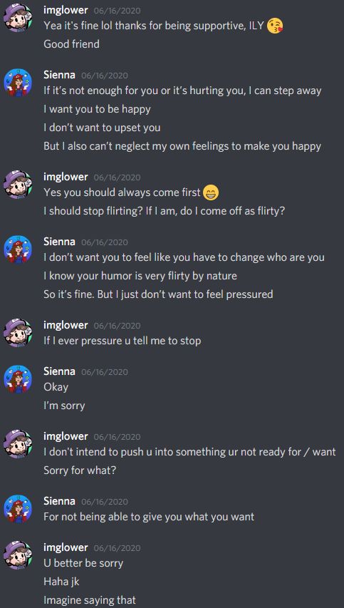
Correction: “Should I stop flirting? If I am flirty, do I come off as too flirty?
In this context, I believe I was also referring to the flirting as sexual events too. I think she got the hint.

In hindsight I can tell that this is a much more serious conversation that I realized at the time. I tried to spark humor out of it and doing that was a mistake. I was more oblivious in my past.
I don’t believe that she properly communicated what she did and did not want me to do based on this screenshot, it seems to me that she was more concerned about making me happy, than making herself feel comfortable. At the time this was all happening, I didn’t realize this. I’m sorry if at any point you felt pressured, Sienna. I never wanted that.
When I said "If I ever pressure you tell me to stop", she did not respond with "That's what I've been trying to tell you this whole time". She never properly communicated to me that she felt this way. If I knew, I would have stopped immediately because even back then I knew better.
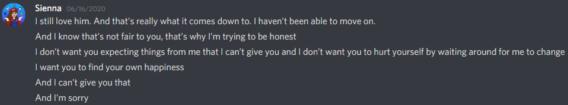
"I still love him", and "I haven't been able to move on" implies that she and her boyfriend broke up at this point (6/16/2020).
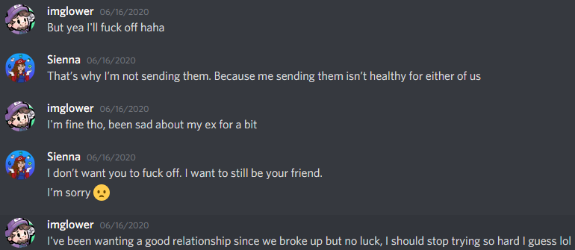
After everything she described above, she still wants to remain my friend. She indeed continued to remain my friend for 1.5 years after this.

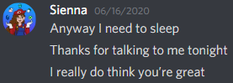
She described me as a "really good guy", after all the events above have happened. Everything in the twitlonger is embellished.

"I really do think you're great"
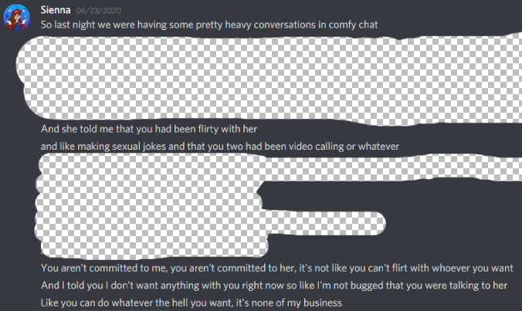
Irrelevant information is censored out. She is talking about Cats4ever.
Notice that what she says here is not consistent with the twitlonger. In the twitlonger, and to the letter to Shagg, she reports that her and her boyfriend broke up shortly after she got in contact with Cats4ever. According to my discord screenshots (aka the only evidence presented), that is false. Her timeline in both stories seems to be wrong. My screenshots with dates included are very out of order for this reason.
She “can’t get over him” on 6/16/2020, and gets into contact with Cats4ever on 6/23/2020.
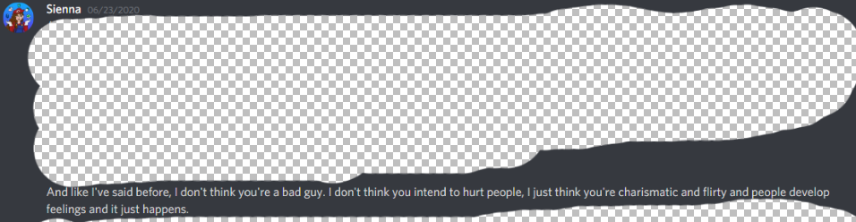
"I don't think you're a bad guy. I don't think you intend to hurt people. You’re charismatic"
She is correct. I never intended to hurt anyone, I just get too careless or emotional.
A week after she “can’t get over him”, Sienna talks with Cats4ever about my involvement with the both of them. The timeline that Sienna is presenting to both Shagg, and to Twitter does not add up so I will attempt to construct the real timeline of events.

Summarization of the timeline she tells to Shagg, and to Twitter:
To Shagg: “Glower disclosed to me that he had been talking to Cats4ever. I asked him if anything had happened (sexually), he said nothing like with him and me, but that they’d been talking a lot. I made the mistake in breaking down to him about [boyfriend]. I felt so guilty for ranting about my current partner to my “ex”. I told Cats4ever everything about our relationship. I even told her our fling had escalated to a sexual thing. We conversed often about the messages that he sent to us. Shortly after this, [boyfriend] and I broke up.”
To Twitter: “At one point, Glower disclosed to me that he had been talking to Cats4ever. Even though he told me their interactions weren’t sexual, she disclosed to me that he did send her sexual things and she ultimately told him she would never send him pictures. We discovered he was sending us the same sexual pictures/messages. Not too long after this, my boyfriend and I broke up.”

The timeline that I can piece together with the screenshots above: I ghost Cats4ever near the beginning of our relationship, she forgives me and we remain friends while also occasionally flirting, sometimes as a joke, sometimes more serious. Sienna and [boyfriend] break up. Sienna and I got sexual over snapchat shortly after, which she initiated and intentionally covered up in her twitlonger. I try to clear communication and set a boundary with Sienna by asking if I was being too “flirty” or “sexual” with her and she only apologizes. Sienna and Cats talk with each other about me. Cats4ever discloses to Sienna that things did not get sexual between me and her (she reports this information, the truth, to Shagg).

Seemingly, there is something off about the timeline that Sienna is presenting in both stories, unless she was still with her boyfriend when she and I were doing sexual things and I didn’t know about it. I don’t know if she actually cheated and was secretly doing sexual things with the both of us simultaneously. I’m not going to make false claims, I am just going to say I don’t know what happened. I understand that the breakup was probably hard for her and the overwhelming emotions may have made her forget exactly what happened. I’ve been there very recently.
A few days after this, we played among us together.
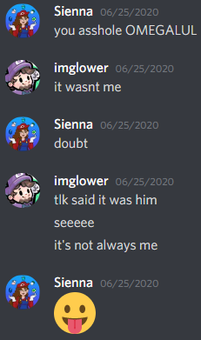
The next day, a streamer joking about receiving snapchat nudes makes her laugh enough to DM me about it, reminding her of our past. Our sexual history is anything but traumatizing, she liked it and remembered our experiences laughter when we talked about it.
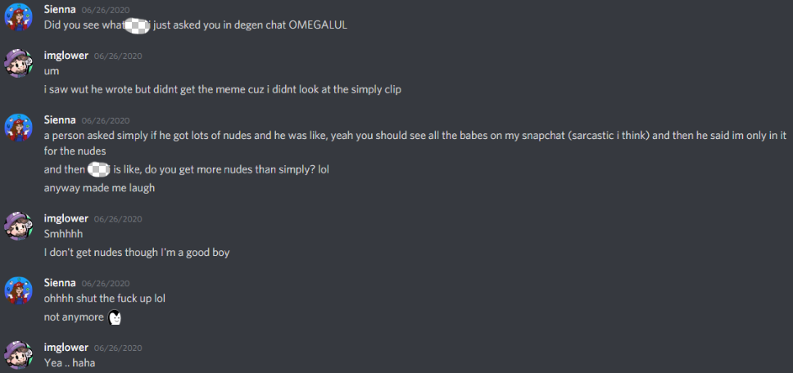

To Shagg: “Finally, after a while of this cycle of him pressuring me, I told him that I really didn’t want to and that I felt coerced into sending things. I made it clear I really, really didn’t want anything with him. He stopped and apologized. He said he was being a dick and he didn’t realize it.”
To Twitter: “After a while of this cycle of him pressuring me, I told him that I really didn’t want to engage with him and that I felt coerced into sending things. I refused to send him more pictures. He seemed surprised at my reaction and apologized. He said he was being a dick and he didn’t realize it.“
To Shagg: “He stopped and apologized.”
To Twitter: “He seemed surprised at my reaction and apologized.”
Manipulative words, and changing the story slightly to make me look as bad as she can.

[Explicit content warning]
To Shagg: “He would comment on everything I posted to me privately, making sexual comments. Even innocent things. I started feeling anxious posting anything ever, because I was worried he would think it was intended for him. I just felt like I was trapped, that I couldn’t get away from this.
I had a conversation around this same time with [boyfriend]. We had been hanging out just as friends, after I moved to [state]. I talked to him about what had been going on and how I didn’t know what to do. He asked me why the hell I put up with this- why I still subscribed, followed, supported him. Why I didn’t delete him off snap. I tried defending him, saying he had good intentions and how he didn’t realize what he was doing was wrong. I told him I felt like glower was making progress. And then he told me how fucking stupid I was for thinking that. He said that it was never going to stop. I remember telling him that I could handle it. That I thought he would learn and that honestly, I knew that if I blocked him he would just do it to someone else. I told him I would rather be the one that dealt with this because I felt like I could. He told me I was enabling an abuser. This was really disconcerting to me. What he was saying, how he explained it to me, really made sense. And I realized that glower was really toxic for me and that I couldn’t just keep doing what I had been.”
To Twitter: “He would continually harass me, sending me sexual DMs about everything I posted. I remember one day I put a video of me and my puppy on my snapchat story, and he DMed me about certain parts of my body that were in that video that he liked. I would post a selfie on twitter and immediately my phone would start buzzing, always his name. No matter how many times I told him to stop, he would laugh it off like it was a funny joke, say sorry, and then repeat the behavior. I started feeling anxious posting anything on any of my social media platforms, because he followed them all, and I was worried what he would send me after he saw them. He admitted to masturbating to more than one of the pictures that I posted. I felt like I was trapped, that I couldn’t get away from him. But I didn’t feel like I could block him. His community was where most of my friends were. I remember telling one of my friends that I felt like if I blocked him, he would just do it to someone else, and that I would rather be the person who had to handle it. Ultimately, I didn’t know what to do.”

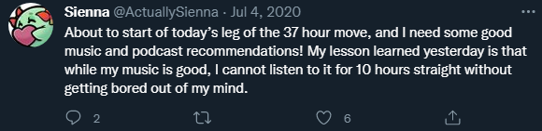
She moved to [state] in early July.
There are massive differences between these two stories so I will respond to both.
To Shagg: I did feel like some of the pictures she sent were intended for me. It felt like she was purposely posting bait for me to bite on so that I could give her compliments. If she “felt trapped” she never told me those exact words or anything like it to express her extreme discomfort. She had the power to block me but didn’t. When Sienna told [boyfriend] that “he had good intentions”, she said the same thing to me when I did give compliments. After this point, I definitely did make progress because this was the last time she felt uncomfortable by my actions.

To Twitter: I always had good and honest intentions with my compliments. I was in no way trying to make her feel uncomfortable and I certainly didn’t think laughing at the situation was funny. As you have seen above, I have inserted humor into other situations where it was not appropriate because I was more oblivious in 2020. The mixed messages that I was receiving after spreading validation definitely influenced my continuous approach. Some of the time she would thank me for the compliments and other times she would ignore them, or shush me. One day she would want it, another day she wouldn’t. Sienna admitted to giving mixed messages in her writing to Shagg shortly after these events, see page 21. These comments above are disgusting and that is not what I would say to anyone under any circumstance today.

[You can continue reading now if you skipped]

To Twitter: “In this piece, I wrote about him. After writing it, I felt extremely conflicted about posting the information about him, and ultimately decided to edit it out. I was scared of how people would react, and I was scared his community would come after me. However, I sent him the unedited version with the section about his behavior in it. After this he absolutely panicked. Since he was blocked on my social media, he couldn’t see that I posted an edited version, even though I had literally told him I didn’t release the section about him to the public. He began to freak out and then posted “his side” of what happened in a document that he sent to specific mutual friends of ours. Ultimately, since I remained silent and he shared his side only, he suffered almost no consequences. Our friends brushed it aside, said it was fucked up but continued hanging out with him.”
After I read about what all of those men did to her, I panicked. I thought I was the same as them. She made me believe that what I did was as bad, or worse. In hindsight, it doesn’t even come close. What I did was virtual and what those men did was physical.

I misread what she sent me, and after I tried to contact her over the span of multiple days after I was blocked everywhere. When I was blocked, my attachment anxiety skyrocketed.
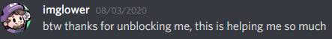
In my panicked state, I wrote a document to my closest friends because I thought that what she posted was public on Twitter and they all read it and hated me, so I tried to explain that the situation was not entirely my fault because I wanted to keep them as friends. If I cared about my cancellation, wouldn’t I have posted something on Twitter to defend myself instead of to my closest friends?
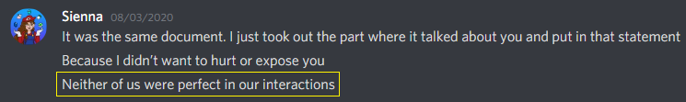
In my panicked state I wrote information that contradicted what I said 11 months ago. The reason I reached out to Sienna initially was to tell her to stop flirting in my chat because my girlfriend was getting upset. In the document, I incorrectly write that it was because her flirting felt serious. Over 11 months of knowing her, I became more attracted to Sienna which made me forget the purposes of our first interaction. I forgot our first DM and reported incorrect information in the document I sent to friends.

The sentence structure in the document is awful and I have to correct it:
Document: “I didn’t know Sienna was that big of a victim of sexual assault, I made very bad assumptions again”
It looks like a 1st grader wrote this and I will now correct it.
Correction: “I was not aware of Sienna’s previous experiences with men that forced her to do sexual activities she didn’t desire. I did not know that Sienna was a legitimate multi victim of sexual assault and as a result, has remaining trauma.

To Twitter: “With that being said, I warned him that if he ever harassed another person the way he harassed me and my friend, I would not hesitate to release details of his interactions with me publicly.”
I did not “harass” Cats4ever, she always welcomed everything that we did.
Sienna held this threat of exposure about our situation for 1.5 years. She held this over my head and was going to continue holding this over my head, for all time. This is emotional blackmail.
To Twitter:“I thought he had changed, but he proved me wrong just a couple of months ago. In the summer, he got involved with a girl he’d met through twitch/discord. After they broke up, he began messaging me about how heartbroken he was and how he couldn’t believe it was over. I tried to console him. From what he told me, nothing sketchy had gone down, they just had mutually decided to end things. I spent a lot of time giving him advice, talking him through it, playing games with him to help distract him.”
If we compare what I did with Sienna to what I did with Jen, what I did with Sienna was far worse in my point of view. Sienna and I never entered an official relationship, but me and Jen did. Jen and I met in person and hung out for 3 weeks, and I never met Sienna. I had much more reason to trust Jen, too much trust. I did not tell you everything that happened between Jen and I because there was way too much information to report. Also, I was trying to respect what Jen wanted as much as I could. Jen kept telling me to keep quiet about everything so I tried to do that as much as I could, until I couldn’t any longer.

To Twitter: “While I was helping him through this, he would make comments to me that made me a little uncomfy, saying things like, “Man, I really fucked it up with you,” or “You’re really the full package, aren’t you?”. One moment he’d be claiming to be heartbroken, the next he was telling me he liked my twitter profile picture, which made me nervous because of our history. I didn’t want to know what he thought of my pictures. Additionally, he began asking me about my love life. He asked me about some of my close friends, asking whether or not I was involved with them romantically. He asked me about previous relationships I’d had and was basically asked if I was having sex with anyone. Once again, I don’t have any screenshots of this in particular because it was on snapchat. I felt conflicted because I wanted to help him, but I was bothered by his behavior. Ultimately, I just made excuses for his creepy behavior, and I told him there was no chance of me getting involved romantically with him ever again. After that our interactions were centered on getting him through his breakup.”
I apologize for giving you unwanted compliments, the only purpose of saying those things was to validate you and make you feel better about yourself. I specifically remember that you told me you were trying a look without makeup and that you were unsure of yourself about it, so I tried to boost your confidence. I was also low key seeking validation for myself from anyone that I could at this time. I got badly damaged from the breakup with Jen. I was not seriously trying to pursue anything with anyone after Jen broke up with me, I was just trying to make others feel happy and wanted because I wasn’t either of those things. I was emotionally destroyed over the breakup I had with Jen for 3.5 months for reasons I reveal below. Sienna was previously one of my closest friends and I thought we had some catching up to do after I was neglecting many of my friends to keep the relationship with Jen alive for months. The reason I asked about her life was because we hadn’t talked in a really long time and I wanted to catch up with her because I considered her to be a really good friend, and trusted her because of our past of opening up to each other. I also needed to socialize about literally anything to get my mind off of the event about Jen. I do not recall specifically asking “have you had sex with anyone”, I think that is a false claim, or misinterpretation. I was basically asking how her love life was as a friend asking a friend and that was it. Sorry if it came off creepy.

To Twitter: “He didn’t have the decency to tell me personally, likely because he knew exactly how I would respond. He must have known that I knew, because he didn’t message me for a while after that.”
Jen didn’t want me to say anything to anyone, so I tried to respect her wishes as much as I could while also seeking therapy. Jen got mad at me when I announced that we had broken up in Cats discord on 11/06/2021. I don’t see why making that announcement would cause any problems, unless she was trying to cover up her tracks, which I now believe is why she got mad.

To Twitter: “The reality is that Glower has had a thousand chances to change and act differently, but he has shown me time and time again that he will continue to harass and prey on his female viewers.”
I have never targeted or “preyed” on a female viewer. Much of my wrong behavior has been corrected and has never been repeated. After months of review and writing 200+ pages for myself, I’ve identified my weaknesses and educated myself on what to do during a breakup. Part of the reason it took me so long to respond to the allegations was to seriously evaluate myself.

To Twitter: “I have enough to bury him. But revenge is not my purpose in sharing these things.”
The statement “I have enough to bury him” is malicious. I have evidence to defend myself in every position. Anything I wrote to you or Cats is behavior that has since been corrected. Anything that I said in any of my panicked states, or directly after Jen broke up with me to be with somebody else, is information that I reported when I was gaslit, having emotional breakdowns, or in crisis. All of those screenshots lack important context, I will properly defend myself now that I’m not crying every day over Jen. I have wrongfully confessed to serious crimes that I didn’t commit, immediately after my emotions were triggered after I was left behind and betrayed by her.

To Twitter: “What I know I probably won’t get is some accountability on his part.“
I have taken accountability in the places where I believe I have done wrong and will continue to do so down below. While I don’t believe I harassed anyone, I do think I made some feel uncomfortable and for that I’m sorry. I hope I don’t miss anything. I have learned my lesson from every situation that I have been involved with and do not deserve further punishment.

More proof for sourcing purposes:
To Shagg: “He said they’d been having troubles for a while and it was time for it to end. What I didn’t know at the time was that she was a girl he’d met through speedrunning. I still don’t know all the details about that, but she’s friends with a lot of people in the Pape community and had been to a GDQ, where they had spent time together in person. So at the time, I didn’t know that I wasn’t the first girl he had talked to from twitch.”
Sienna admits that she doesn’t know all the details of my relationship with Lexy. Since this time, the two of us have never talked about it. She got all of her information from other people who don’t know what our relationship was like, then Sienna falsely reported that I had “harassed” this person and irresponsibly included her in a place she didn’t belong without her consent.

To Shagg: “Because my history with glower is complicated, as you just read. It can’t be condensed. It’s a year full of two shitty people doing shitty things. And while he did harass me and I’m not blaming myself for that, I do blame myself for not standing my ground. I blame myself for enabling him. And I blame myself for using him when I was at my lowest point.”
Sienna admits her faults to Shagg. She says “I blame myself for not standing my ground, for enabling him and using him”. We were both at low points in our lives, both made mistakes in this entire situation, and we both “used” each other. The statement “he did harass me” is her opinion.

To Shagg: “And as angry as I was at him, as hurt as I was by him, I didn’t want him to suffer. So, I decided to talk to him. And we cleared things up. He didn’t fully understand that I edited the twitlonger, which is why he shared his side of the story with everyone else. He felt he needed to defend himself because he thought I had smeared him. I could have been clearer in my communication; he could have actually read what I said. He couldn’t clarify or ask for my permission because he was blocked, so he posted it. It was a misunderstanding. Not a malicious attack. So, I forgave him for that, even though I wish he hadn’t done it. It still hurt me; I’m still mortified.”
Me creating the document was because of a miscommunication and because I could not clear communication. When I can’t communicate, I panic.

To Twitter: “Anything I say about my interactions with the other women who he harassed has been posted with their permission and after they’ve read it.”
She never got permission from Lexy. No one ever reached out to her besides me.

The number of times that Sienna intentionally changed her initial writing to Shagg to make herself look better, or make me look worse is 11 times.

This optional 16 page document I will show off the friendship that Sienna (and Cats) and I had after our fling relationships had totally concluded. This does not prove my innocence, but it will support the case that while some of my actions were wrong, there was recovery and friendship leftover, supporting the case that what I did was not irredeemable and therefore I do not deserve to be “canceled” forever, or further attacked. I recommend reading this. https://docs.google.com/document/d/1bOhd0RWGVlLpqvBIoofOlMkIyW-O9FP0U-TRD6boetY/edit?usp=sharing

Sienna’s display of forgiveness:
The reason I asked the question if I am an abuser to Sienna is because one of our mutual friends did something bad, and directly compared what I did to what they did. After that, I sought reassurance from Sienna (& Cats, see page 9 of this document) to confirm that what I did wasn’t that bad because I doubted myself, and felt terrible.
Me: “Would you call me an abuser?”
Sienna: “I have forgiven you.”
Sienna: “While I would say you’ve done bad things in the past, I don’t think that’s who you are today and I wouldn’t use that term to define you.”
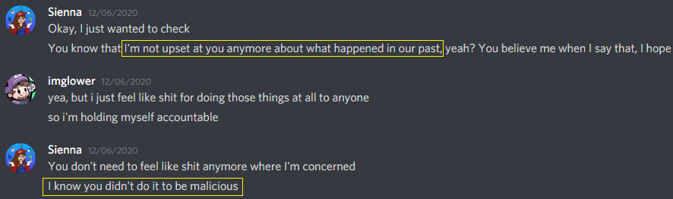
Sienna: “I’m not that upset at you about what happened in our past”
Sienna: “I know you didn’t do it to be malicious.”

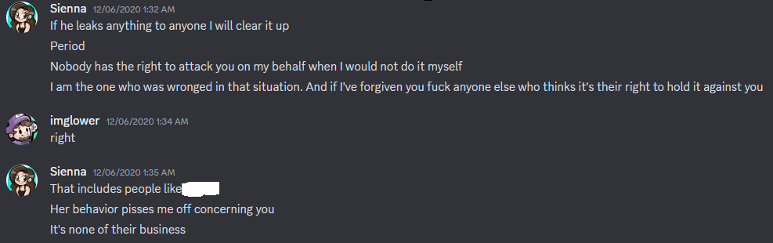
Sienna: “I’ve forgiven you”. “It’s none of their business”.
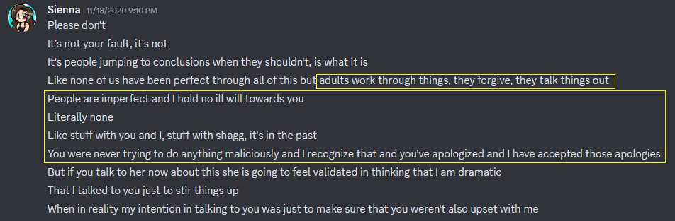
Just read what’s in yellow because it’s monumentally important.
The “It’s not your fault” is referring to the drama between Sienna and Cats. Not the situation between me and her.

I confess that I’ve made mistakes in my interactions with Sienna, but not nearly to the extent that she has alleged in her twitlonger. I’ve learned from the mistakes I've made, the experiences I've been through, and I have greatly improved myself.

This part is optional but has a very important quote below so I do recommend reading it:
From October 2020 to January 2021, Cats4ever and Sienna really disliked each other. Cats4ever believed that Sienna was the source of drama because of what happened between me and her, the random displays of rude behavior Sienna exhibited towards her, and because Sienna gave hopes of a relationship with Shaggaliciouss, and she let him down for petty reasons. After these events, and a few slightly aggressive conversations between the two of them, Cats4ever kicked Sienna from her discord, and blocked her on social media. Sienna directly compared how wronged she felt by Cats, to how wronged she felt by me. Sienna said that Cats4ever treated her worse than I did.

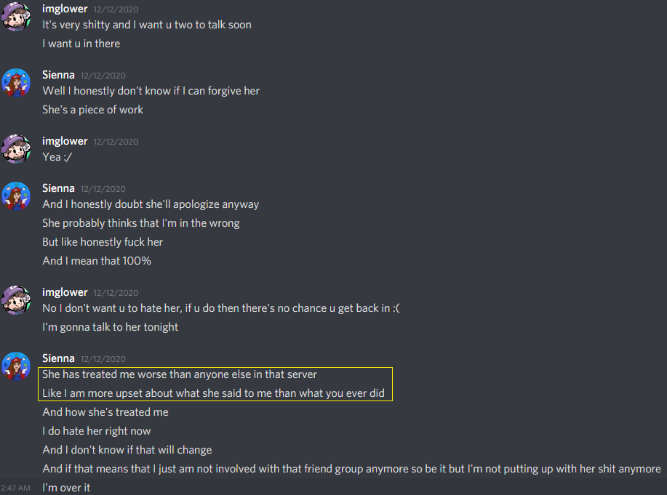
Sienna: “She has treated me worse than anyone else in that server.”
That includes me. I was in that server.
Sienna is reporting that Cats4ever, has treated her worse, than I did.

Sienna: “I am more upset about what she said to me than what you ever did”.
Sienna says in this quote that she is more upset at what Cats did to her than anything I ever did.
So if petty drama between two women is more upsetting than the claimed “harassment”, then what I did can’t be nearly as bad as anybody is claiming. Everything Sienna is saying today is being oversold to you.

These quotes do a great job at defending me, so I will now show the drama that unfolded between Cats4ever and Sienna. You can skip the next few pages, but if you want Sienna's perception of what I did, compared to Sienna’s perception of what Cats did, you can see it for yourself. The below events made Sienna more upset with Cats than with me.
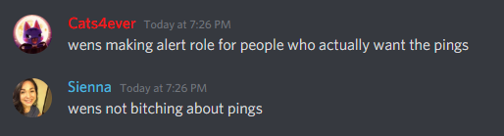
10/02/2020 ^
Sienna was rude to Cats for seemingly no reason, or reasons I can not remember or know and did this on many occasions, many I do not have proof of. It gave the impression to Cats that Sienna was just a source of drama because of what had happened between me and her, this random rude behavior towards her, and how she was playing with Shagg’s feelings.
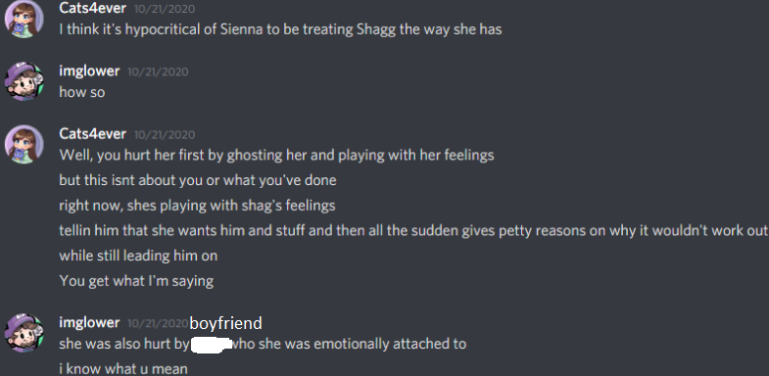
Sienna knew about the effects that ghosting and leading someone on could do to someone, then she proceeded to do it to Shaggaliciouss. This made Cats4ever dislike Sienna.
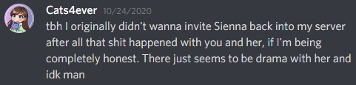
Cats says Sienna is the source of drama.

[The next 5 gigantic screenshots are entirely optional, I do not recommend you read them because it involves resolved drama. The TL;DR (Too long; don’t read) is that they try to talk things out to become friendly, but then Cats kicked Sienna from her server, and blocked her after Sienna said she can’t trust her, said Cats apology was disingenuous, and she isn’t a real friend.] This behavior made Sienna hate Cats more than me for what I did to her (everything above that is claimed as harassment).

Important: In the 2nd gigantic screenshot Sienna says “Glower and I resolved things”.
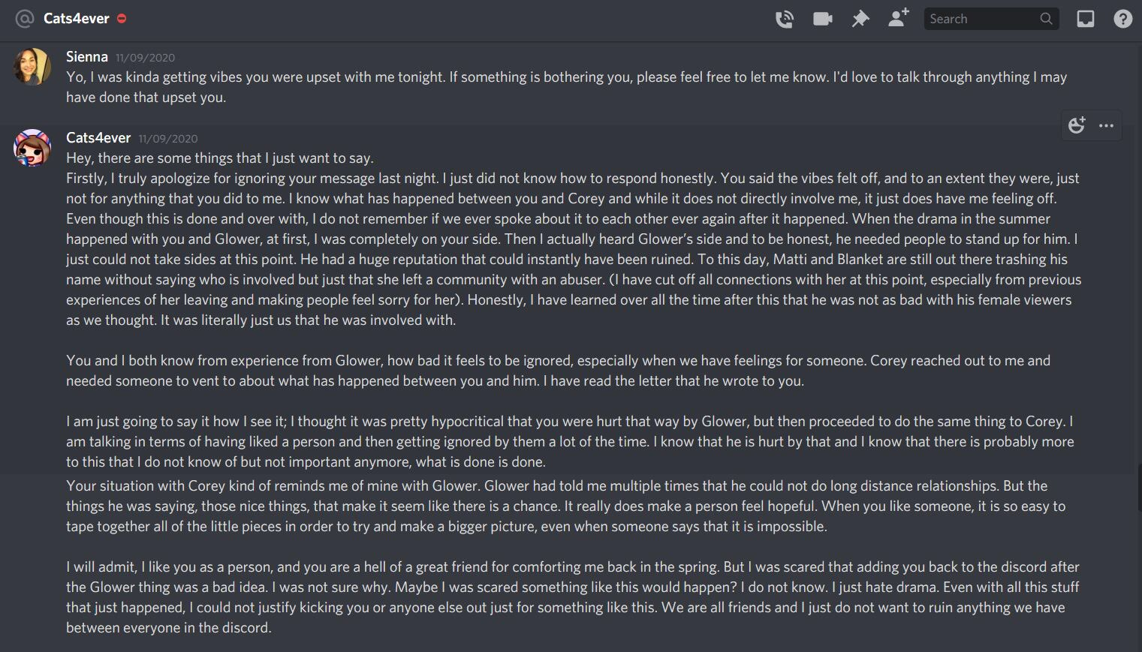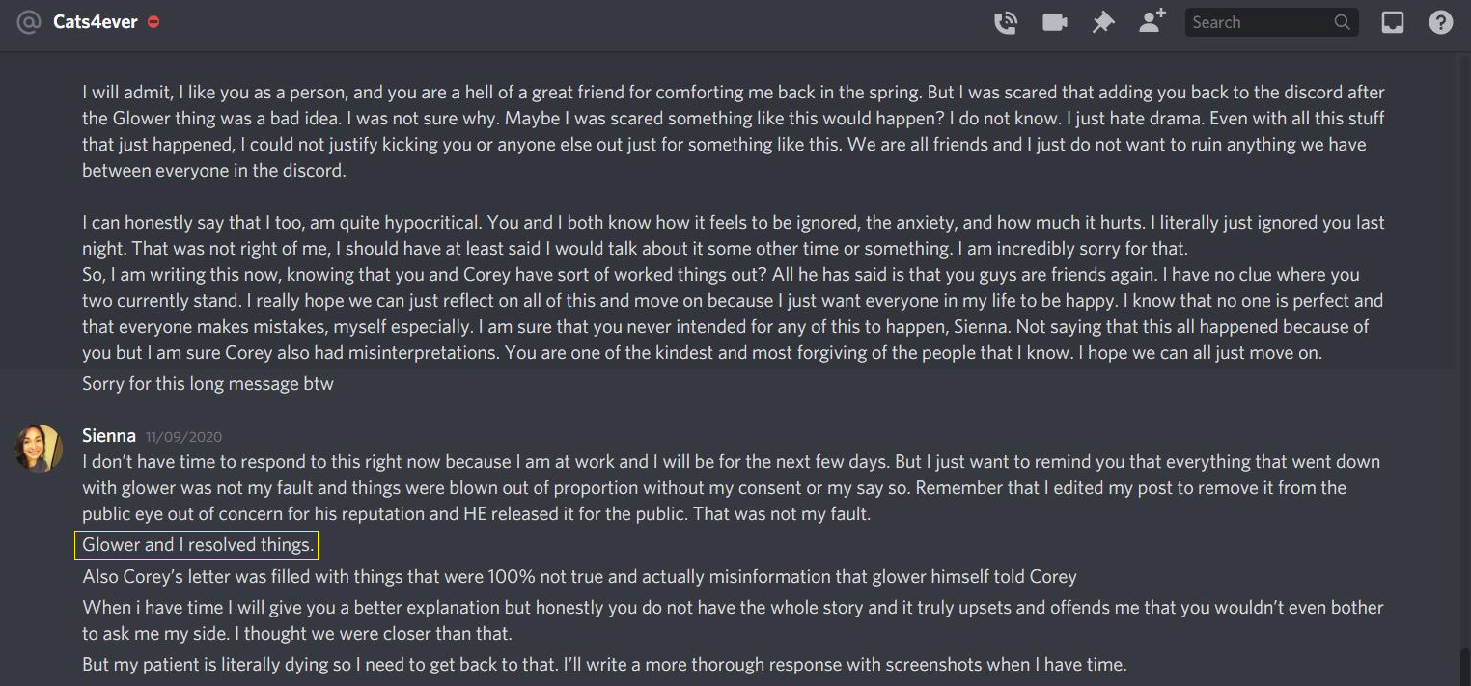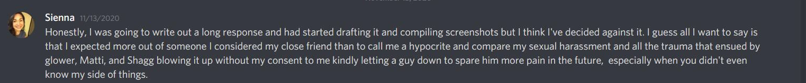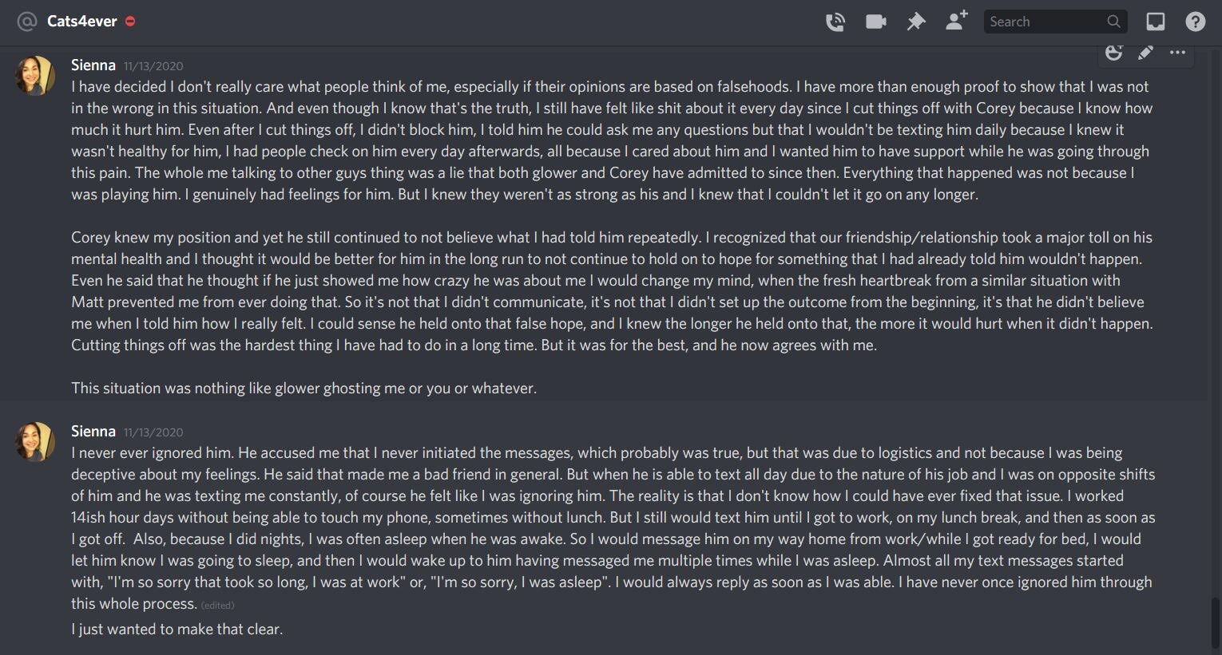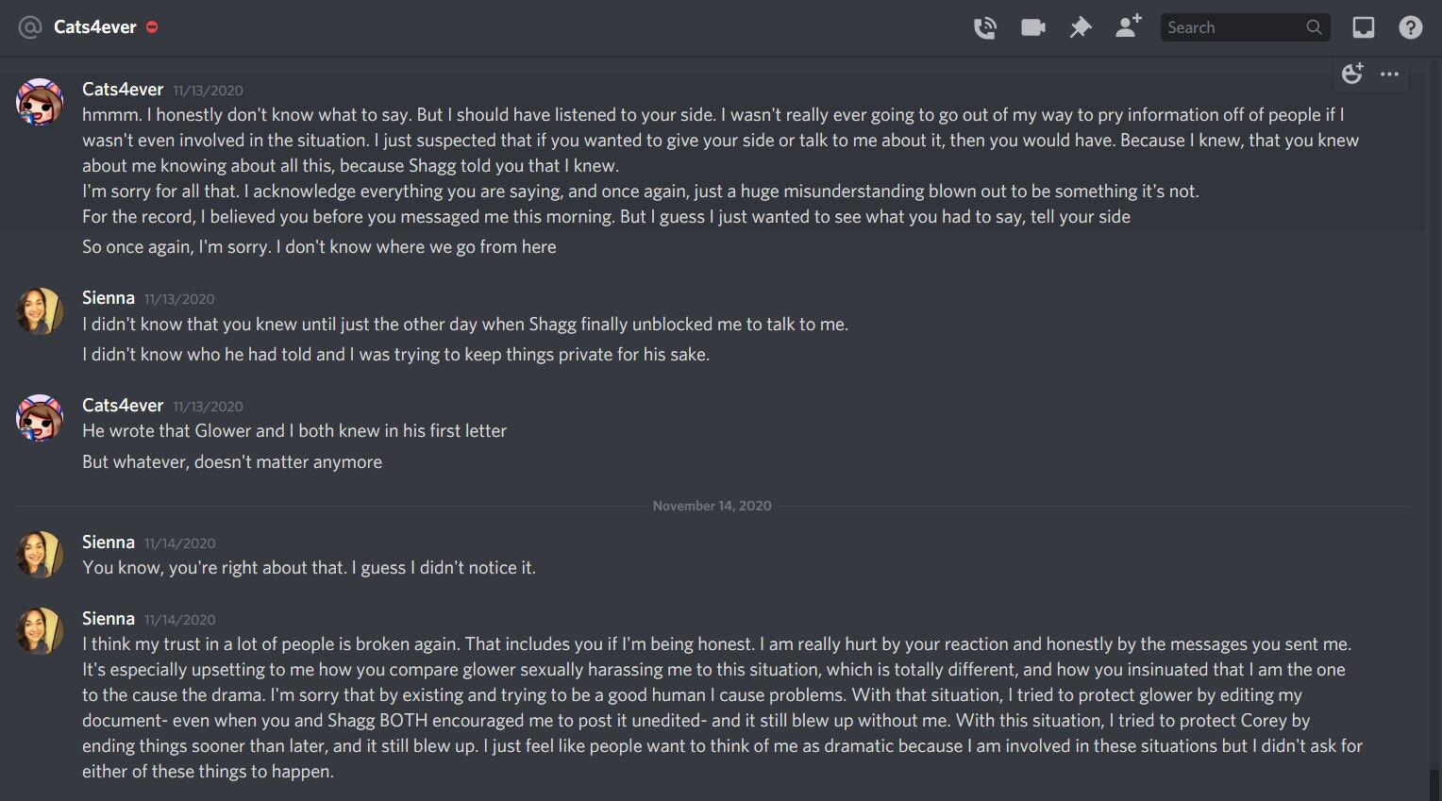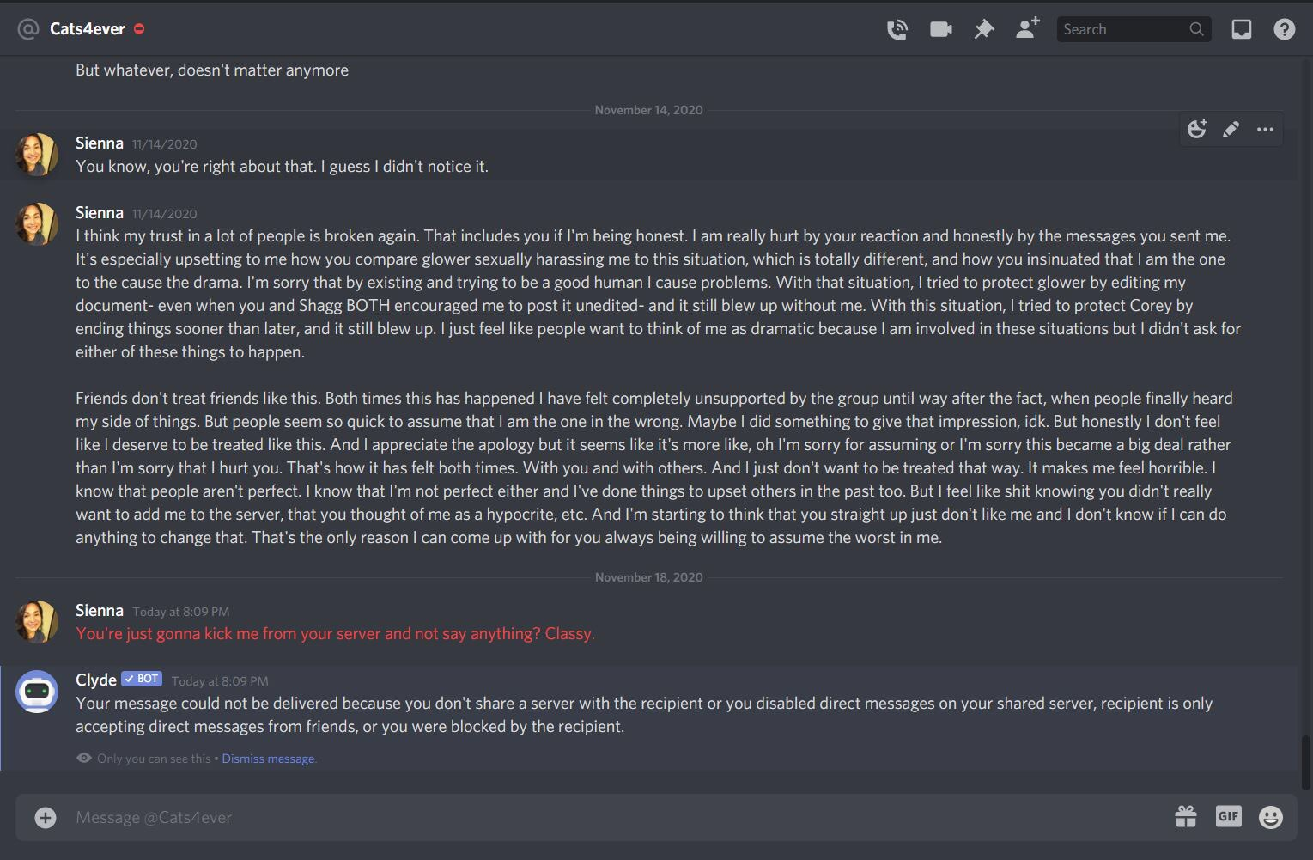
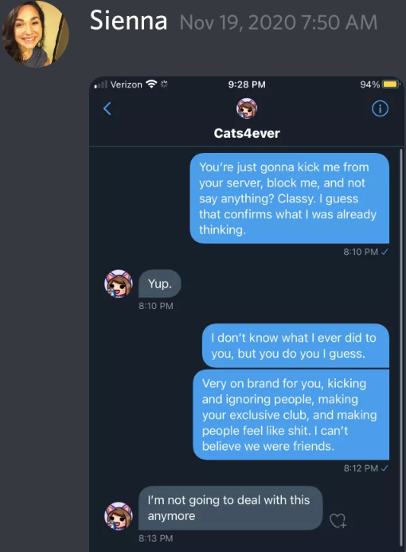
This is a conversation between Sienna and Cats4ever. Sienna’s messages are on the right, Cats on the left. Blocking, kicking, ignoring, and making an exclusive club without including Sienna is “more upsetting” than anything I ever did to Sienna, by her own words.

[Optional read. Sienna sent this to Shaggaliciouss.]
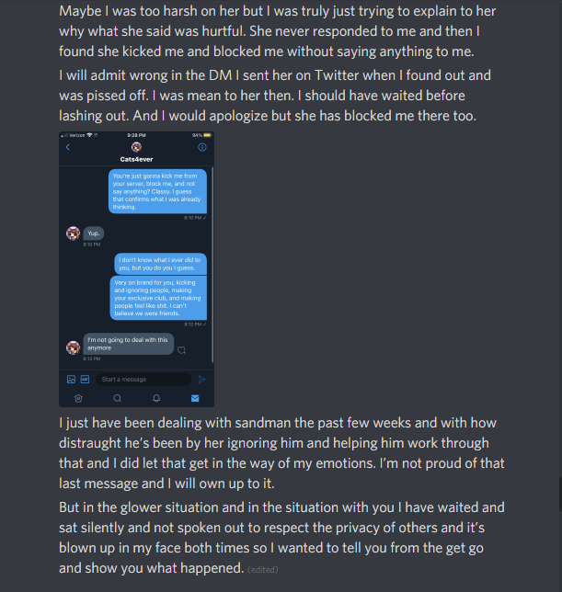
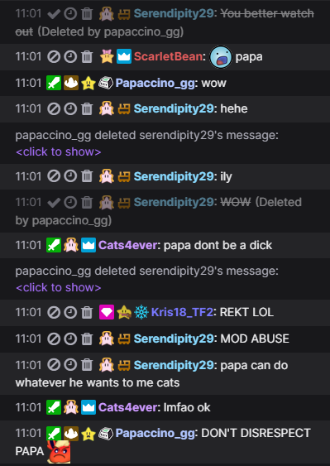
12/12/2020 ^
Papaccino_gg deletes Sienna’s message.
Cats: “Papa don’t be a dick”
Sienna; “MOD ABUSE”
Sienna: “Papa can do whatever he wants to me Cats”
Cats: “lmfao ok”
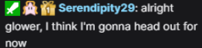
12/12/2020 ^ Sienna feels left out because she isn’t in Cats discord.

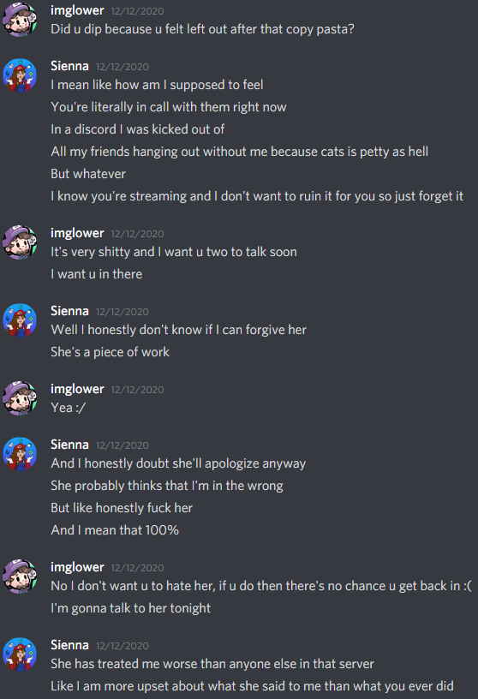
I contacted Sienna because I could tell she was upset, then she told me that what Cats did in all these situations is worse than what I did.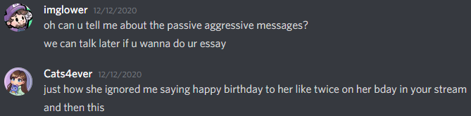
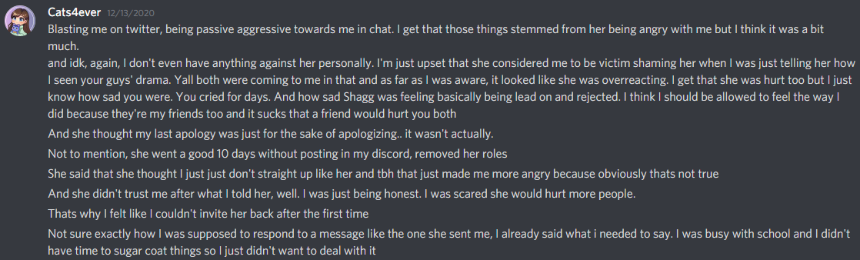
Cats4ever sends me a list of reasons she doesn’t like Sienna. ^
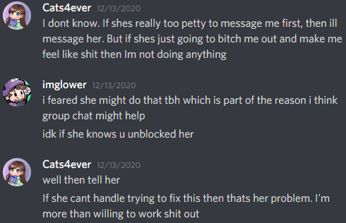
At this time, I will once again deny that what I did to Sienna is “harassment”. I believe there were many miscommunications because of mixed messages and unclear boundaries, but my intention was never to bring any harm or to bother her to the extent that she claims. If Sienna says that the drama that happened between her and Cats4ever is worse than what I did, and now they’re good friends, teaming up to attack me on Twitter, then it’s not impossible for me to be redeemed too.

The number of “harassed women” goes from two, to one.

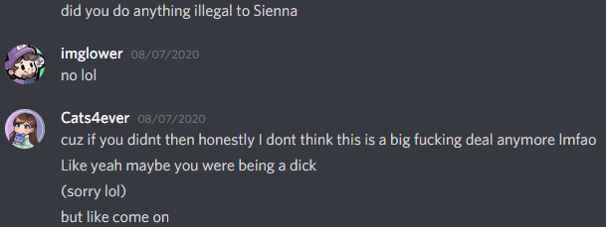
Cats is right.

Now let’s talk about Jen.

Jen:
The first thing I need to address about Jen is the screenshot that has been passed around where I admit to sexually harassing her. I retract that statement. I did not sexually harass Jen.

When I wrote that, I was having emotional breakdowns about the breakup. After Jen gave me much of her time, validation, love and promised me a future, she unexpectedly broke up with me and it destroyed my mental state. I was emotionally unwell for 3.5 months after she broke up with me. I was crying more than I ever have after the breakup. I believed anything Jen told me because I was deeply in love with her and trusted her with everything. Jen gaslit me into believing that I sexually harassed her, and that everything that went wrong in the relationship was my fault. I punished myself immediately and held myself accountable for everything because I believed what she said in both instances, but upon much reflection, writing many google docs for myself in the past few months, with help from many friends, I can conclude both of those are false. I do believe that my actions that day were wrong and that they did make her uncomfortable and disappointed, but to go as far as to say that I harassed her is going too far.

There is much needed context and emotional appeal that I need to cover before I speak further. I will briefly outline our entire relationship and all the events that were taking place before, during and after the break up now.

I’ve had to rewrite this part at least 4 times because it was too long, too emotional and too personal. This is part of the reason it took so long to respond to the allegations.

It’s not possible to leave emotions completely out of this because it involves a breakup with a person that I loved and thought I had a future with. I will do my best to get right to the point.

I will summarize our entire relationship below now:
Jen and I were in a long distance relationship. I am on the east coast, she is on the west coast of the U.S. From 3/21/2021 to 8/04/2021 the relationship was amazing and we didn’t have any major fights. Once in June and once in August, she visited my house and we hung together in real life and had a very adult relationship for the 3 weeks she was here. We did everything together when she was here and it was one of the happiest times of my life.

Between the dates of 8/22/2021 and 10/24/2021 we had a lot more fights mostly because long distance communication was difficult.
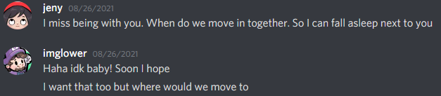
Jen and I fantasized and discussed moving in together many times, we even looked at housing at one point after she visited once. I would have committed to doing it.
10/10/2021 - > She said I can visit after she was done with school and then 3 weeks later she dumped me.
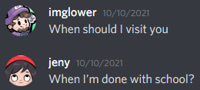
10/23/2021 -> She was very affectionate and loving over text as she always had been.
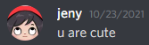
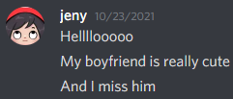
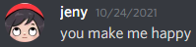
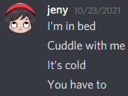

10/24/2021 -> We fought about a scarf she wanted me to buy for her. It was a pretty big fight but it wasn’t something that wasn’t fixable if we both put in the effort to move past. We both have blame in the situation, I have ample evidence to prove that this fight was not entirely my fault but there is no reason to elaborate. Another big problem she had with me was that when we would call, I would be silent for long periods of time. She complained about that a lot during the relationship, but also said things like this to me. She gave many mixed messages about what she wanted in many situations and I couldn’t tell what she really wanted often.
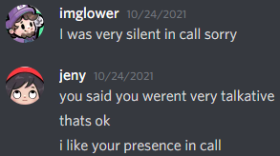

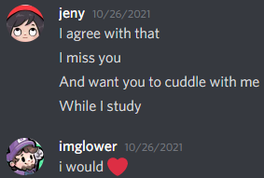
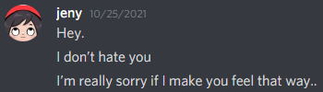
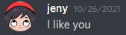
From 10/25/2021 to 10/27/2021 -> She told me she didn’t hate me for the scarf fight, then things went back to normal, she was supportive of me when I was down, affectionate and loving as she always had been. There was no point during our relationship where Jen sat me down and told me we should discuss our problems/fights. Not even after the scarf fight which was by far the biggest fight we’ve ever had. She later used the scarf fight as a big reason to break up with me and blamed me for everything even though she had a part to play.
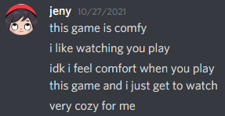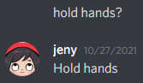

10/28/2021 -> We get in a call and I helped her practice Super Mario 64 for 4 hours for her 16 star race in 3 days. Things felt normal.
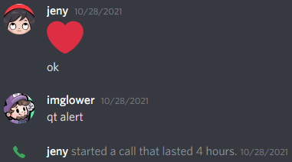
10/29/2021 -> I helped her fix her N64 controller for 1.5 hours on a video call. Things felt normal.
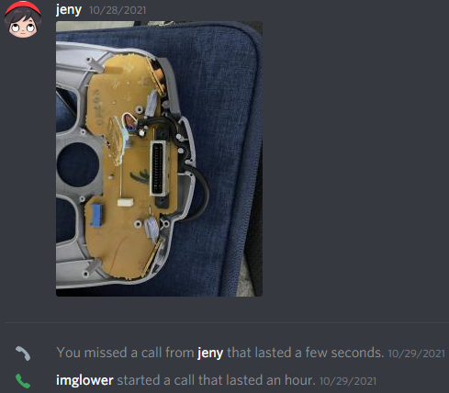
From 10/30/2021 to 10/31/2021 -> We have no activity on discord, instead we used snapchat. In our snapchat history, I have 8 selfies saved from her. In the selfies she is not home, she’s on the streets and at some hotel. I don’t know anything about who she was with, where she was, or what she was doing, the only thing I know is that she was not home. In the selfies she dressed in many different outfits. I have proof of these events with screenshots, but I don’t think it’s appropriate or necessary to share the photos.
10/30/2021 -> She makes a Spotify playlist with Alex. Alex is the man she began to date immediately after she broke up with me. This playlist is exclusive to the two of them.
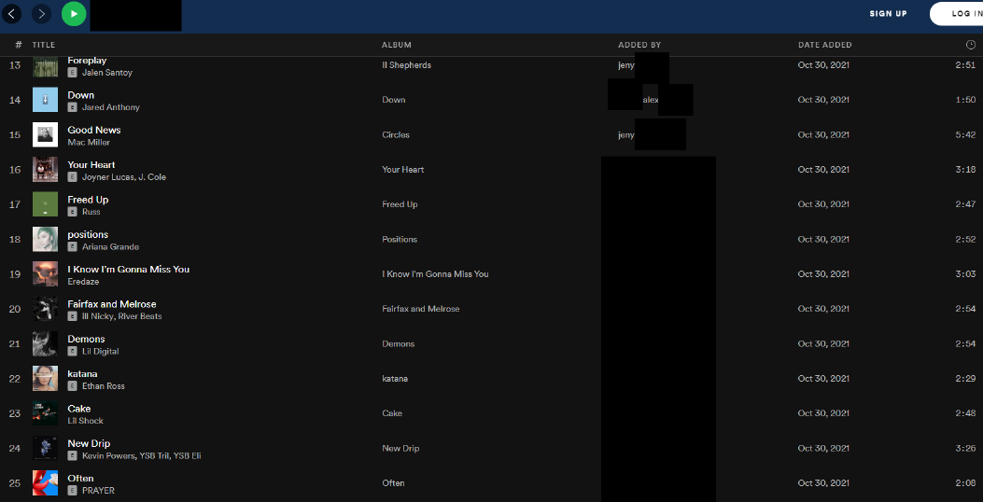
The first 118 songs were added while Jen and I were still in a relationship, and on the same day she broke up with me, 17 more songs were added. As I was fighting to resolve the problems in our relationship, more songs were added daily.

I don’t know how close she was with Alex at this point, but ultimately, she was still in a relationship with me when they made this and established a close connection. They did this behind my back and very soon after they made this, she broke up with me, and they started to date. I don’t know if Alex was aware of the fact that she and I were still dating when they made this. My best guess is that Jen covered it up, but I can’t know. Before they made this playlist I can only assume that the two of them had exchanged phone numbers, snapchats, etc and were communicating for a while to get to know each other first. The first thing you do with a new romantic partner is not a Spotify playlist, that likely comes a little down the road once you get to know each other. How long were they talking for? What was their relationship like? I have no idea and it kills me.

Here is a video of the playlist up to the date of 1/29/2022.
https://www.youtube.com/watch?v=tw8vbn3f4lE

I’ve written countless pages on this but none of it will prove my innocence, so I will not share any of it. It’s best if I keep how I took all of this between myself and my closest friends. There is so much I want to say, but can’t, so I will just write one emotional paragraph and leave it at that:

My perspective was that we were both happy in the relationship, even planning to see each other in person again, for a 3rd time in less than 1.5 months, then in the blink of an eye she left me to be with him. The playlist gave me reason to believe that she emotionally cheated on me. Specifically I believe that she “monkey branched” from me to him. I was under the impression that I wasn’t good enough for her anymore, so she replaced me with someone else. I don’t know if that’s the truth but that’s how I absorbed all of this. It destroyed me and brought me to my lowest point in life. This is the reason I stopped streaming altogether. This is part of the reason it took me so long to respond to the allegations. I got so depressed, it got unhealthy. I don’t know how much I should say about how this has affected me, it got bad.

If she was honest with me, and told me everything, I could have understood why she wanted to leave me. But no, everything came as a surprise and I had to agonizingly piece everything together myself because it never would have been communicated otherwise. She wasn’t honest about her feelings towards me and wasn’t honest about finding someone new behind my back while she was still dating me. The impact I have felt from the surprise abandonment and betrayal by someone I trusted, loved and expected a future with far outweighs anything else going on. The result of the lack of honesty, poor communication and constant unpleasant surprises heavily influenced all of my behavior and destroyed my emotional state for months, but despite that, I am responsible for all of my actions.

10/31/2021 -> Alex follows her Twitch account. It seems like they made a strong connection before she broke up with me. I don’t know how long he has been lurking in the background for. He may have been the magnet that pulled her away from me.
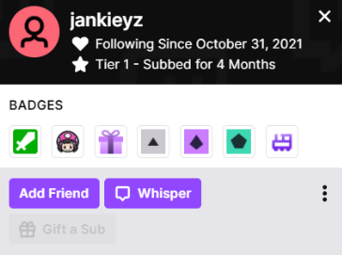
Not long after this, he subscribes which shows commitment “Subbed for 4 months”. This screenshot was taken on 2/15/2022. I know that this is his Twitch account because when I still cared about her I watched her stream in small portions. In the first 2 minutes of the stream, he would sub and Jen would say “thanks Alex”. I know that his name is Alex because Kearstin told me his name. I never asked her for his name, she told me his name when she tried to explain to me that Jen was moving on and that I should too.

Note: On October 31st, 70+ songs were added. Presumably they got in a call or were hanging out together and that’s when he also followed her on Twitch. I don’t know if they met up on those nights she went out, but I’ve assumed that they did for months.

11/01/2021 -> Out of nowhere she is upset with me.
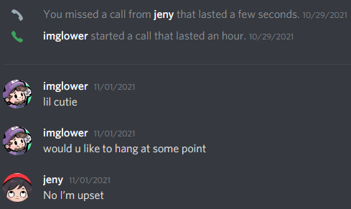

To quickly summarize the timeline before getting into the actual breakup:
10/23/2021 -> Everything is normal.
10/24/2021 -> Scarf fight.
10/25/2021 to 10/27/2021 -> She tells me she doesn’t hate me for the scarf fight then gives normal affection like always.
10/28/2021 -> I helped her with SM64 for 4 hours.
10/29/2021 -> I helped her fix her N64 controller for 1.5 hours. 2 selfies on Snapchat.
10/30/2021 -> She makes a Spotify playlist with Alex. 5 selfies on Snapchat.
10/31/2021 -> Alex follows her Twitch account. 1 selfie on Snapchat.
Note: In all selfies, she is dressed up, and out of the house. I don’t know where she was or who she was with.
11/01/2021 -> She is upset with me.
11/02/2021 -> She breaks up with me over text.

11/02/2021 -> She breaks up our 8 month relationship with me over text.
I did not respond well to this because it was totally unexpected. Days before this, she was affectionate and caring, providing loving texts, cute selfies, spending time with me in discord video calls. Weeks before this, she promised me I could visit her. Everything felt normal, then she flipped. I still don’t understand it and probably never will. I was composed for 3 days because I was in denial, then started having crying breakdowns because I was desperately trying to fix our problems, and she didn’t want that. This is the breakup text she sent me:
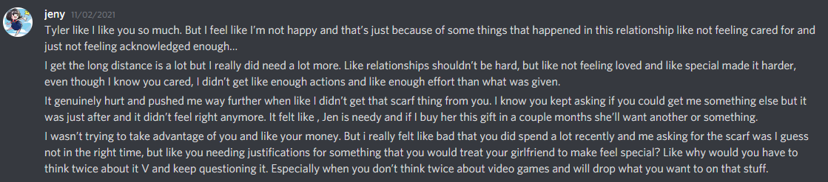
Jen: “I really did need a lot more”. In hindsight, I believe that she had already made up her mind before having any discussion at all because she met someone else to replace me. I don’t know if that’s true but that’s how I perceived it with the evidence I have.
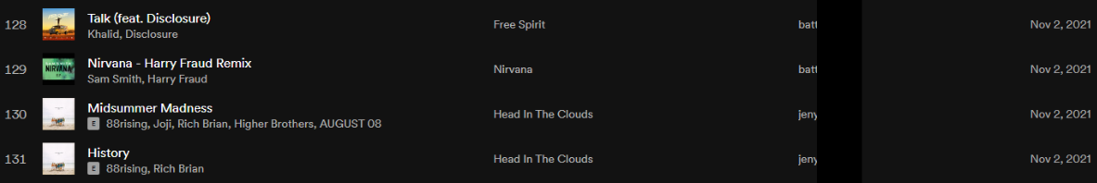
11/03/2021 -> We called for 2 hours. Jen told me that the changes I made to appeal to her needs that she mentioned in the breakup conversation felt “forced”. I didn’t know that many of the things she mentioned bothered her because she never told me about much of what she said until she broke up with me. She did not change her mind and trust that I made serious efforts to change to be a better partner to her even with me behaving differently towards her. The unexpected breakup, along with my confusion brought a lot of emotion out and I was super desperate after this because I expected a future with her based on her recent promises to me.

11/04/2021 -> I try to call and she says she is not ready to be in call. She says she needs time. (playlist at 159 songs, 41 songs added since she sent the breakup text 2 days ago, presumably, she was hanging out with him a fair amount at this point while I was still trying to fix things).

11/05/2021 -> My desperation reached a point where I started having crying breakdowns because she wasn’t working with me, she changed and I didn’t know how to change her back. I sent these vulnerable and desperate messages and she ignored them.
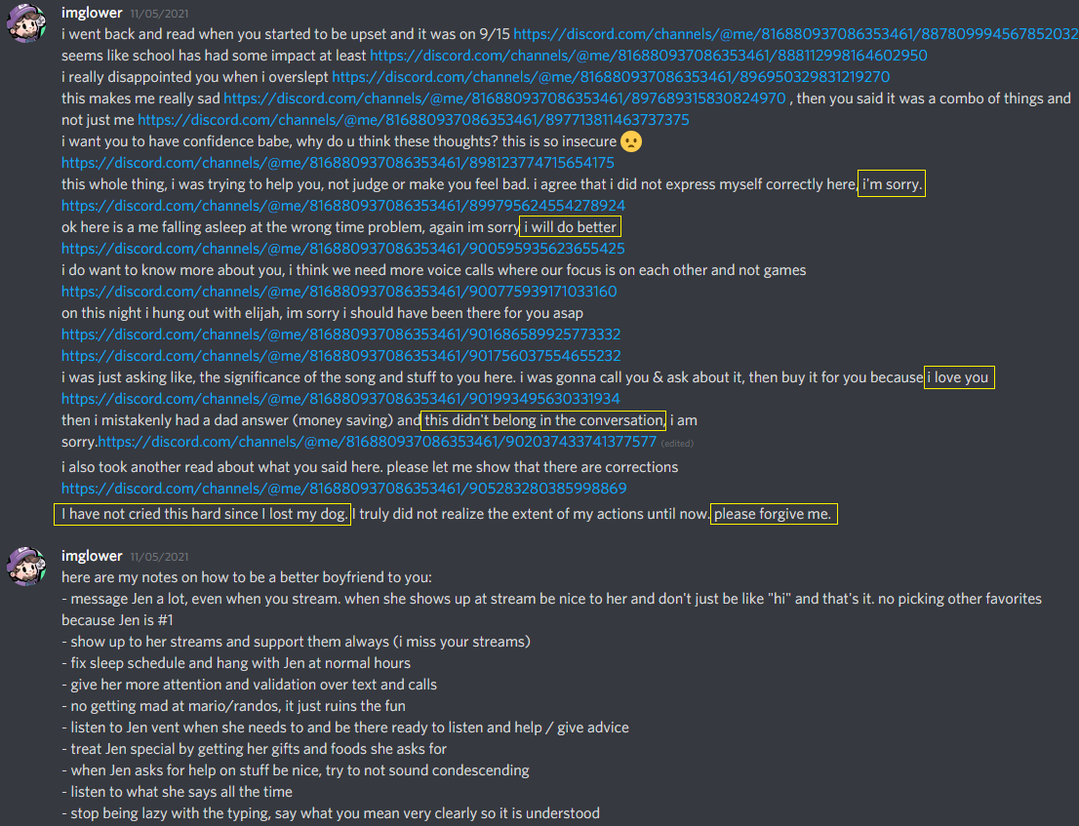
I am so embarrassed about being this desperate and that’s another lesson I’ve learned in this situation. I will never drop my value this low again.

After this point I stopped eating and sleeping. The relationship meant so much to me. I got my hopes up to see her again soon and held onto that for months and was let down. She was sweet and affectionate days before. It didn’t make sense, I got so confused. She was ending the relationship and denied any chance for me to make up for everything without any prior warning. 4 months ago I didn’t know how to prove to her that the relationship was worth it…

[Explicit content warning]
11/07/2021 -> I attempted to regain her attraction to me by employing things sexual in nature. I was desperate, and thought that introducing sex would make her change her mind because nothing else I tried worked. I asked if she would want to be friends with benefits since she was firm about not wanting a relationship and she said no thanks. Then I asked if I could send a picture, she said yes but it can’t be sexual. The photo I sent was a picture she took of us when she was at my house in June. We were both fully clothed and she was touching me while we were standing in front of a mirror smiling. There was no direct skin to skin contact in the picture. The picture was not revealing at all and was more humorous than it was sexual due to our facial expressions. After I sent the picture I sent a few sexual sentences to her against her wishes about things I thought we both enjoyed in our past, and after that she was repulsed. After I realized that nothing was going to change her mind, I continued to let my emotions take control of me and then I called her shameless, and selfish. I feel terrible about doing all of this and there really is no excuse for my behavior. I’m sorry.

We had this very same picture saved onto our snapchat pictures & video history. At the time, because I knew that the picture was saved and could easily be accessed by either of us at any time, I didn’t think that it could cause any discomfort, I was wrong about that. I thought if I reminded her of our exciting past, she may come back to me, I was wrong about that too. The picture I sent was a click, and a scroll away anytime either of us went to our Snapchat DMs, which we used daily. This does not excuse my behavior, but the context may help defend my case in the eyes for some that read it.
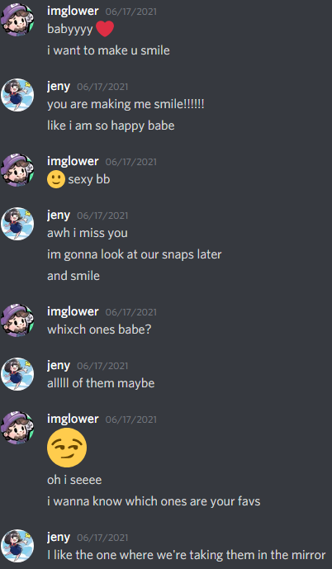
Proof that we had things saved there and they were readily available. At any point, she could have viewed these, and in her own time, she did go out of her way to see them.

The reason I sent that picture and said those words was because I wanted our relationship to be repaired, not because I desired sex in that moment. I knew she was out of the house so there was no chance for it to escalate any further. I was a fool in love trying to save a relationship I loved. I was fighting for a future she promised me in the wrong way. I did not take the right approach and made many mistakes throughout this entire breakup, even after this point. I’m ashamed at how impulsive and emotionally driven I was in this entire breakup. I’m sorry for allowing all of this to happen. It’s not excusable and it will not happen again. I’ve studied what to do during a breakup and feel very prepared for the next time it happens. I know to apply the no contact rule and to go to very specific people should this happen again.

After the events on snapchat, we had a 30 minute call on discord where I turned my webcam on crying, telling her how sorry I was for making her feel uncomfortable and saying she was “selfish” and “shameless”.


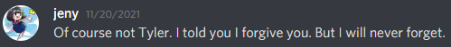
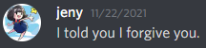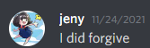
After that day, Jen forgave me for my actions and remained on good terms with me.
After this point I was really emotional and could no longer think for myself. I trusted everything that Jen was telling me. She essentially told me that everything that went wrong in the relationship was all my fault when we got on a phone call, and that I sexually harassed her. I trusted what she said and beat myself up about it until 2022. Upon much reflection, Jen is wrong. The breakup was a result of her actions too, and I did not sexually harass her. When I was broken, I trusted what Jen told me, and I wrongfully confessed to Cats4ever and Kearstin.

11/09/2021 -> We had a phone call for an hour talking about closure, but because of the things she told me, I think it did more harm than it did good. She said “guys hit on me all the time, you had your chance”, and “you don’t know what you have until it’s gone”. It just made me feel terrible, like everything was all my fault and that she was already ready to move on and didn’t care about me. Like everything I ever did for her was insignificant.

11/10/2021 -> She posted a picture with the new boyfriend in her car as a story on snapchat. She rarely posted stories on snapchat so this was a total shock for me. I loved her and I was still fighting to save the relationship, even after I knew with 100% certainty that someone else was hanging out with her, and despite that, I continued to fight to get back in the relationship for weeks. After she went on this date so soon after we broke up, I questioned if she ever loved me. I didn’t understand how I could be thrown aside so quickly for someone else after all that we experienced together, so I began to talk to some of our mutual friends about all of this.

After these events, Jen did not withdraw herself from me. After the events on snapchat, she came to my chat and complimented me
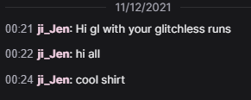
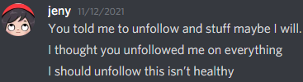
She wasn’t uncomfortable to the point where she had to distance herself. She came into my chat and was friendly with me. She said she should unfollow, but didn’t.

The events that made Jen actually hate me was me continuously going to friends about our breakup, not what I did on snapchat.

(19 pages) You can see all the evidence of that here but it’s optional, I would say that this document is very important. I do recommend reading it, but I also summarize it below:
https://docs.google.com/document/d/1K4MLojdesvJhL2v6D9M0CKv2mqe0fcUvjq07dznP99E/edit?usp=sharing
Pages 4, 5, 6, 18 and 19 are the most important. She emotionally blackmailed me and then acted upon those threats.

Quick summary of the 19 page document:
Page 1-2: (11/10) She wants to be friends, she says we can remain civil. She wants me to stay with her in our mutual servers.
Page 3: (11/12) She went to my chat while I was streaming and said “Hi good luck with your glitchless runs, nice shirt”. She told me that she should unfollow, but never did.
Page 4, 5 and 6: (11/17) She began to dislike me because I was reaching out to our mutual friends about the breakup. She emotionally blackmailed me.
Page 7: (11/17) She shares concerns about being “painted in a bad light”, but also said she wanted to remain friends, and be civil.
Page 9: (11/17) Worries about her being “painted in a bad light”.
Page 11, 12 and 13: She doesn’t hate me and forgives me 4 times.
Page 15: (11/20) She unbans me from her stream and she hopes we can remain civil.
Page 16: (11/22) I probably made her laugh with a joke, and proof that she did not unfollow my Twitch account after a few weeks of me going live daily. On 11/24 and onwards we seem to be on good or neutral terms, but then she posted a statement on 12/01.
Page 17: (12/01) She posts a statement in discord servers to get me out. Perhaps her reason for posting it was to get her boyfriend in because he joined 12 hours later but that likely isn’t the only reason.
Page 18 and 19: (12/21) After I reached out to a friend, that friend contacted Jen and Jen assumed that I was talking with that person without having a conversation with them first. This is when she posted the initial tweets. The push Jen needed to put out that tweet was me going to friends about the breakup. She acted upon her emotional blackmail on these pages.

Jen’s actions had a significant influence on my poor behavior as a whole.
- (10/24 to 11/01) She emotionally led me on, manipulated/stimulated me and made me believe she was happy with me and never sat me down to seriously discuss any of our problems. Days before the breakup, she said “You make me happy” and in general was affectionate as she always had been. Her feelings were disingenuous so the breakup was completely unexpected, and as a result, extremely hurtful, painful and emotional.
- (? to 10/30) She established a relationship with Alex behind my back while we were still dating, I don’t know when that started, it was likely before 10/30 though.
- (11/02) She sprang a very aggressive breakup over text on me, much of which I will not show, and did not reconcile whatsoever, likely because of Alex’s involvement.
- (11/05) She ignored my most vulnerable and emotional messages.
- (11/09) The phone call did not help me recover or feel better about anything because of some of the things she said.
- (11/10) She posted a selfie with a new guy, knowing that there was a chance I would see it a few days after she unexpectedly left me. I don’t know if it was intentional to “flaunt” him in my face but it sure felt like it.
- (11/12) She showed up in my chat after the events on snapchat, and after her date which gave me hope that she was still interested and possibly that the date went poorly.
- (11/17) Jen emotionally blackmailed me multiple times.
- (12/01) After Jen said she would not post any statements, she did anyway which came as a surprise to me. This resulted in me losing many friends. I knew the new boyfriend joined the servers very soon after too which made me believe she didn’t care about me whatsoever and spiraled me into a depression that lasted for months.
- (12/21) Jen acted upon her threats of emotional blackmail and brought a private situation into a public light.

I understand that despite all of this, I am responsible for my behavior. Next time I’ll just keep to myself and not allow what other people say or do affect my emotions. I know who to go to and what to do in times of crisis now.

Conclusion:
Jen did not hate me for my actions on snapchat. She hated me because I kept reaching out to friends about the breakup because she thought I was telling one sided of the stories to them, possibly exposing the information I reported on page 76 above to them.

It greatly upsets me to see Jen report that our relationship was traumatizing. I agree that my behavior on November 7th was not acceptable, however that doesn't mean that our relationship as a whole was bad. For proof that it wasn’t you can read how much she missed me after her 2nd visit here (6 pages, this is optional): https://docs.google.com/document/d/1no3LHtry0q5G8KmQjOfRja8G7xTUb-52vyP1FCNYTvs/edit?usp=sharing

I am once again denying that any of my actions are “harassment” and now the number of “harassed women” goes from one, to zero.

To Jen: When we fought about the scarf, I mentioned I’d want to surprise you. I was hinting at surprising you with a controller when I visited you because I knew you needed a new one. This has been on my mind for months, I have to tell you this, even if it doesn’t matter anymore.

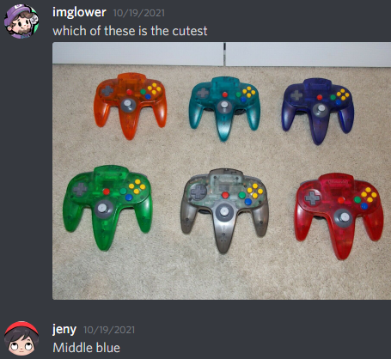

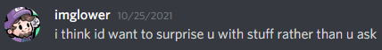

Jen, I’m sorry for making you feel uncomfortable. I got way too desperate to save our relationship because I loved you and thought we had a future together. You know I’m better than how I acted deep down inside of you. I tried so hard in so many ways to prove to you that I was worth it and went in way over my head against your wishes. I’m really sorry for doing that. I’m also sorry for any trash talking that I might have done. I meant none of it. I was just so disappointed and hurt. Everything was unexpected and I didn’t know of a healthy way to cope.

The reason I kept going to our friends was because I could not stop crying. I didn’t want to admit that I still cared about you or accuse you of cheating because nothing good would have come from those confessions. I didn’t expect the breakup, or his involvement. I finally understand that the reason you left me was because of long distance. I thought it was something that I lacked for months, but it wasn’t.
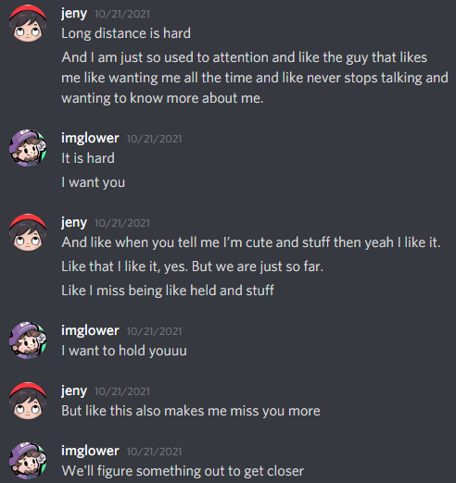

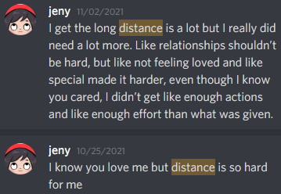
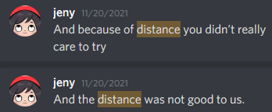

The only reason you were unsatisfied was because of the distance. I wasn’t able to give everything you needed me to because of that. I really believed that if we were local, or moved in together like we had imagined, things would have worked out which is why I was so desperate. I won't forget how compatible we were when you were here.

I can say with relative certainty that you emotionally cheated on me, and that you gave up on me so that you could be with him. I don’t know if more happened that I’m unaware of but the thought of it has haunted and damaged me for months. These events have brought me to the lowest point in my life and brought the most amount of emotion I’ve ever expressed across the entire spectrum. I don’t know if I can forgive you for all of this yet, but I think I want to someday. I will need more time. It doesn’t make sense that I’m still crying about this 4 months later, but I am. You can call it an obsession if you want, but I’d prefer to call it care.
Disclaimer: Making the doc had a heavy influence on my emotions.

I don’t know if we can ever be on good terms again. Any time I see your name, it hurts me. The pain I’ve felt has given me a lot of drive to improve myself in many ways, thanks for giving me the power to do that. You made me happy, I know I did the same for you too. Thank you for the relationship, I really did love it. I hope you find all that you want in life.

To Cats: I’m sorry for ghosting you early on. I’m sorry for sometimes saying weird things, or going to you about my problems and being a burden. You were one of the best friends I’ve ever had. I trusted you with anything and relied on you so many times. Thanks for being a shoulder to cry on when I needed it, I hope I helped you in the same ways.

To Sienna: I’m sorry for making you feel uncomfortable, I never wanted that to happen. I may have misunderstood what you really wanted from me. I understand that you want nothing to do with me anymore.

To the friend group: I’m sorry for going to some of you about the breakup. I didn’t have the willpower to keep my thoughts, feelings and emotions to myself when I learned the truth. It was too much for me to handle all at once. I’m sorry for bringing drama you didn’t want into the servers. I wasn’t strong enough to tolerate the pain of abandonment and betrayal alone.
Next time I will be.

To those that still hate me and continue to spread toxicity even after reading this: Leave me alone. Go get a hobby.

To random people that took time to read everything: Don’t reach out to any of the accusers or their friends and spread hate or harassment towards them.

As a whole, I definitely did make mistakes, and I feel terrible about the actions that I am responsible for, however the girls that I was in contact with in these situations were not traumatized or severely hurt by my actions, they just felt uncomfortable and disappointed. The original twitlonger has a lot of false and fabricated information in it. Much of what was said was manipulated, over-exaggerated and oversold. The girls today are all too stubborn to say that I didn’t wrong them that much, but I still proved, with their own words and actions from the past, that they were still fine with me after what happened.

I understand that I’ve made mistakes, but my mistakes are not irredeemable.

Now I have to fight for my community and leaderboard positions.

Just so the public is aware, my leaderboard times, and World Records for Paper Mario have been completely removed from speedrun.com before I ever got the chance to defend myself. There was no due process whatsoever. Minutes after Sienna posted her twitlonger, I was immediately banned from the Paper Mario speedrun discord, and many people made quote tweets mere minutes after she posted it. Every word that Sienna wrote was believed as if it was the gospel truth even though a lot of it was false, manipulated and fabricated and I have undoubtedly proven above.
Examples of the quote tweets along with time posted. Names are anonymous.
https://docs.google.com/document/d/1kYFRoMKjDFl8NGJ4SFs0X4h0zQms84h6THn6Dqdpqmk/edit?usp=sharing

It seems likely to me that they had already read what she said and prepared scripts. I was character assassinated, kicked, removed, banned before I ever got the chance to disprove all the false and manipulated information and share any much needed context. There was no grace period where I could try and prove my innocence or share my side. None of the mods reached out and asked for me to explain myself. The women were praised and I was instantly removed from the Paper Mario community without any recourse or without community involvement.

I have been told that the Paper Mario moderators made these decisions without ever asking the accusers if they wanted me removed prior to them removing me.

This is not a good display of leadership by the Paper Mario moderation team. Naturally, since much of the information in the twitlonger is false, fabricated, oversold and over-exaggerated, re-evaluation of my leaderboard position, and involvement in the community is required.
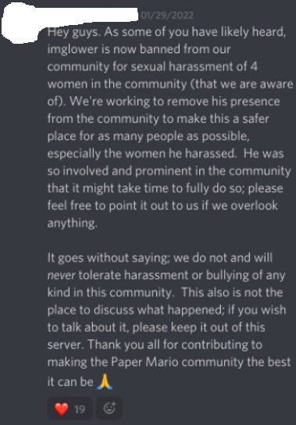
The information above was posted to the Paper Mario Speedrun discord and is false, but I am being punished, publicly shamed and humiliated for all of it. I don't know what the “bullying” comment is about, I’ve apologized when I believed I hurt people in every situation that I’m aware of. This announcement message has since been deleted.

Update as of 2/2/2022: It seems more people have been added to the mod team without community involvement. There was no vote held for these people to be elected into their positions of power. The decision to ban me and remove my times before I could defend myself was taken before any of them were added as far as I know.

A few of the leaderboard moderators are claiming that their times are the World Records when they did not physically beat my times. One could make a legitimate argument that the reason the other runners care so much about this situation is because removing my runs and my times benefits them directly. I don’t know their intentions but it is a possibility that this is the case.

What warrants someone to be worthy of being “canceled”, and in this case “removed from the leaderboards and/or community”, is completely subjective. There are many people that I talked to privately that believe that my actions did not justify my leaderboard position and community placement to be removed, especially without getting into contact with me, listening to my side, or talking to the accusers first. Likewise, there are many that only know of the accuser's side and want me removed.

Random people I am not associated with on this reddit post, do not think my actions warrant a ban. https://www.reddit.com/r/speedrun/comments/se2dm6/serendipity29_accuses_paper_mario_speedrunner/

I did the following and was forgiven by everyone that felt wronged:
- Sent unwelcomed text messages

I did not do the following:
[Explicit words warning]
- Damage someone to the point to where there is remaining trauma
- Pursued sexual interactions with an underaged individual
- Kill someone
- Physically harm, or abuse someone
- Verbally harm, or abuse someone
- Inappropriately touch a person without permission
- Grope someone
- Rape someone
- Post threats of violence
- Act on threats of violence
- Commit a crime, felony, or misdemeanor

The claims of harassment are false, and the women I was involved with will not be harmed in any way if my name stays on the leaderboard. Therefore my speedruns deserve to be on the Paper Mario leaderboard. Furthermore, it is defamation of character to remove my times and pretend that they do not exist.

To my friends that supported me through this, and had my back no matter what, I can not thank you enough, you might have saved my life. I am at the strongest and happiest point that I have ever been at in my life at the moment and things will only go up from here.

Thanks for reading, if you continue to support me, remain my friend, or sympathize with me, I greatly appreciate you. If you were once my friend or supporter, and I have disappointed you to a point where you can longer continue to be those things, I am sorry. I will miss you, and I love you.

