Hello everyone, it’s “bella”
There has been so much false information about this situation online that it’s reprehensible, I can't seem to comprehend it because it’s so out of left field.
For starters, I never posted anything and yet people are claiming to be me and claiming to know me.
Not to mention the absurdity of KiwiFarms, although I only saw it briefly, I have been informed that multiple random people are being doxxed for seemingly no reason.
Never once posted yet there are people claiming I made around 60 or so pages of interaction and that I'm manipulating them.
Their accusations towards me are:

- Pedophilia
- Necrophilia
- Gore
- Animal Abuse (they literally claim I boiled a hamster)
- White Supremacy
- Nazism
- Grooming
- Mass manipulation that could only have been performed by someone with mind control
- Drawing illegal porn
- Incest fetish
- Cat fetish?
- Stealing money from chris
- Manipulating him into raping his mother
- Trying to kill him/ convincing him to commit suicde

Now if you think ANY of these are true you are utterly mistaken. Why people believe this is way way way beyond me.
The “evidence” they had for this is something like an account that I'm not even associated with nor can I even find or have since been deleted.
They also have a huge discord log posted by someone who had no evidence that they even know me and has claimed to be my ex-lover.
We’re not.
This individual posted around 30,000 discord logs from a “chess channel”
I'm not in a chess channel nor is that my discord.
This person says their name is Zoe/Douglas Cham***
Never interacted with them nor have I ever posted in a discord with them in it nonetheless an official college chess discord.

Here's the original post:
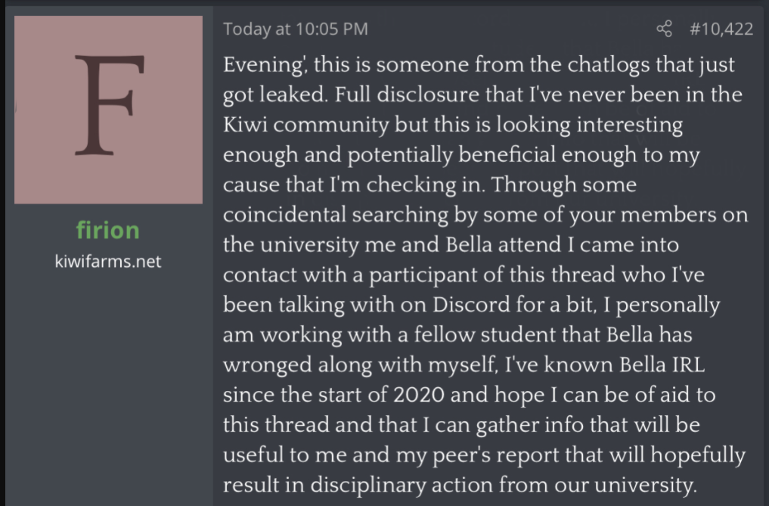

This was right under a supposed dox of my phone number and address
Don’t know this person, not my address, nor my phone number and nobody seemed to fact check it

So to clarify, these “chess club” discord chats are NOT of me
- Not my discord
- Don't know this supposed ex lover and anyone they're talking about
- I was never in a server with them, not even friends with them on discord
- The chat logs claimed I did certain things like steal money from Chris. If you believe this I encourage you to talk to the police, that would clear that up because I did not steal from them in any shape or form.
- Never posted loli or animal abuse
- Never EVER abused an animal or hurt an animal

I am in a chess club, but it is not in discord.

KiwiFarms is very focused on painting a few things here, again, with no evidence whatsoever.

There is some very clearly edited and cropped screenshots between a supposed text conversation of Fiona and I of me saying “YEAHHHH WE DID IT WERE THE BEST TROLLS IN HISTORY”

My only words for that is; Seriously?
I have evidence to the contrary and I will show it here shortly.

Before those obviously suspicious conversations even came out, the KiwiFarms post was still only painting the narrative that I manipulated Christine Chandler into raping her mother.
With no evidence, again, whatsoever.

I will shed proof to that in a bit.

Kiwifarms found about 40 different personas questioning the logic or reposting already available information they claim to have been me.
Not a single one is mine.

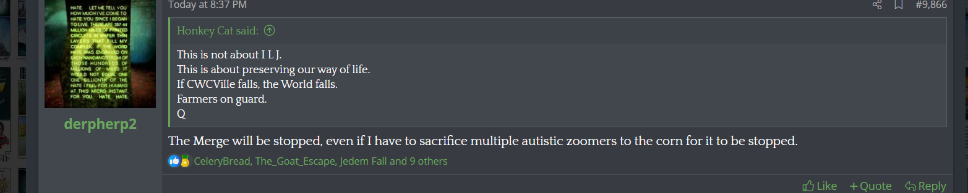

Besides the OP, Spookybones, saying he “wants to scalp” me, that hatred seems misplaced considering he has no evidence and no two strings of logic he can tie together.

Despite me wanting to stay out of this and showing no presence besides people claiming to have been me, I will come out in the open today.

- I was never a troll
I did not work for praector, i received no compensation from praector, I don't speak to any people from praector.
I got his number from a person who I briefly spoke to who worked there, however I never interacted with them again.
I was interested in Chris lore and had read some of the sonichu comics and found it funny, I thought liquid chris was hysterical, so I thought it would be interesting to talk to Christine or Sonichu at the time.

After a few days of no contact, the fellow (forgot his name) sent my number (burner, because I knew she had a record of doxxing people) to Christine and I received a text.

Immediately I regretted everything

No this person was not fun to talk to at all, I was as polite as possible to them but they seemed to feed into that. They took my “oh wow... that's neat” as “I completely believe everything you say about being a goddess from another dimension”
Despite my lack of response they latched onto me way too quickly.

At one point they tried to convince me I was transgender because I apperently would be a male sonichu.

At one point they told me about the ridiculous things praector would have them do such as trying to create a cult and I attempted to subtly urge her to be more suspicious of them although that didn’t work.

I met them less than a year ago, but I gave up contacting them altogether for a few reasons

- The groups surrounding Christine such as the watchdogs were extremely aggressive and toxic
- I couldn't take the mountains upon mountains of texts every morning about how their sex dreams were and how the merge was going and how Rosechu was and pickle rick this yadda yadda
- Dealing with Christine, even only giving her replies once a few days such as: “oh wow that great” was a tremendous amount of effort

I used to care for their “lore” but after talking to them IRL I quit completely and deleted the burner number.
I was VERY nice to Christine, even going so far as to send them markers and pickle rick mints to them on their birthday as well as nice letters every now and then, and Christine was very nice to me back. Sometimes I actually enjoyed the conversations with Christine because it lightened up my day and I told her so. I didn't inform anyone of Christine besides two girls who didn’t know who she was and were not very fond of her.

Even though the conversations could be pleasant, they were not pleasant enough for me not to feel drained having to read sexual content from her so I deleted the burner from around March until late june.

I felt a little bad about leaving them in the blue like that without any explanation so i took some time away as a break and created another burner number where I said that I had lost my phone and reconnected.

Christine seemed really happy to reconnect with me and even invited me to the everfree event right out of the blue, even inviting me to their new private server so that i could talk to this girl “Fiona”
As soon as I joined the server, people were very aggressive for Christine’s attention and I immediately did not like it. One very gossip-prone person named “neko” asked me to help him doxx some guy and got very angry when I gave him half-assed information and didn’t aid him in finding this person whom they said they had been searching for obsessively for 9 days straight.

The group apparently knew her for about a decade and they all insisted they had crazy powers like she did which i found very stupid.
However, all these people besides Conner were very nice and when push came to shove, they denounced Christine which must have been very hard after a decade of supporting her. All but Neko who seemed very on edge and demanded me for the full unedited “4 hours” of content. When I said no, they blocked me and attempted to throw me under the bus several times by providing obviously insane interpretations of the situation to Kiwifarms.

Anyways, another person who struck me as even more aggressive than Conner was Fiona or ScootalooSister. I immediately tried to be her friend because we were both women, but she very strongly thought that was a bad thing and that I was competing with her for Christine somehow. I made it clear that I was NOT interested and instead offered to help her by being her wingwoman.
When I asked her why on earth she was even interested in Christine at all, apparently she told me she had a fetish for “gross things”.
She was completely determined to sleep with Christine and I informed her that she would probably regret that and that I wanted to protect her from Christine. I even offered to be HER bodyguard at the event (not Christines), and not initially a photographer but I did offer to take photos so that I wouldn't be in any much later on.

Anyways, Fiona had said that she was genuinely in love with Christine and I was happy for them.

I congratulated Christine on her new relationship with Fiona and later, Christine sent me this:

https://imgur.com/a/d1pYidg
https://imgur.com/a/d1pYidg
https://imgur.com/a/ZKc5Vxe
(I edited the time stamps out here because they might be very confusing seeing as I was in between two time zones writing that)

I was concerned with how they asked me to use a different messaging app because “the feds might hear her”

I take the call with Christine

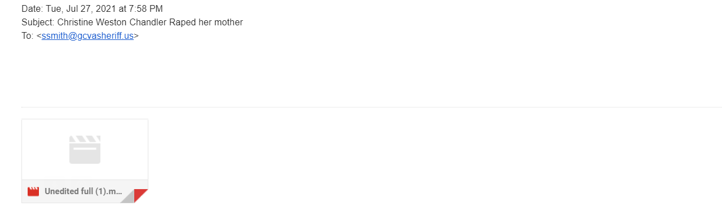I send an anonymous tip to the police at a link I found somewhere on their website

And then I called this


There were 2 people in this call minus Chrsitine

Me and another girl who I invited to come a bit after the call started

When I first entered that call, I had NO. IDEA. WHATSOEVER. That Christine would say that

At first I did not believe it, even after Christine said “Bella, I want you to look me in the eye when I say this… I am having sexual relations with Barbara”
I just froze and said “yeah I figured..”
I asked him to tell me more about it, but the other member of the call did not contribute.

I told him that my computer lagged and I was switching devices so I could leave and invite the other girl to record through a third party audio which she was listening in on since I was on video call and Chris could see me record.
However, I did manage to sneak in bits and pieces through my computer while the other person got it on their tablet.
We ONLY recorded the parts of the call that were incriminating, we regret not recording more because Christine goes into greater depth when we stopped. We did not continue because it was hard to keep a conversation running with her and my friend’s tablet would only record so much at a time, and I was more focused on how I spoke and acted so that I wouldn't startle Christine or seem judgmental.

What else she told us in that call was truly and utterly repulsive. It is rape by every definition. Some people say I sounded happy in the call, not a single iota of me was happy.
I thought Christine was harmless, I have never ever ever ever ever in a million years imagined this.

What else was said is only the business between me and the investigator whom I've been in contact with.

After that, I made the mistake of telling Fiona about it.

Here’s the convo of me telling Fiona about what happened and her leaking it

https://imgur.com/a/UlYiy2k
https://imgur.com/ a/opgzBBN
(there is one post here that mentions us being trolls, i said that sarcastically because of people's initial reaction and their comments on her and many other posts)

Let me make something clear. This is NOT her fault. I was irresponsible and I sent it to her, a young girl with past trauma which unfortunately encompasses her sex life. She is not a bad person, just someone way in over her head.
She said she wasn’t going to post anything, but I shouldn't have sent it because people clearly lie on the internet and now it has spread everywhere because she didn’t think it would blow up.
Everyone makes mistakes, she didn’t know, but she does now. She learned her lesson, you don’t need to cyberstalk her to try to reach out to her.
I don’t know where she is and she went afk, but she is realizing the gravity of her situation now so DO NOT harass her in ANYWAY SHAPE OR FORM.
DO NOT try to find her. She or her friend leaked the video of me mentioning her name and her college. DO NOT try to find her
She is not responsible for the leaks, she posted it online but I sent them to her so it’s my fault. I did not expect her to put my voice in or my info and to crop ot to make it sound like I wanted Christine to rape her mother but that wasn’t her intention.

I post these only to disprove any narrative and fake texts surfacing, this was my initial reaction.

Anyone who is editing text messages including text messages that you don’t see here is most definitely one of Fiona's many friends.

She is very young, do NOT come near her.

At first I thought the ridiculousness of Kiwifarms would die down, I thought that there was no way in hell someone would believe that because it’s completely bull.
I was disproved when GiBi posted an entire video crediting them and an entire discord of texts that I wasn’t even in, posted by some supposed ex lover of mine that I don't even know and whom nobody has tried to validate nonetheless GiBi.
He justifies everything that was said there and mentions people pretending to be me with his only bit of evidence left completely unfactual.
At first he was even defending me against them but then they threatened him with a doxx and now he wants them back on my side.

This was NEVER my intention to let it out into the public. But here we are and here I am

Please stop doxxing and harassing innocent people. The incestuous rapist is in jail and kiwifarms users trying to blackmail me to redact the info and claim its false isnt going to change that.
Again, i’m the one who's been talking to the investigator, she admitted to it, they have everything I ever sent her and vice versa.

