TRIGGERS PRESENT: cheating, racism, sexual abuse, grooming, suicide.

On behalf of everyone involved, I'd like to make it clear that this is not a reflection on the LGBTQ+ community. Vile people come in all identities - straight, gay, trans, etc. - just as amazing and kind people come in all identities. We absolutely do not condone the use of this document to justify transphobia or homophobia, as this all stems from a single individual's actions.
- Rhiannon

CHOCOBODIN’S TESTIMONY
I dated EeveeA from mid 2017 to late 2018. I used to be hesitant about writing this in fear of retaliation but now the only thing I’m afraid of is the embarrassment of admitting I dated her. It’s humiliating to reveal that these things that happened weren’t enough for me to end things but I’d never had a serious relationship before and was naive with a bad case of “I can fix her” syndrome.

I tried to be as supportive as I could during our relationship - finding her a place to live away from her family, figuring out providers to get started with her transition, designing her stream branding and overlays, always being active in and modding her streams, giving clothes/makeup/skincare to her, responding and holding space and giving advice during her various life struggles and emotional breakdowns, etc. After our breakup, she’s consistently told many people I’m a fucked up person and a horrible partner who traumatized her for not wanting to initiate or reciprocate sex and never complimenting her. She literally tweeted on her private twitter that I traumatized her sexually while she is the one who violated my consent on multiple occasions.
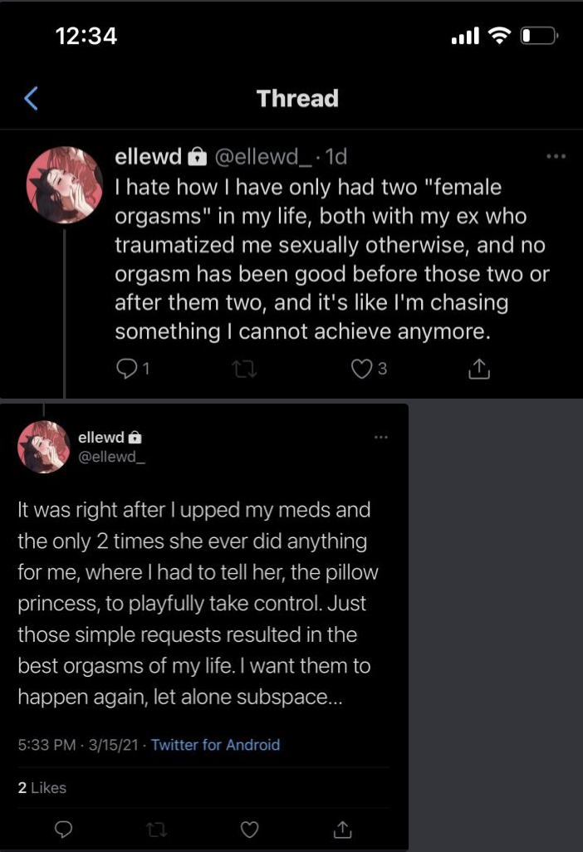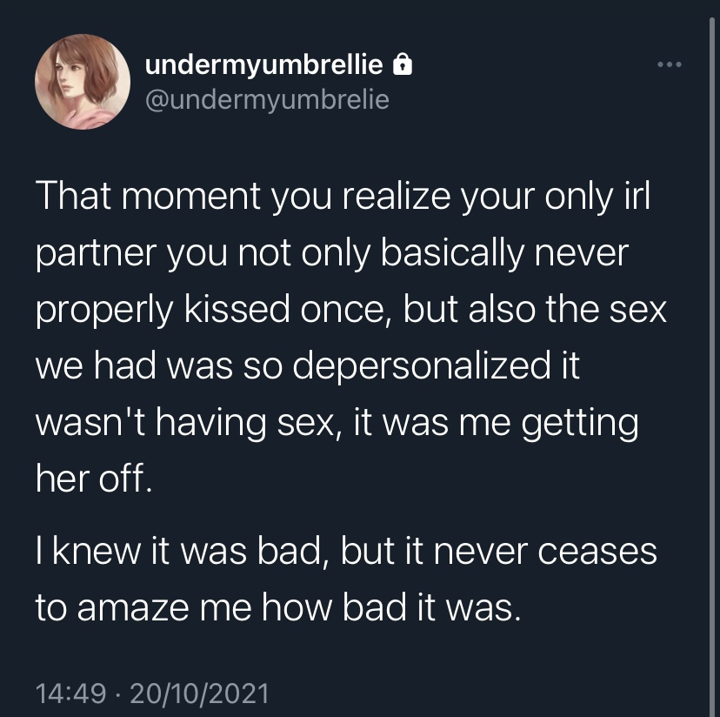

It has been beyond frustrating keeping my mouth shut for years about the absolutely heinous things she's done while she villainized me to her large following. There is so much more beyond what I’m sharing here but I’ll try to keep it to just objectively fucked up things and exclude general shittiness from now on.

CHEATING
EeveeA has a chronic problem with cheating. The beginning of our relationship started off with her lying to me, another member of her community, and I believe her two partners at the time about the status of her relationship so she was dating us behind one another's' backs. Shortly after this, she got her wisdom teeth removed and claimed that her pain medication caused uncontrollable arousal which led her to sext a mutual friend of ours when I wasn’t being receptive enough to her messages. She denied this happening despite my having screenshots of their exchanges. She then tried to cover her tracks by denying she and I were dating to the other people she was lying to despite telling me multiple times before then how much she loved me. I have learned recently that she also sexted a minor during this time.

After our relationship ended, we were still friendly and she visited me a few times in NYC afterward. One such time, I attended a party in downtown Manhattan and had left my keys at my friend’s place uptown. I was drunk and I asked her to please stay up and let me in when I came back to my place. When I returned, she helped me undress from my outfit and I was drunkenly rambling about how I thought I embarrassed myself in front of someone I had a crush on at that party. Then I made a joke about how sexually frustrated I was from the party and she started fondling my breasts and nipples saying how she could help me out with that. I brushed it off and rolled over to go to sleep. I later checked timestamps on twitter to learn that she and Lilith were in a relationship during this time. Additionally, Eevee lied about this event to a friend in DMs saying she took care of me while I was “the most emotionally distraught she’d ever seen” and that I’d had sex with someone while I was out which is a complete lie.
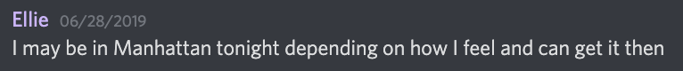
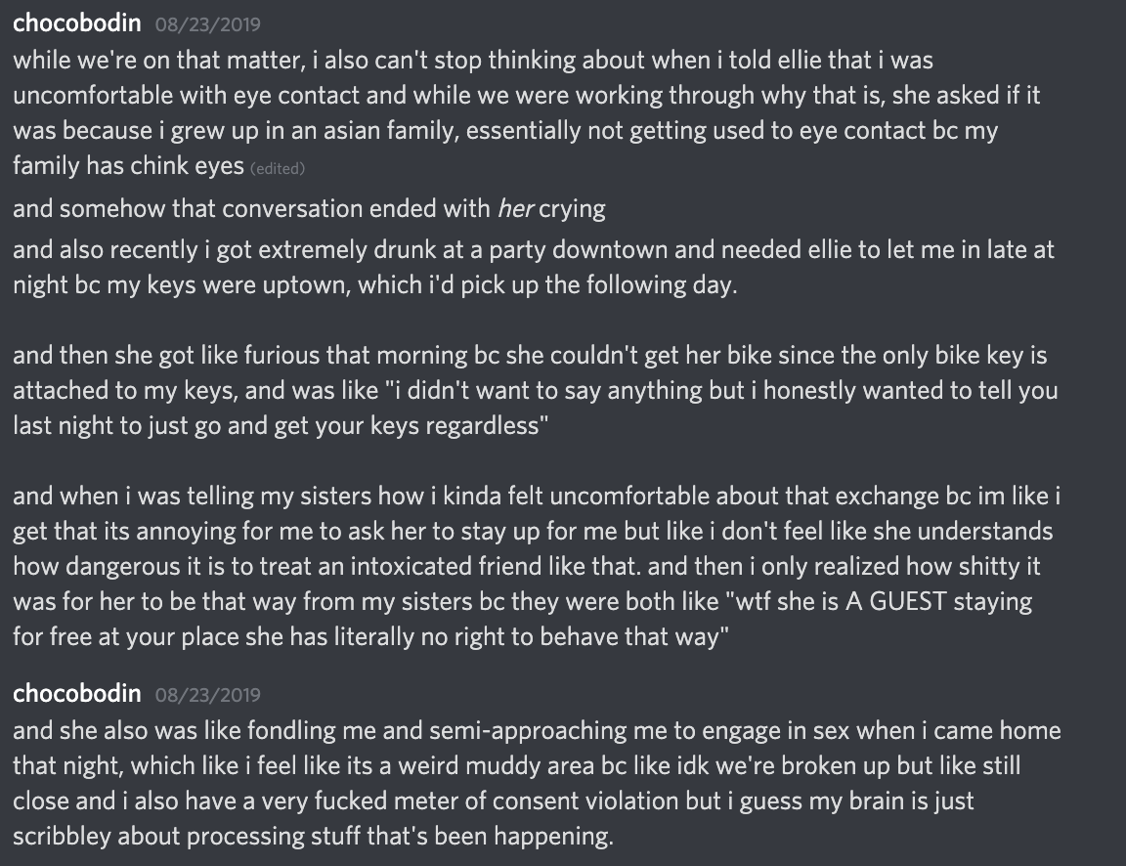
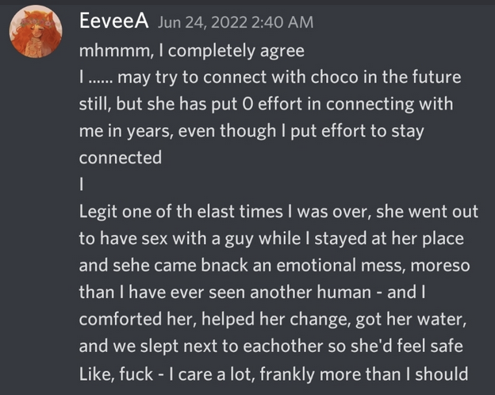

CONSENT ISSUES
At Twitchcon 2018, we both got drunk - me incredibly so. When we returned to our AirBnB, I was very aggressive with my “bratty” speak and goaded her on to be rougher with me until it escalated to her on top of me smacking me incredibly hard across the face twice to the point I felt my brain rattle inside my skull while saying “you bitch” repeatedly. I was so drunk that she realized I was sobbing before I did. I was super embarrassed and told her everything was ok and we would talk about it in the morning. The morning after, I told her that there was some miscommunication and that while I had expressed curiosity about being slapped before, we hadn’t discussed actually going through with it and especially in my inebriation and how hard she did it in combination with the verbal aggression was likely why I reacted poorly. She did say sorry and that she felt terrible but then followed up that if I had heard the way I was encouraging her last night, I was really into it at the time. Then she sheepishly added “I hate to admit this, but when I realized you were crying I got harder for some reason.” Before this, there were various times where I expressed discomfort or pain during sex which she would laugh off or ignore. I want to reiterate that I don’t fault her for misstepping during sex itself but that when I would communicate any issues I had, they were disrespected and ignored.
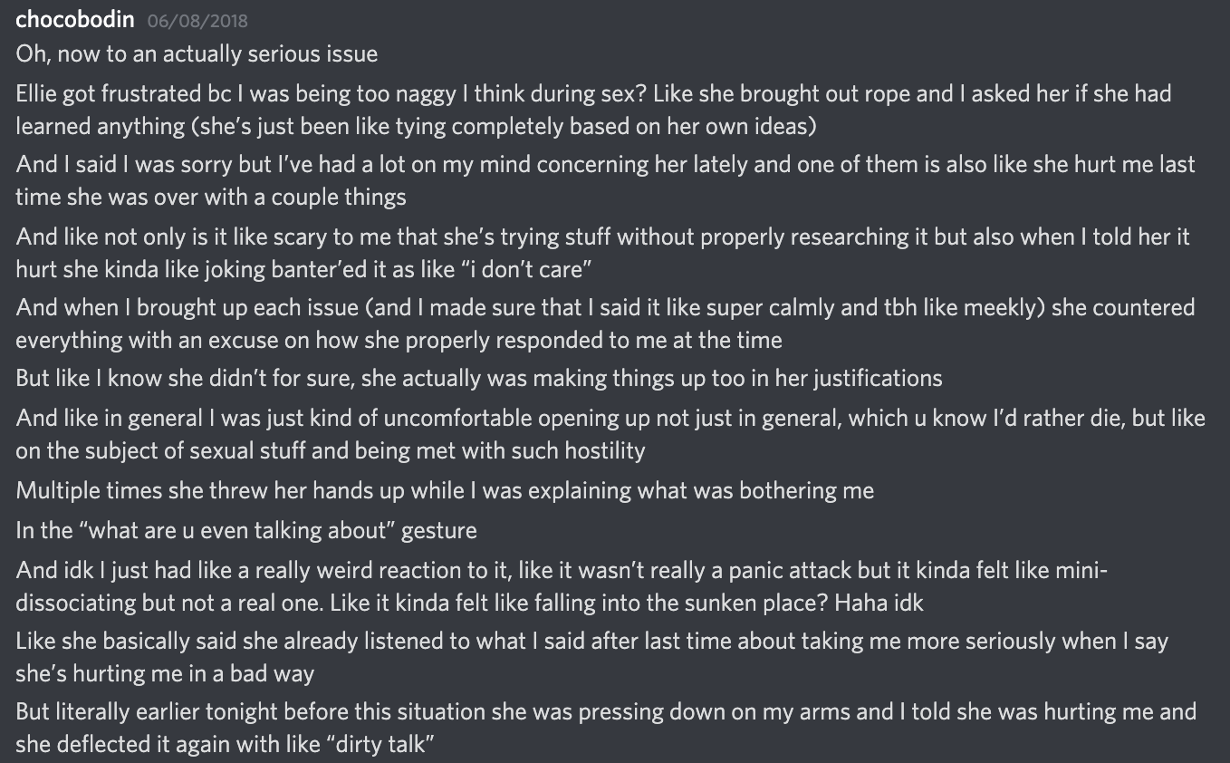

HYPERSEXUALITY
Lilith has a more robust explanation on Eevee’s hypersexuality and I can corroborate her experiences to be similar to mine. I believe part of the reason Eevee very often demonizes me is due to my refusal to engage her 24/7 sexually and I became much much much more resistant the longer our relationship went on. The reason she started sexting other people when she was on pain meds was because the reactions or responses I was giving her weren’t good enough. You’ll see another example of her hypersexuality in the section about our breakup.

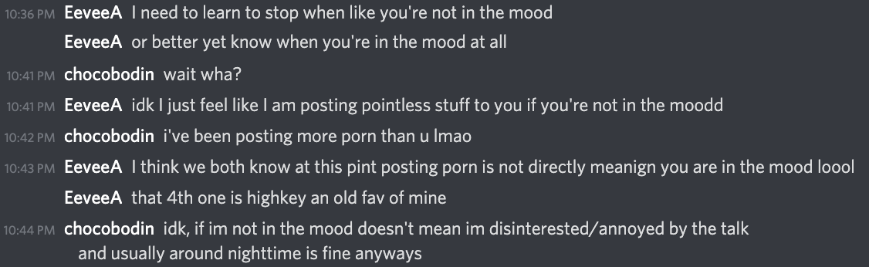
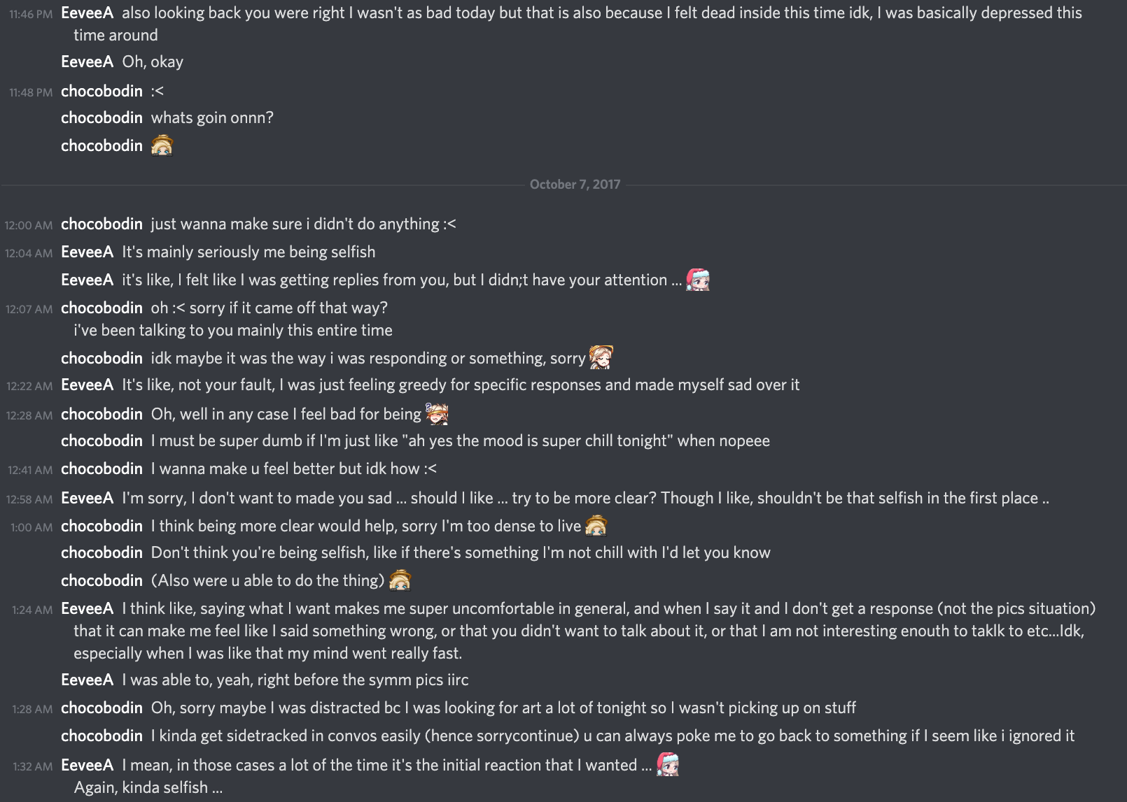

Also, this is pure pettiness but she also feels the need to bring up that she was a very experienced lover and that it was never reciprocated but this is also untrue. She dated me for 1.5 years in a LDR and neither of these numbers make any sense. It was also confusing and offputting as she would claim that fucking me made me her dysphoric and ejaculating made her dysphoric, so I either had to blow her or use my hands or toys but if I took too long she would also get frustrated and claim that she was getting dysphoric again yet would be upset if she couldn’t finish. This combined with constantly feeling like a nagging mother, being chronically disrespected and underappreciated, and knowing that sex would be a given made me extremely resistant to wanting to reciprocate - which she has vocally hated me for since. Later on in the final dms between us she accused me of only ever saying I love you when she gave me the wildest orgasm of my life despite the truth being a great deal were faked in an attempt to boost her self confidence and end things sooner.

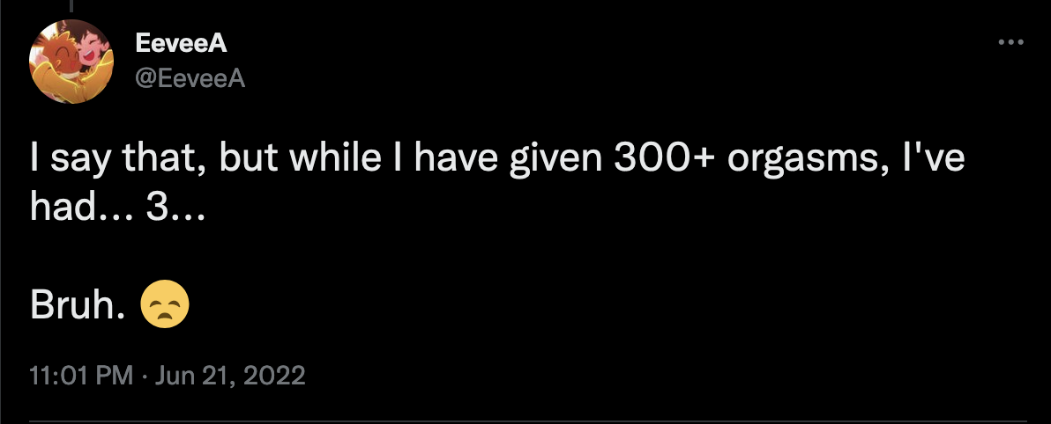

SUICIDE BAITING
I can’t recall the reason, but one time I visited her in Baltimore she was upset by something I did and left the apartment without explanation late at night. She returned an hour later and told me she had been walking around the city streets barefoot hoping to be hit by a car and complained about having glass stuck in her foot.

Early on in our relationship, I told her I wasn't looking for an open relationship but that I do enjoy flirting and making out with ppl when I’m like dancing and drunk and she said she was fine with this. In 2018, we went to Otakon together and at the rave I started to dance with some girls and told her to join us which she declined. I asked if I could make out with the girl I was dancing with and she told me “yeah, go have fun!". Then told me shortly after this happened that seeing me make out and dance with another girl made her suicidal.

THE BREAKUP
In December of 2018, my cat Moses started making weird wheezing noises and 3 days later I had to put him down. This was an unbearable loss for me at the time and up to that point I was a very unemotional person, now violently wailing and hyperventilating literally from waking to sleeping for days on end. During this time, there were multiple incidents where I asked her to join voice chat on discord for emotional support and she said she was busy masturbating and would join after she finished. One time when we were on voice and I was sobbing through my grief, she put on a sultry voice and asked “does this help?” and I heard slick masturbation noises over the mic. This was absolutely jarring because we'd never done anything like that before and I’d never indicated an interest in this kind of scenario. Ultimately, we broke up as she said "I just don’t know how to console you through this."
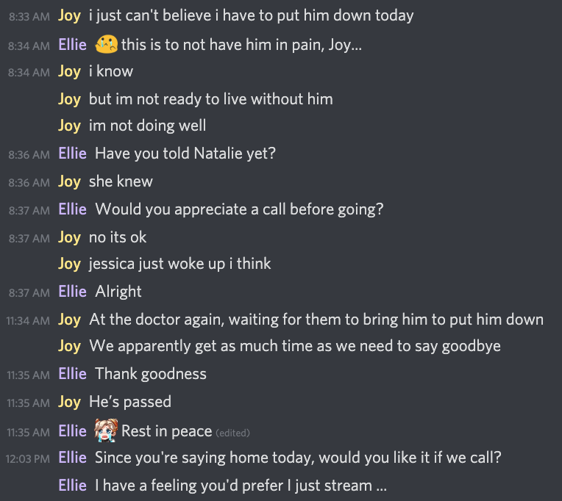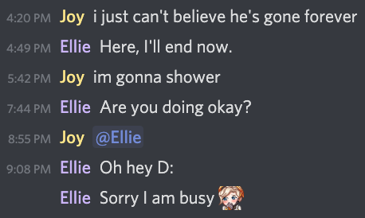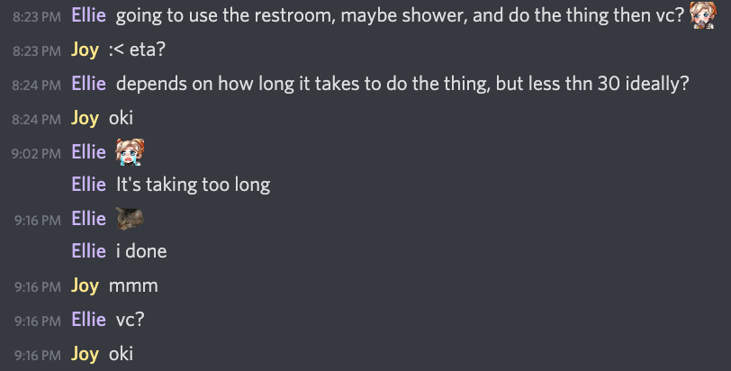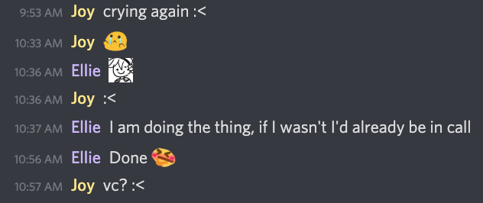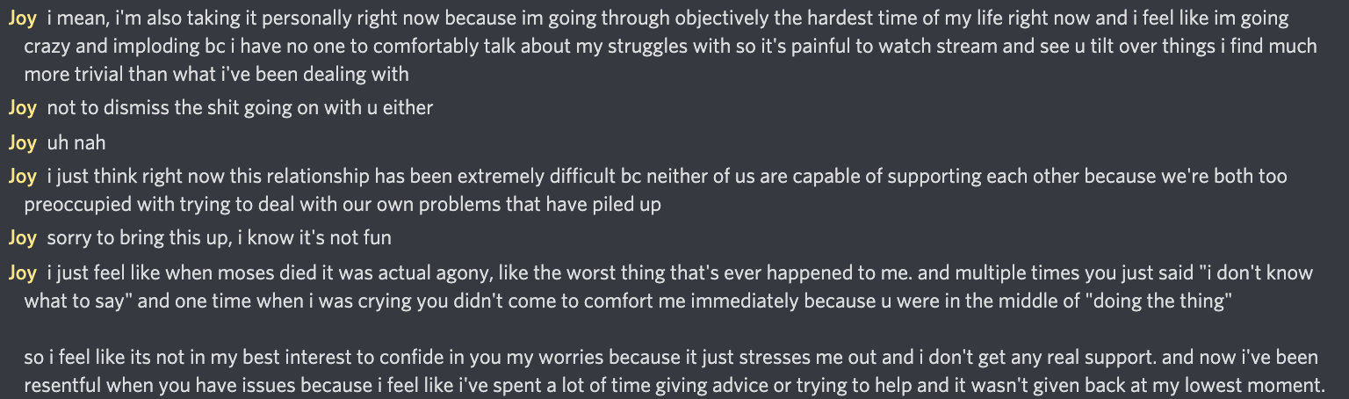

OUR FINAL COMMUNICATION
This is after Joom’s death and aftermath. You can read more about it in the titled section. I can’t convey how strongly I felt about Joom and how close he and I were. He made me feel so special and loved and safe and respected especially after a very difficult time in my life.

After I explained to Eevee on one of her twitter threads why she was in the wrong on this ReiMei situation
https://twitter.com/chocobodin/status/1548371110197993474?s=20

She used this as an opportunity to DM me for the first time in 2 years and tell me how being banned from Joom’s server hurt her feelings. The attached screenshots are an incredibly long read that are optional but tl;dr I brought up most of the issues stated above with her and she either denies it or excuses most of it and spends a lot of time arguing with me.
https://imgur.com/a/DVkcT35

Her issues with me are over-exaggerated but I don’t even care. It’s insane that she would think this was an appropriate situation to shift the conversation into complaining about how I hurt her feelings. The gravity of what she’s done to people is incapable of breaching her thick skull and she’s only afraid of being ostracized. She expressed fear to a friend that I’d reveal what she’s done to cope with my grief of Joom’s passing in the event she became successful which is the most insidious and selfish way to think about your actions.
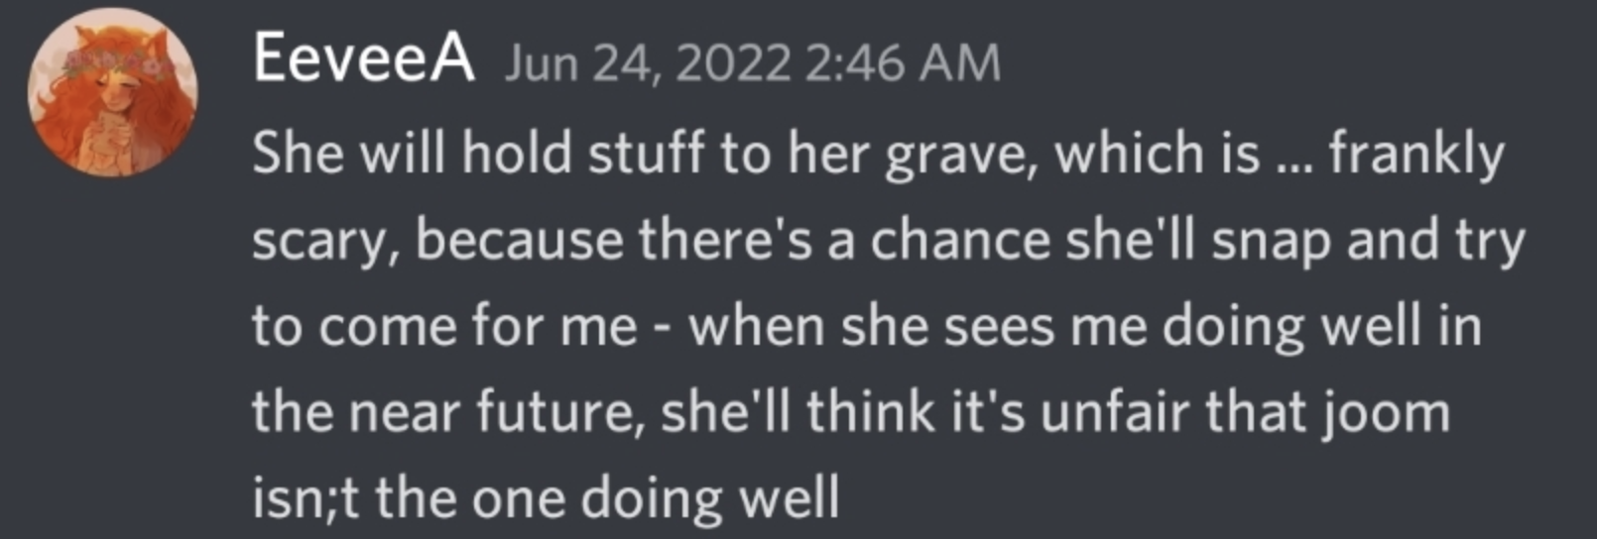

TO EEVEE
If Eevee happens to read this - as I told you before I don’t believe you’re actually capable of change. I’ve lost that faith after 6 years of evidence to the contrary. After speaking with Lilith about our eerily similar experiences, it’s clear you have a pattern of behavior that you repeat almost comically between relationships. I’m sure you’ll think “why share any of this if you don’t believe I’ll change?” just like you did the last time I confronted you. It’s because I want people to finally know the real you. It’s what you and I and everyone else deserve. If you ever intend on returning to any community under the guise of having grown from your past, they should know exactly what actions you had to grow and repent from. It is not our responsibility to hide our truths to make your life easier any more and your chances have run out. It’s clear any private attempts to address your behavior have fallen on deaf ears and maybe forcing your transgressions into the limelight will be the wakeup call you finally need.

Your pathetic twitlonger apology was utterly toothless and I refuse to have people think the only thing you did wrong was being complicit in someone else’s actions. You have not changed, what you have done is finally found a partner who would indulge your chronic sexual impulses and prioritized that need being fulfilled over anything else you learned about her. How cruel of a message to send to your past partners: “you as a person did not matter, only my sexual satisfaction does - I am happier with a pedophilic racist than you.” I know you still don’t have any remorse beyond “I’m sorry I’ve made people mad at me” and that you only messaged me in the 13th hour once you learned I was writing this. There’s no way you’re really sorry when for years you’ve slandered me over NOTHING and made me into a boogieman for your other partners and social circle. When you’ve had years to open a dialogue with me at any point and chose to instead repeat your mistakes with other victims. Even in July I gave you the opportunity to provide closure and you instead chose to ghost before seeing it through like you do everyone in your life the moment you feel even an iota of discomfort. You are a cowardly narcissistic sex pest who thrives on undeserved praise and pity and I have never known more relief than finally getting to share that side of you with the community.

Lastly, I wanted nothing more than to forget you ever happened to me ever since we stopped talking and you couldn’t even give me that. You somehow found a way to make the experience of grieving Joom’s death even worse which I didn’t even imagine was possible. I can’t even think of the person I loved most in the world anymore without the shadow of you haunting it and I will never forgive you for that.

LILITHSWORK’S TESTIMONY
I want to start this by saying that this document is not intended to dogpile Ellie/EeveeA because of the current situation regarding her (ex)girlfriend, ReiMei. Instead, this has now become a much bigger issue that stems from many people reaching the end of their limit with the consistent problematic behaviors shown by Ellie, and the surfacing of some much greater issues.
We are not doing this for the sake of it; this is not a grudge or because we feel burned by the things she’s done or said. They are objectively dangerous behaviors that have shown no sign of changing or improving - this has become apparent when comparing everything she’s said over the last 6 years.
I was Ellie’s girlfriend from mid-2019 to late-2020.
Whilst we were in a long-distance relationship, there were confirmed plans for me to move to the US once I finished my university degree. There were also plans for me to stay in the US with her over a 3-month period in the summer of 2020, all flights were booked and paid for. (This was ultimately canceled due to COVID, which started the end of our relationship)
This situation has been very hard on me due to my fear and anxieties of retaliation (which will be a sentiment mentioned by a few of us) and the outright rejection that she would give at the things that she’s done. More times than not, each of these situations have been shrugged at by Ellie as she “does not remember them / being like that” which is incredibly invalidating and distressing to me and others who can remember them very clearly and are still affected by them.
There’s so much I want to say, I’m afraid I will miss the most glaring issues, but I will try my best to be concise but everything Choco says in her testimony is what I believe and agree with after my own experience of being in a relationship with Ellie. Most of these situations took place on voice-call so I wont have evidence for them, I guess you’ll have to take my word for it considering everything else and how much they align. The things that happened to Choco were much more serious and dark than anything that happened to me. I am here to give further weight to her testimony as our experiences dealing with Ellie’s behavior are very similar.
She came into our relationship citing that she had never really had proper affection or attention from someone before and that I was so special and important for giving that to her. And as someone who was a viewer of hers for 2-3 years prior, it buttered me up good.
I was not a perfect girlfriend and I allowed my emotions to get the better of me near the end. I had become incredibly insecure, and her behavior never seemed like it was going to change and frankly, being around that negative energy all the time was very draining to me as I was going through a bunch of other stuff at the time.
She did end up apologizing for how the last month of our relationship went and how she treated me afterwards.
I will only be including behaviors that I consider The Worst and they have become a consistent dangerous issue with her throughout any relationship she has had, before and after me.

HYPERSEXUALITY
Ellie is hypersexual and nobody that is within her inner-circle (or even on any of her 3 Twitter accounts) will disagree with that. Whilst I am in no place to diagnose anyone with anything, sex/porn addiction is the closest term that I can think of to explain the level of intensity that I and others have seen and experienced from her.
Whilst there was no forceable demand for sexual stuff from her towards me, there was an edge of pressure that came along with it. This sometimes began with her mentioning her ex’s (Choco) “mishandling” of Ellie’s desires aka not dominating her or making her orgasm enough. These were mentioned consistently in our relationship from the version that Ellie gave, they seemed valid but as we can see from Choco’s accounts, things ran deeper.
During the honeymoon phase of our relationship, I assumed this was simply enthusiasm brought on from our new relationship, but since I was also an avid fan of hers for 2-3 years beforehand and I think my need for her approval got the better of me. That is not on her, but I do believe it was her responsibility to consider the power dynamic of dating someone from her own audience/community and how that would affect the relationship.
IIRC most of her past partners have been found via watching her stream.
Whilst hypersexuality isn’t the worst thing in the world and doesn’t mean the person is a monster or an abuser, this is a type of behavior that I have never seen with anyone else and it has been something that many people have brought up when it comes to how she socializes with people, not just sexual partners. I’ll leave it to them to talk about that themselves.
When it came to the times that I didn’t want to talk or do sexual stuff, she would act understanding before sending me porn or mentioning something very sexual within minutes – she would apologize each time, but it would be quickly forgotten, laughed about and done again. I told her about my personal issues with sex and whilst she again acted understanding at the time, there was barely any pause to incite sexual situations without asking how I felt or caring if I was into it or not.
Because of how negatively she spoke about her sexual experiences with Choco, I wasn’t capable of rejecting her or asking for my own needs to be met or even considered that often. Many times I would feel very pressured into having phone sex with her just to make her stop moaning at me and end the conversation so we could move on.
Towards the mid-end of our relationship, and due to the ongoing disregard for my interest or enthusiasm, all my desire to participate in any sexual activities was non-existent, pairing that with COVID stopping international flights, she didn’t have a confirmed future of having sex with me anymore. This is when she began pulling away emotionally since I was no longer offering her what she wanted.

CHEATING
We were in a long-distance relationship and considering her hypersexuality, I knew she would probably cheat on me one day. I had been cheated on in a previous relationship which Ellie knew about. She knew how it caused me to be insecure sometimes and this was also one of the reasons why I felt like I had to give in to a lot of sexual stuff to stop her from going to get it from somewhere else. We talked a bunch about this, and she consoled me that she would never do that. She never once admitted to having cheated on one of her ex-partners and if I had known that, I would never have dated her.
During our relationship, Ellie visited her ex-girlfriend (Choco) a few times. One of these times whilst visiting, Choco was drunk and Ellie groped her before offering her sexual favors. She lied to her about being single. This was confirmed by DM’s given by Choco aligning with my own anniversary twitter post. I think this shows how little she cared about what I told her about myself or our relationship.

CONSENT ISSUES
One of my biggest issues regarding her hypersexuality towards me is fully represented when we were video calling each other and it had started as a wholesome conversation about my day and how good I was feeling about myself. I decided to take a selfie of myself at that moment to remember how I was feeling, so I took off my headphones and I could not have gone longer than 30-60 seconds before I came back to the sounds of her loudly orgasming into the mic. During this time, she decided to masturbate over me whilst I was unaware.
She mentioned my low-cut shirt and how great my boobs looked in it and I remember just staring at the screen for a long time. It felt like she was saying she was compelled to do it because my body was so tempting to her, as if this was my fault. Which made me feel very incredibly vulnerable and frankly, violated.
I know there are many things within this document against her that are more seriously vile than this, but I did feel very dirty after she did this to me. She did not ask if it was okay before she did it nor did she tell me she was going to do it. I would not have consented to it, I just wanted to talk to my girlfriend about my day and maybe play a game.
To have this overtly inappropriate sexual situation sprung onto me against my will made me feel worthless and like nothing but a sexual object to her, which I think I was in the end. A means to an end. This is one of the only times that I made my disgust with her known very plainly, and she did seem remorseful (if not a little aggravated by my objections to this), then she briefly apologized and tried to move the subject on.

SUICIDE BAITING
This was constant after I talked to her about things that she did that I did not like. She is extremely clumsy in the things she says and time after time, she would say some of the most insulting things to me.
When I called her out on those, she would immediately shut down and start tweeting on her private account that she was suicidal. Every time she would get pulled up on anything she would do, she would apologize before following it with “I’m a terrible person” “You don’t deserve this” “You deserve more than me". The timely references to suicidality gave me seemingly no other choice than to retract what I’d said, compromise my boundaries, and diminish my own issues for the sake of hers. There were frequent off-hand comments about how she went outside and wished for cars to strike her or harm herself in another way. Which is something that happened to many others who dated her.
This happened on numerous occasions and was immensely devastating to deal with, both emotionally and mentally. Being on the other side of the world and completely powerless to stop her because “what if this time she actually isn’t pretending”.
The fear of having even low-stakes normal issues turned into me pleading with her to not take her life or to just answer my calls. Knowing that if I needed to establish a boundary it could be met with such intense emotional turmoil was extremely scary. There was never a moments consideration for the mental torture she would routinely put me through but it would happen all over again.

TO ELLIE
Ellie, if you reach the end of this, I want you to know that I genuinely want you to change. But it has shaken me to my core to learn what you have done. You led me to believe Choco was some heartless cold bitch who never cared about you. You simply ignored the shit you did to her or heavily edited the stories that you told me about her. All whilst covering up what you had done to others.
I cannot ignore how many things that happened between us is a strong pattern for how you’ve treated other people. I have seen the things you have done to strangers, to your mods, your community, friends and even to a minor. A lot of us thought we were alone in feeling like this but the behavior matches up across most of these incidents. The hypersexuality and the lack of care about consent to name a few.
You told me during our breakup that I was nothing but good to you and you will always remember our relationship fondly and happily. I was not perfect, there were things that happened that I regret and how I responded wasn’t always great either. There were occasions that I rose to your levels of anger and pettiness etc, that I really regret. But having been regularly pushed to my limits it was no surprise that I broke.
I was so deeply afraid to even unfollow you because I was scared of your platform, of your self-appointed moral figurehead of the OW community, that I felt trapped by you. You’ve been muted for over a year because even the site of you retweeting something would make me nauseous. I would keep up pleasantries with you if I couldn’t avoid them, because of the remnant fear instilled in me should I displease you.
I didn’t want to go against you at first, or even make the vaguest of comments, because I had too much love and respect for your community and the friends we shared. I thought I was the only one who was made to feel so deeply uncomfortable as a result of your behavior, and that I was a bad person to view you that way when you are always “trying your best to improve” but frankly, all the years of empty words with no evidence of actual change isn’t enough.
You want people to believe in you and give you room to grow, but that shouldn’t be your motivation. Stop thinking about what others can give you in your life in order for you to live it properly (and healthily) according to your own “morals” and the standards you hold other people to. You need to do this for yourself and get away from the internet, porn and girls who tell you what you exactly want to hear because they look up to you. I want you to truly understand how your actions caused so much pain to so many people, and how you are so hopelessly enveloped in your own pity you barely even noticed their suffering. Because without confronting the things you have done there is no real way for you to become a better person that you say you want to be.
I’ve thankfully moved on from this and I’m happy now. I have healed from this situation but I wanted to make my stance known. I've stayed in silence for years because of my fear of you and how you make me feel.
That should say enough.

INAPPROPRIATE WITH A MINOR
(account written by chocobodin)

In 2017, when Eevee was allegedly uncontrollably horny due to pain medication she was sexually inappropriate with a minor aged 14 at the time. I became suspicious because I noticed Tsu (Rhia) had just posted a bunch of content in Eevee’s server when it still had a #nsfw channel that was the exact fetish Eevee had mentioned to me a day prior. I was led to believe it was a vague comment mentioned in passing and let her know that was not okay and to be sure never to talk about things like that again. Tsu has confirmed that Eevee no longer engaged in that behavior beyond this incident but the messages themselves are deeply disturbing and indicate that Eevee knew that what she was doing was wrong and inappropriate contradicting what she told me in our final communication.

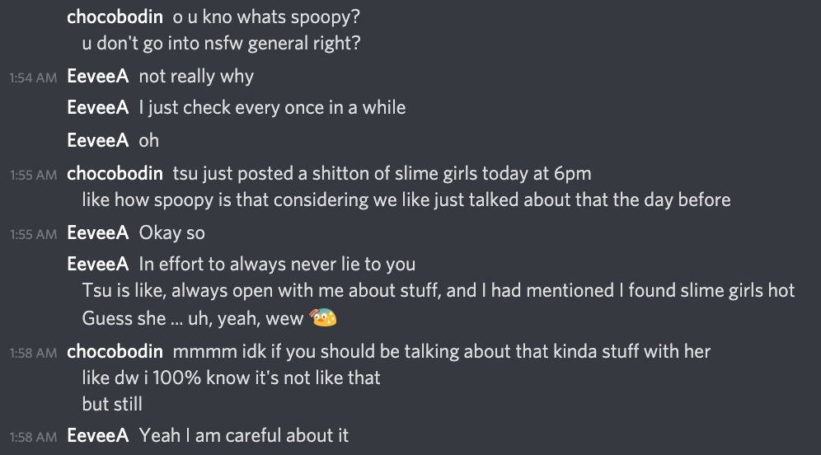
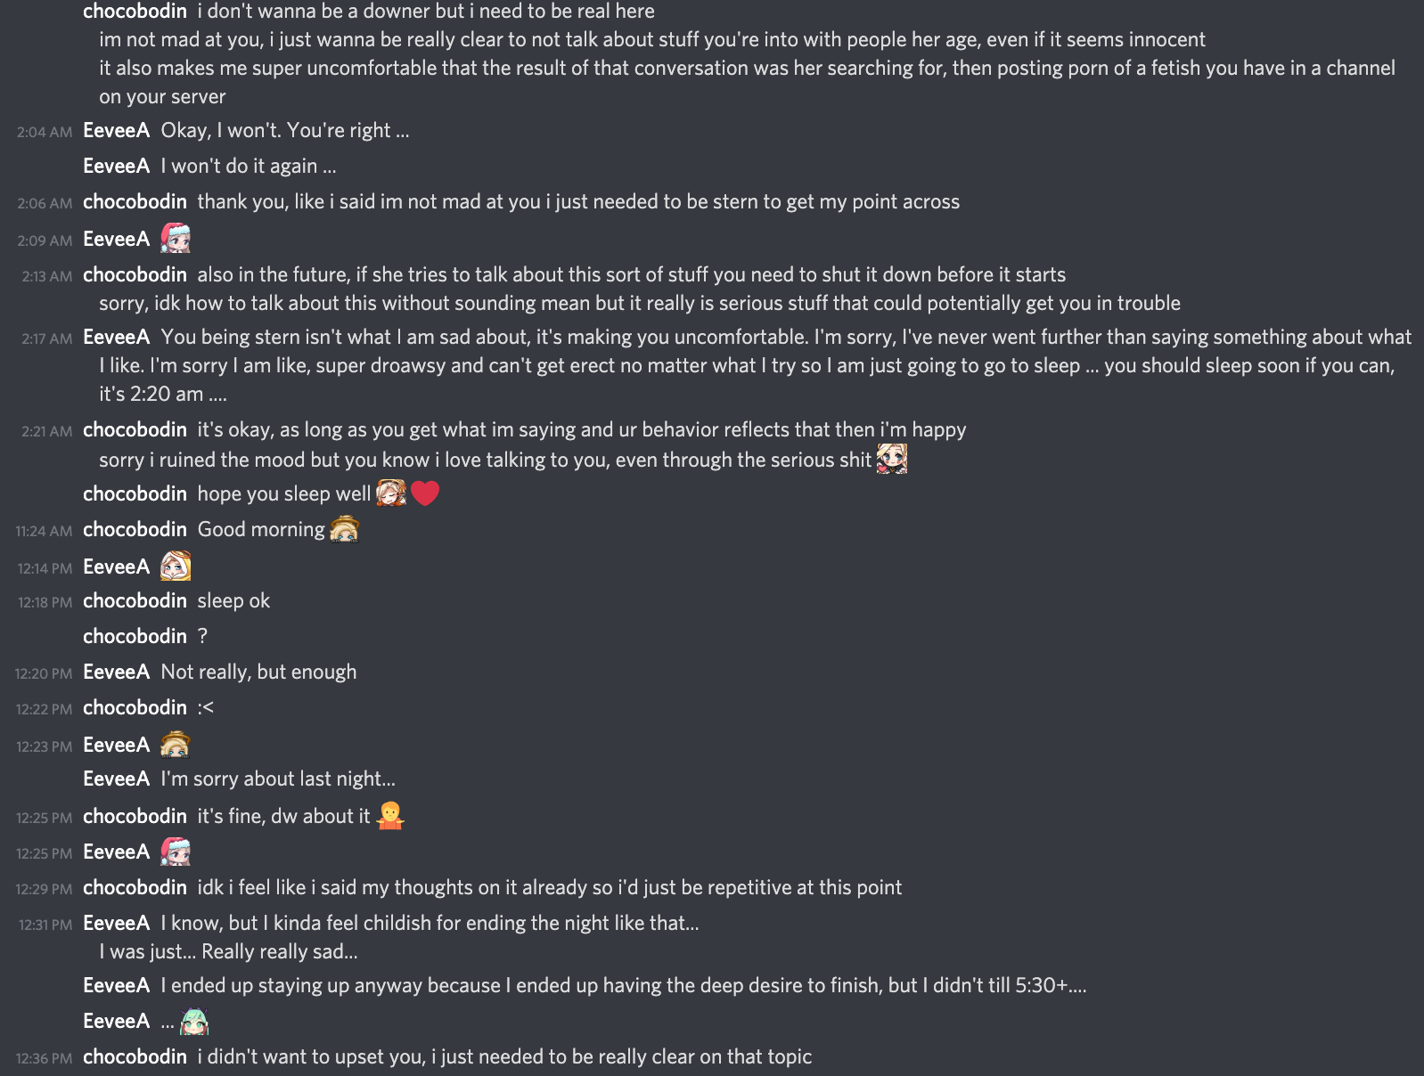
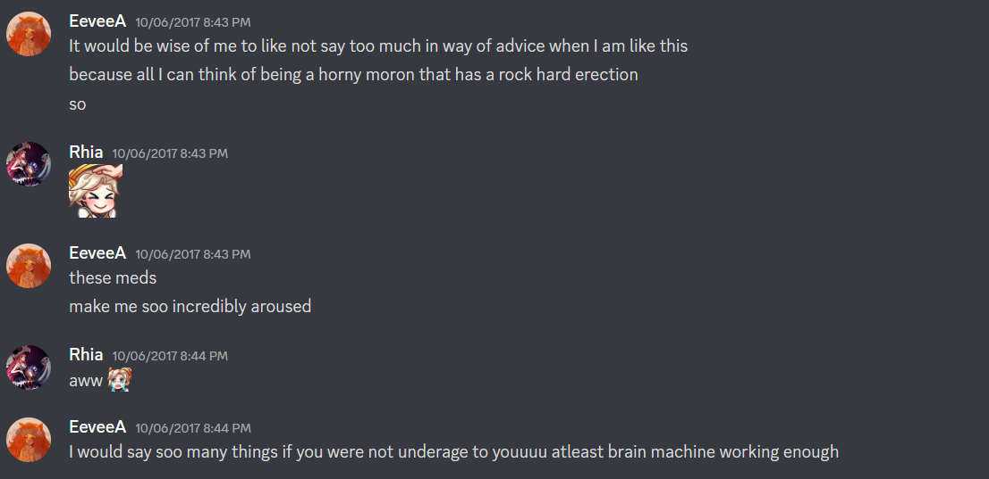
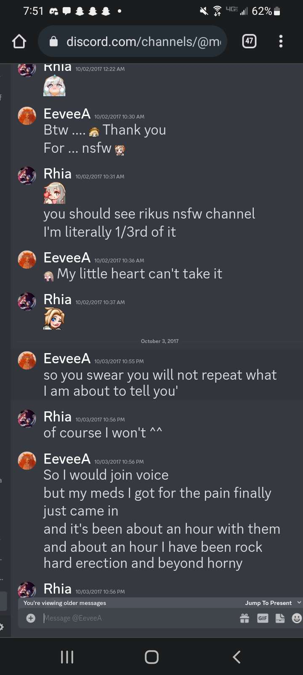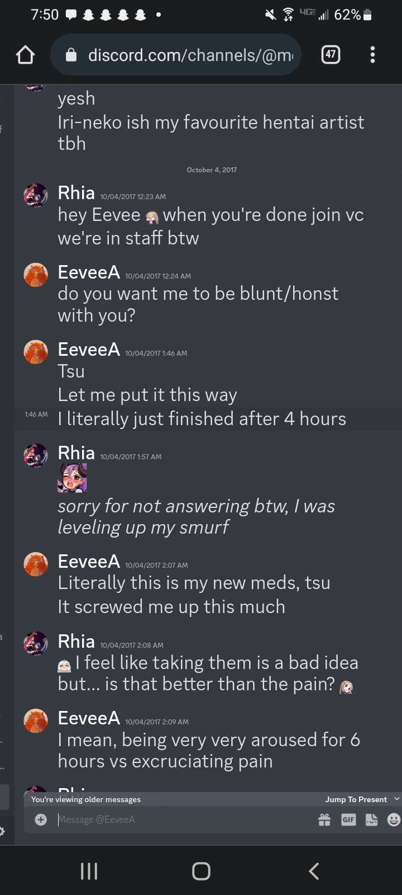
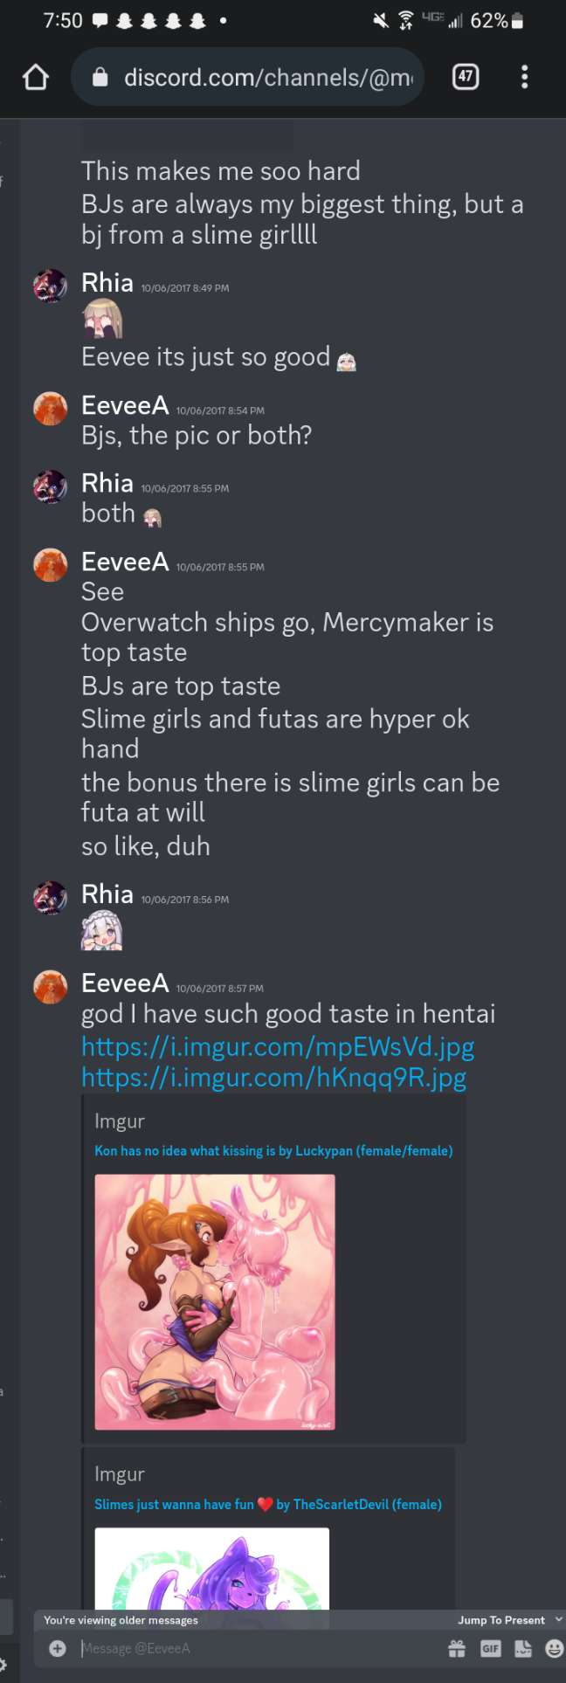

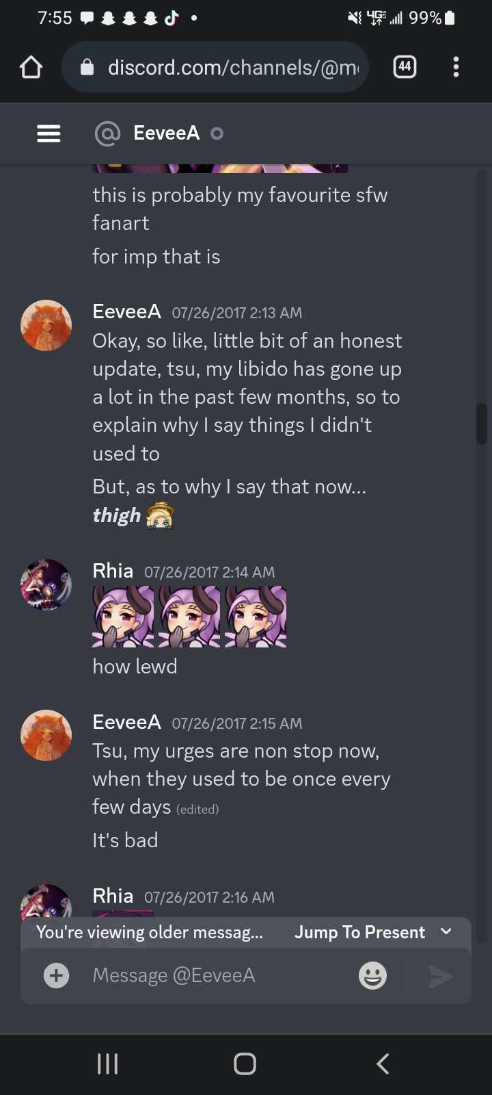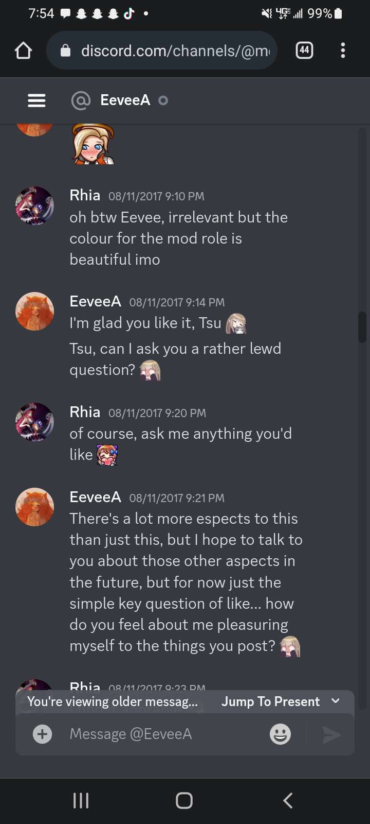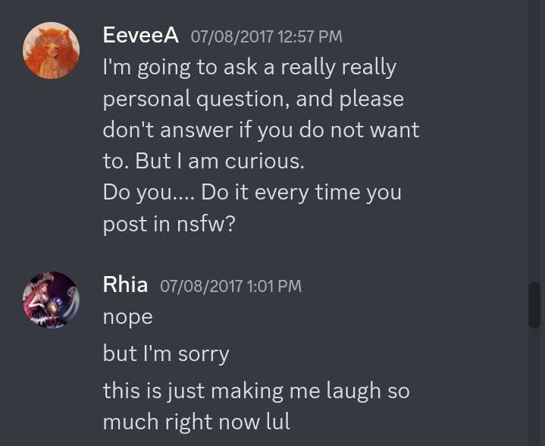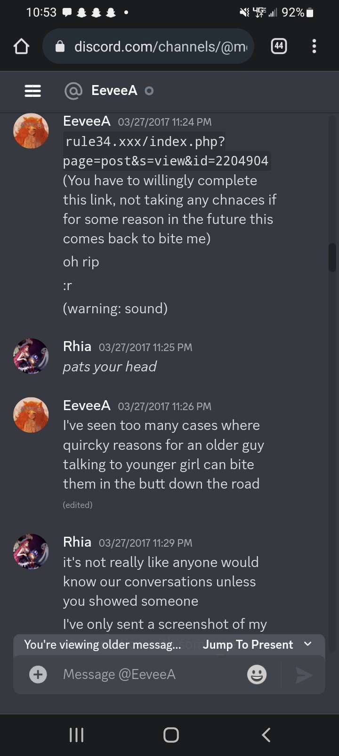

STATEMENT FROM TSU

Hey, Eevee. Sometimes when I spot your streaming notifications in my email, I wonder "who would I be without EeveeA?"

My mind first jumps to all the friends I made in your community, followed by the vast improvements in my gameplay that led to making more friends - a lot of which I'm still in contact with to this day. So, obviously, your influence begins positively. Honestly, I'd not thought on all the negative things you had brought to my life until recently. I guess I'd blocked it out so I wouldn't have to face the fact that my once-favourite streamer is such an awful person. So... let's get into everything you've done and how you've affected me.

The first time you ever DMd me, you commented on my age. Said it kept throwing you off because I acted older than just 13. At the time, I was using a Mercy profile picture. Hentai that I'd cropped because I was a child and thought it would be funny. You said her hand position made it look like she had her hand on someone's head to suck her off. Close guess, I suppose.

We talked about overwatch. My journey in comp. We talked about hentai and fetishes and everything. Remember the time you started hrt and told me how hard you were? How you thanked me for all the pictures I'd send in the nsfw channel? I was 14 at that point.

Yeah. I certainly remember.

You definitely knew - definitely know - that everything you said to me was wrong. You even acknowledged it as you were talking to me. It's sad that I can say I believe all of this, believe how you are. That I can believe everything in this document. It's sad that I believe you only stopped talking to me in a sexual manner because you were caught. Because you were told to stop. And even then, no one knew the extent until I was invited to share my story recently.

It's as I've been typing this, thinking about it, that I realize how much of an effect your actions have had on me. Your casual way of talking about sexual topics with me, everything you shared. You were twenty years old, Eevee. The age I'll be in just a few short months. As a legal adult, I've not once been inappropriate with a minor. Maybe it was different with you because you had a desire to, but... you're also human. You control your actions.

I think you're part of the reason I had so many sexual interactions with older - much older - men. Maybe that would've been different without you, maybe it would've stayed the same. But you were someone six, seven years older and acted as if it was both okay and not at the same time. The confliction in your vocal view on this was confusing, but I leaned towards it being okay so I could have some sense of validation over having this level of intimacy with someone popular. So... not only are you a pedophile, but you, maybe not quite on purpose, abused your position of power as well.

Everything about you just sucks so much and I feel as if there's not a single word nor combination of them that properly encapsulate you as a human being. Nothing feels vile enough.

I'm not a saint at all. I've cheated in past relationships - only the ones after speaking to you. I think a part of it is how you were openly sexual with me as you had a girlfriend. You didn't directly say anything you wanted to do so me, so I assumed it was okay to act similar with others when I was in a relationship myself.

Eevee, due to your vileness and pedophilic actions, I've at least had some positive personal growth. I've learned not to trust older adults, or date with a significant age gap. I learned how bad cheating was, and I've finally learned to value myself. Back in March, I even ended a two year relationship with someone 6 and a half years older than me.

Granted, I may not have had to learn so many of those life lessons if I'd not met you. Also, I recently learned that you spoke to your mods about me being a CSA survivor. I told you this in confidence, and you used it to justify my access to NSFW spaces.

I'm not quite sure how to end this, so I'll just say thank you for at least existing so I could connect with some amazing people. I suppose that's all you're good for at this point. Please attend therapy, Eevee, and be open, honest, and actually work on yourself. I don't know if... well, anything about you is salvageable, but you can try.

Also, if there’s anyone else who was a minor and had Eevee interact with them in a remotely similar way, please come forward. She doesn’t deserve to be protected. Actions have consequences.

-Rhiannon

REACHING OUT

Although it can be extremely challenging to share your experiences, we encourage any victims to come forward in any abusive or toxic situation they find themselves in, including those affected by EeveeA. Shame finds comfort in secrecy; so it takes courage and it is very exhausting to heal, but there is always hope and healing. It’s not your fault and always know you are never alone.

We should strive to be a generation free from abuse - Mari.

Feel free to use these sources:

RAINN National Sexual Assault Hotline: 1.800.656.

HOPE https://www.rainn.org/resources

DISRESPECT OF JOOM’S DEATH
(account written by chocobodin)

Joom and his Discord community for a long time have lost all respect for Eevee due to a combination of her unpleasant personality as well as the details I shared with them about our relationship. When Joom went missing, a mod was reaching out to everyone to see if anyone had his main phone number for us to try and contact. I believe this is how Eevee was aware something was wrong but the details may be incorrect - someone else may have mentioned it to her after streaming together. In any case, Eevee has not been close with Joom or active in his community since maybe 2020 as far as I know.

I believe the only reason she knew something was wrong and to keep an eye out for updates was because of these two individuals putting it on her radar, therefore when we officially announced to the server that we confirmed he was gone, she screenshotted the post and tweeted the news within the hour of without asking anyone in HIS community how they would like things to be handled. In the immediate days after his death, she was back to tweeting horny innuendo tweets which I find wildly disrespectful.
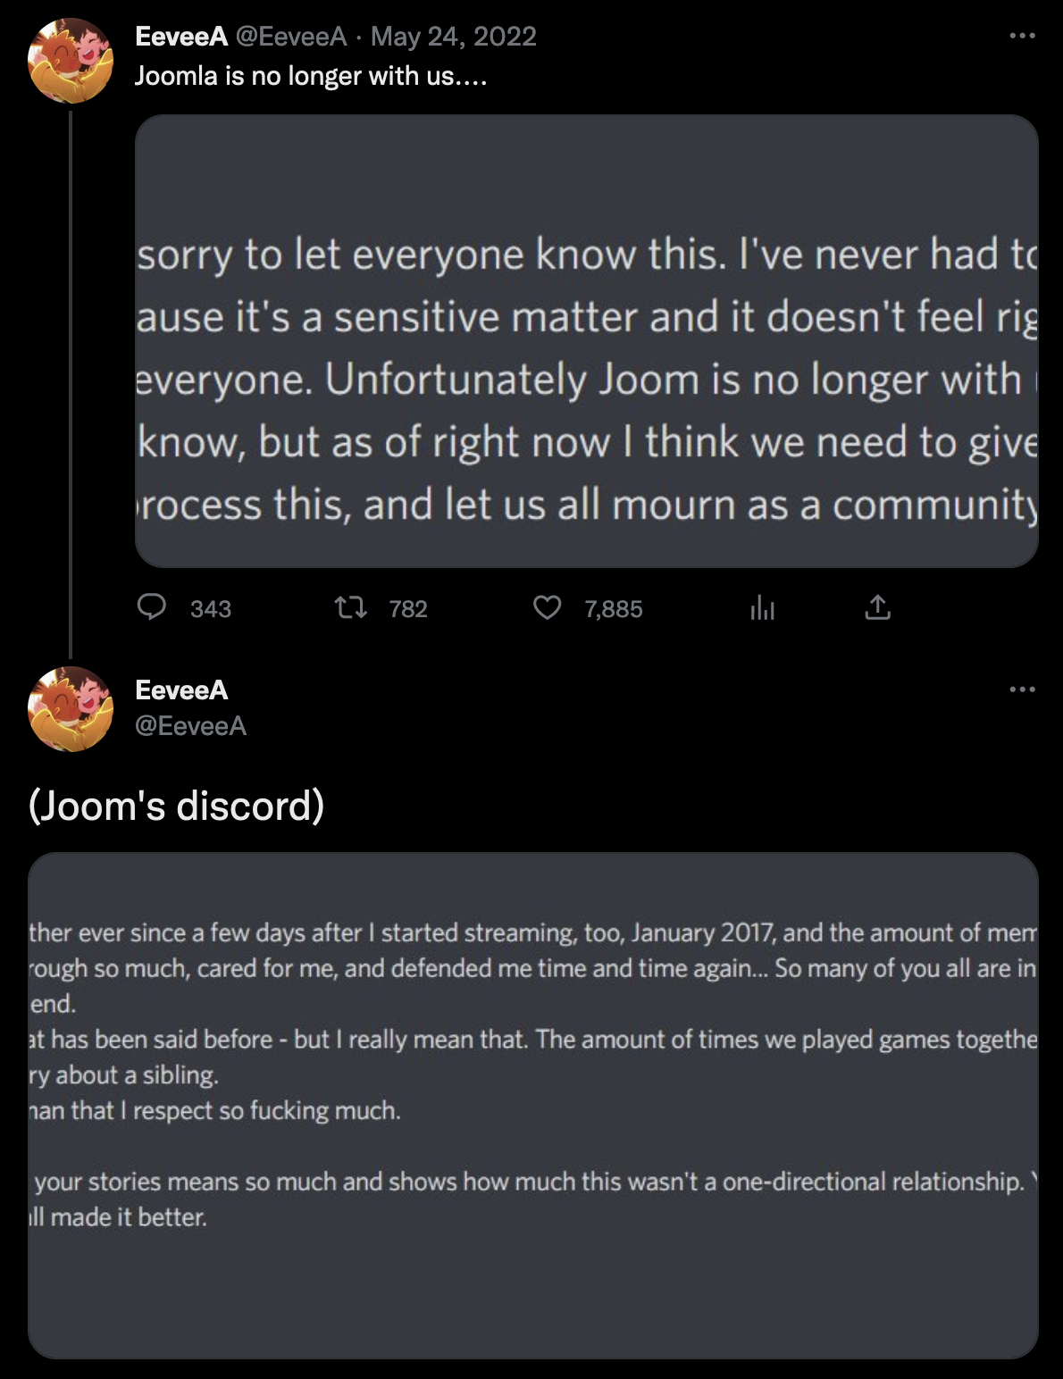
https://twitter.com/EeveeA/status/1529170305234739202?s=20

Shortly after this, we had 2 @everyone mentions + a pinned event planned within Joom’s server for a memorial. You can view it here if you’d like to see it but it is very emotionally raw as a warning. Not only did Eevee not attend, but you can see she is streaming on Twitch during the service.
https://www.youtube.com/watch?v=AVHFXVW7oZ8

Even despite this, we had mods reach out to various streamers including her asking to participate in a series of charity streams where funds would be raised to help transport Joom’s body back to his family in Serbia. She did not respond to any of these messages.

As a community that no longer has a streamer to make fair modding decisions for, and in our understandable grief and long term hatred, we banned her a week or so after these events transpired. She still believes this is an unfair decision that doesn’t factor in her side of the story (discussed in the imgur link under “OUR FINAL COMMUNICATION” in this doc) and insists that she had the right to post the news of his death publicly.

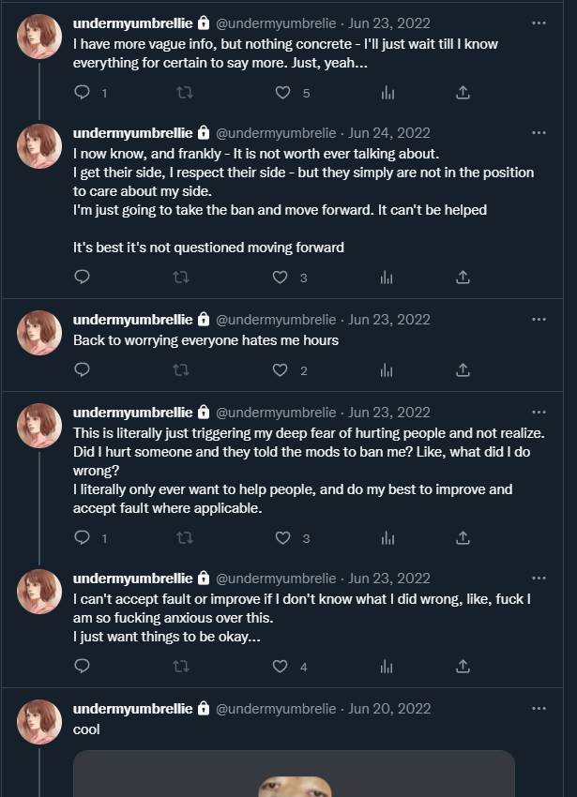

STATEMENT FROM ULNA
I don't really know if I belong with everyone else writing in this document, but there are things I need to get off my chest. EeveeA (Ellie) was one of the first friends I made after I stopped molding myself for people and tried to put myself out there in internet spaces(twitch, social media, new discord servers) for the first time. Originally, I met EeveeA as a viewer coming from a raid. She expressed interest in me dming her and that's where we started to grow close. She was extremely sweet to me which is something I hadn't really experienced outside of when I acted to appease people. Because of this I soon felt safe around her and considered her a dear friend. In hindsight, there were many things wrong with our friendship at different times.

Money

Ellie always seemed to be struggling with money. As the type to want to do whatever I can to help those I care about, I gave everything a full time student with a job across could about 3 months despite my own problems. I gave her about $950 of my income from my current job, twitch payouts, and commissions. This does not include what was raised from a secret donothon I did to help raise money for her insurance which she found out about half way through. That raised about $300. At first, everything was for helping her afford her insurance for her bottom surgery. Then after sadly losing her insurance and appointment, it was to help cover the difference that her roommate had not been paying. At the time, I didn't think anything was wrong with this. However, once I was no longer able to help financially, she started talking to me less and less. This was also around the time she started dating her most recent ex. After 3 months of dating, basically all contact seemed cut, leaving me feeling used and abandoned.

Self Victimization

Being what I believed to be a close friend, Ellie talked about her past a lot to me. Hearing what others have said recently and comparing it to what I've heard has been enlightening to say the least. As someone with no prior experience in any internet spaces, I took what Ellie said at face value and considering at the time she was one of my only friends. I trusted her. She described Chocobodin as a pillow princess who never appreciated her and left her insecure about her body. She minimized her behavior towards Tsu as just a minor mistake about slime girls. Which seems to be consistent across multiple years.

"Corruption"

This is one of the things that feels the worst for me personally. Ellie made a lot of jokes about "corrupting" me and seemed to take pride in it. By the time I met Ellie, I certainly wasn't pure but I definitely was still very innocent in a lot of matters. I didn't know a lot of stuff outside pretty vanilla things or sexual innuendos. I was exposed to a lot of her kinks to get me to potentially like them. Blinded by the fact she was one of my first friends and someone I was crushing on, I ignored my gut feeling in a lot of weird situations.

She sent me porn while we were playing a game together live on stream to see my reaction. Another time on stream I told her I would cry if she kept doing something and she said something along the lines of 'joke's on you I find it hot'. At the time I shrugged it off as a playful jokes. I was happy that I was getting to talk to her and learn about her through some of these interactions despite leaving me feeling weird. After hearing a lot of the other things coming to light, these once playful but odd memories have turned out to be deeply sickening for me.

Little closing statement

I am honestly still sorting my head around a lot of this. From losing a friend to finding out how vile they've been to writing as part of a statement against her. I don't think I have it in my heart to forgive a lot of these things especially when there has only been a lack of change for multiple years. If you are reading this Ellie, please don't run away or try to deflect. Please take accountability and work on making lasting change.

STATEMENTS FROM OTHERS

STATEMENT FROM BIO

I am not speaking up on behalf of myself as I do not consider myself a victim nor do I consider Eevee to have done something significantly hurtful to me, but I do want to use my voice to affirm the credibility of some of the other statements from the years 2016-2017. I had been in a long distance polyamorous relationship with Eevee and one other person for several months of the year 2017. I can't say the relationship was healthy for any of us and I can't say that she was the only person at fault for that, so I have no personal grievances against her.

What I can say is that over the course of our relationship, she has been showing similar patterns of behavior that don't seem to have gone away and have led to others getting hurt by her for years to come - stories that I believe based on my experiences with her, despite my hazy recollection of our time together due to struggling mentally at the time. I can also corroborate the story of a victim Eevee has approached sexually when they were underage - I clearly remember Eevee giving them access to restricted nsfw spaces despite fully knowing about them being a minor and revealing sensitive personal information to justify this, and as I had often interacted with the victim on the server/in the livestream chats at the time as a moderator, I fully believe their claims and feel deeply ashamed for considering the justification good enough at the time.

Considering the other experiences people have had with her, I have little reason to think she's changed and has ceased this behavior, which is why I think publicly holding her accountable for this is necessary. The only thing I wish for her is that she manages to use this as a moment for introspection and genuinely seeks to change for the better outside of content creation, both for her own sake and for the sake of everyone around her.

STATEMENT FROM LYISHI

I joined Eevee's community in 2017, I was 17 at the time. After recently experiencing an end to my friendships in highschool, I was very lonely and I just wanted a place to belong. Eevee's admin team took a liking to me, which brought me very close to many of the things that happened early on. One of the admins, who Eevee considered her best friend, began flirting with me. Eevee approached me one day asking if I liked him, to which I replied yes. Her response to this was extremely vague.
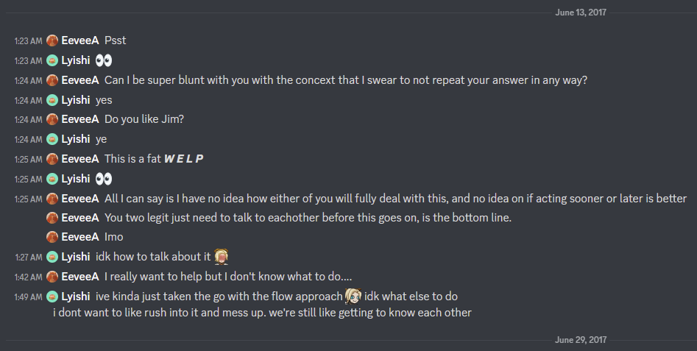
I didn't know what to make of this and expressed intentions to just continue as things were happening. Little did I know that she was alluding to the fact that he had a girlfriend IRL of 4 years. Despite this, she still encouraged me to be with him and she would give me advice about things that made him happy and let me vent to her about anxieties that I had. At no point did she warn me.
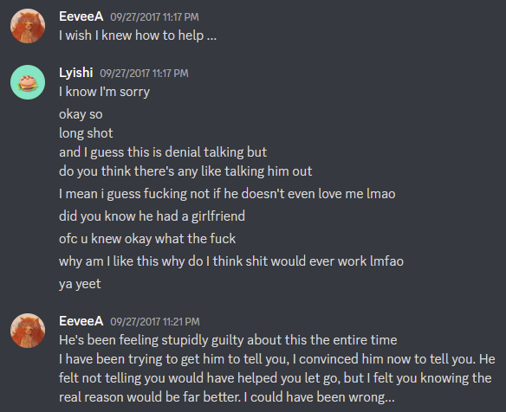
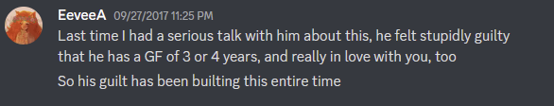

He told me himself that he had a gf, but ended up lying to me about breaking up with both of us. Thinking he had ended his relationship with his gf IRL, when he came back to me only a few days later telling me how much he missed me and loved me, I thought I was safe to continue the relationship. What followed was several months of an emotionally abusive cycle where he would love bomb me in dms but then later verbally insult and abuse me in public chats. Eevee never stepped in to stop this or remove him from the community if she witnessed this or became aware of his behavior. It also became apparent that he never left his IRL gf nor did he tell her what he did.

At this point I had become an administrator for the server, so I asked for him to be removed. After that the only concern I remember Eevee mentioning to me about him was when could he come back into the server. I find it frustrating that it was my responsibility to forgive him and let him back into a space I wanted to claim that space as safe for myself. After he came back she reinstated his admin position, which has remained ever since, despite him never helping out with moderation or admin duties even before all of this happened.

Eventually I moved on and focused on the server and the community. This went on to reveal other issues with Eevee, where she chronically disrespected staff’s time. Eevee would talk to me on average about twice a year. Our moderation chat was completely dead, and I was the only active moderator save for a small handful of people that would be around rarely. I was running the server by myself with no feedback. On top of that, Eevee and I would try to schedule time that we could meet and work on the server. For most of my time as admin, I would do a lot of work to get us together, including reminding and leading meetings. In the last few years of my time there, I stopped doing that and decided that I wanted to see if she would ever do anything herself. We would schedule times, where she would promise we'd finally get together, and then the day would come and pass with nothing said. She would never even acknowledge or apologize for days missed. This happened 3 times in a row over the course of almost 2 years. She never changed.

Screenshots to show passage of time and zero acknowledgement:
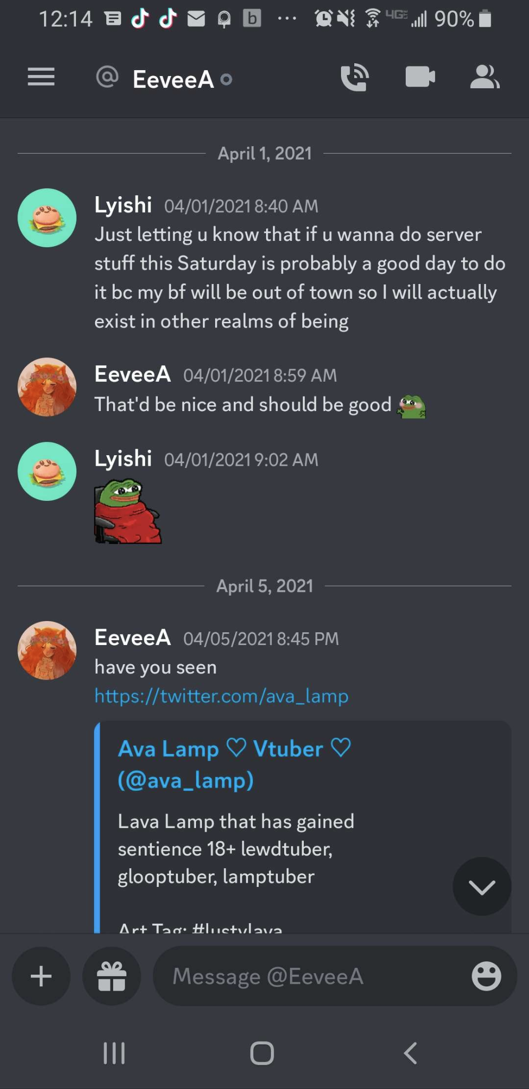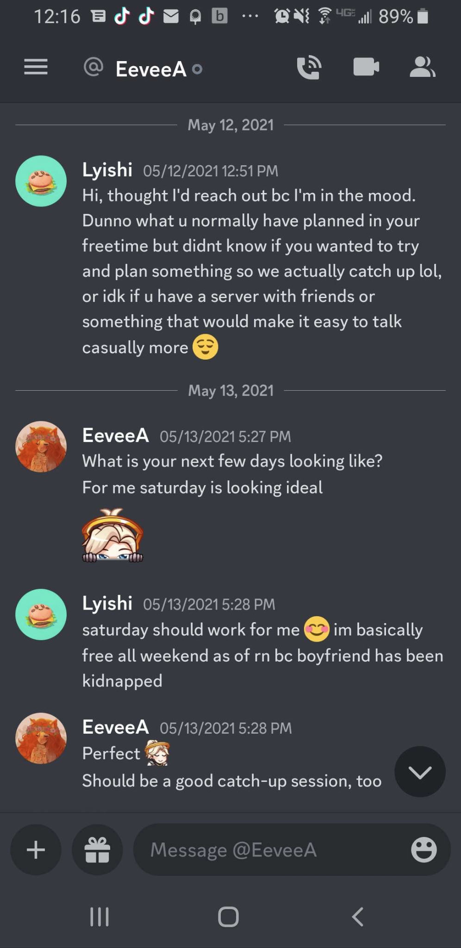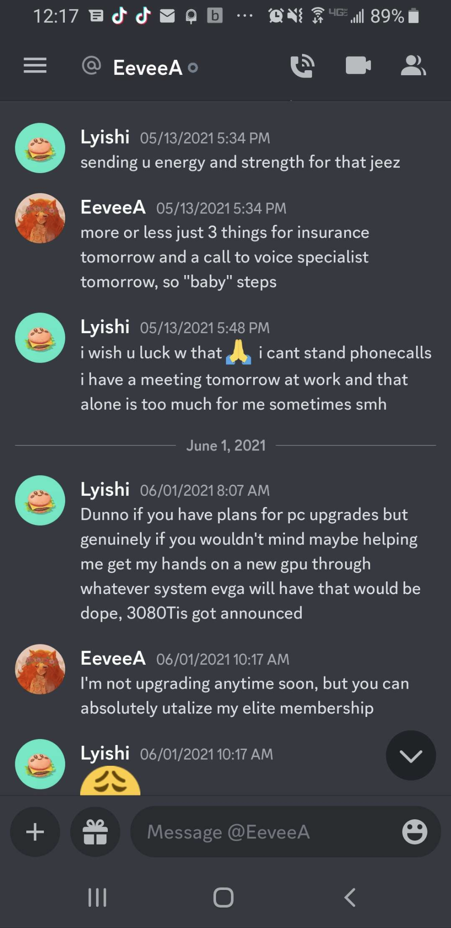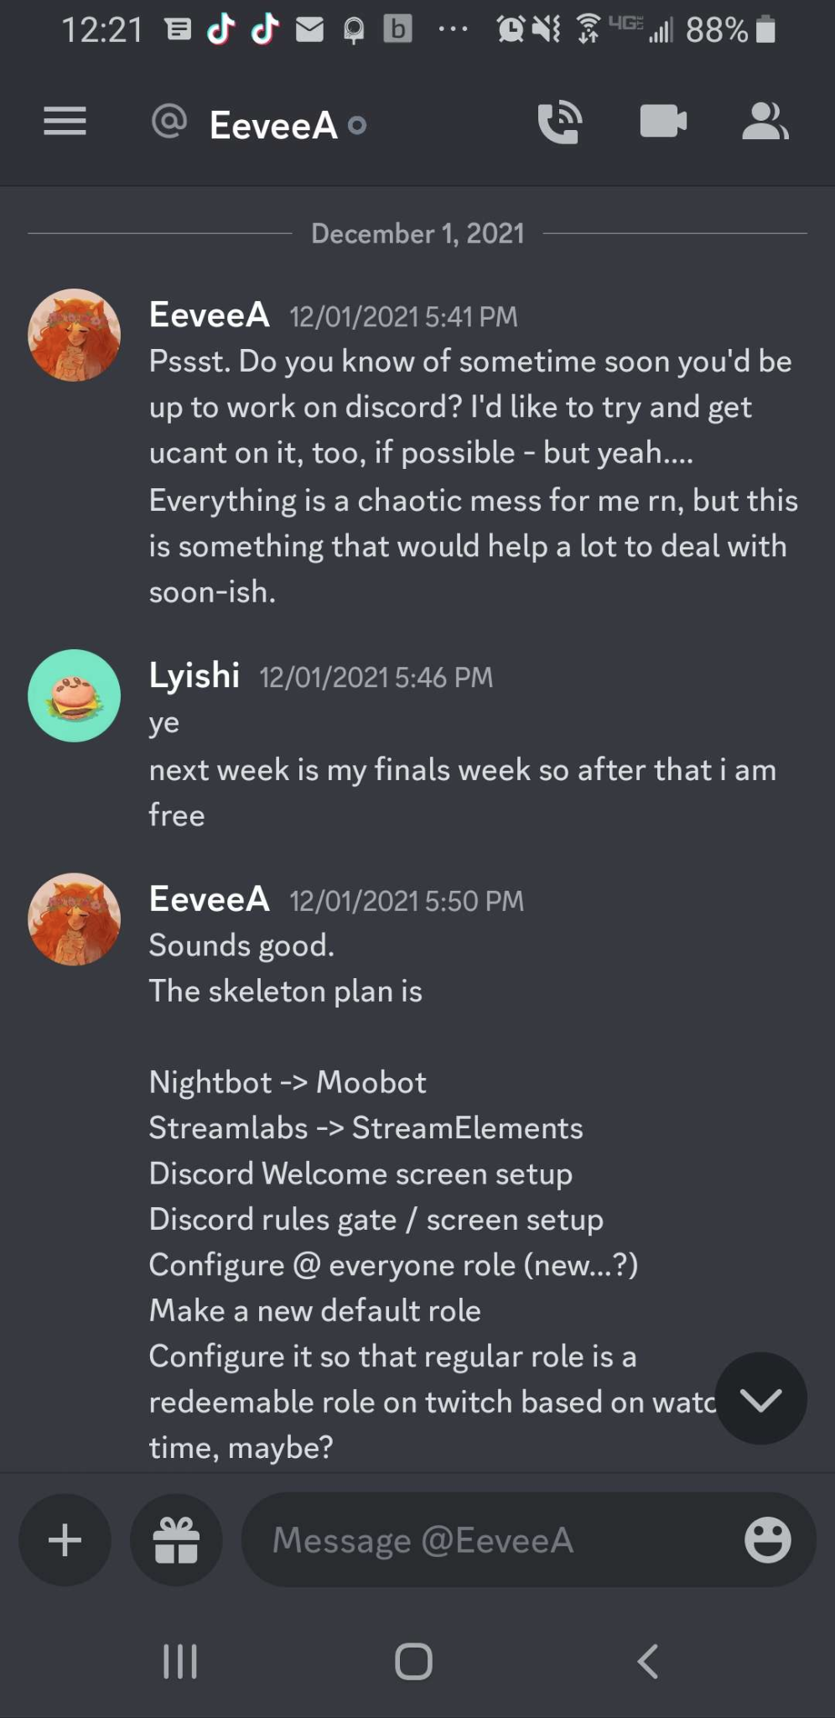
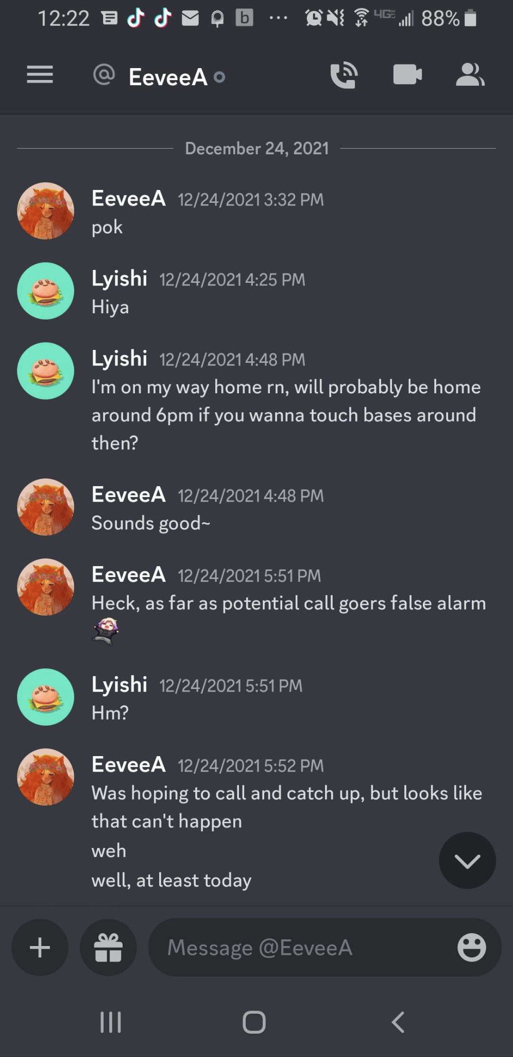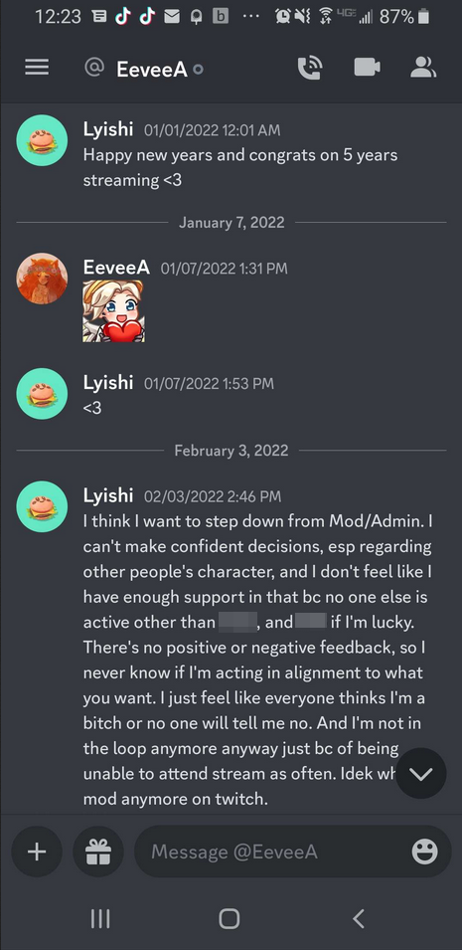

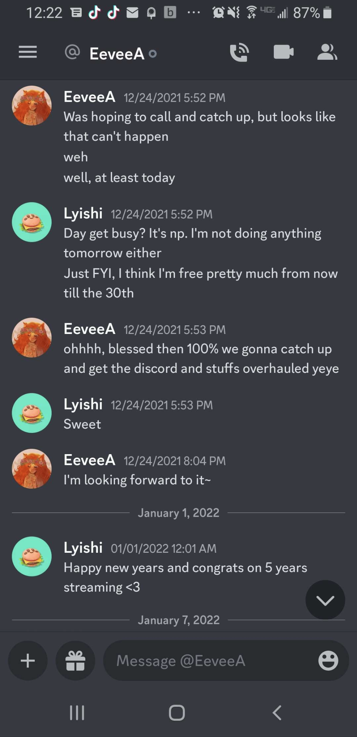

While this is extremely mild compared to everything else, it’s a character flaw and another pattern to show how she doesn’t take accountability and everyone is secondary to her. If you are wondering why I didn’t reach out to remind her, it’s because that is what I’d been doing since 2017, and I was tired and wanted to see if she even cared that I had set time aside for her. I feel like I only worked on the server with Eevee helping maybe three times over the course of 6 years.

Eevee, you’ve apologized more about the same things than any other person I know. Yet you have changed the least, it seems. I think you need to understand that apologizing isn't about being forgiven, no one owes that to you no matter how trivial you think an issue was. It is admirable to want to be better. But you have to evaluate why you've been saying that for 6 years without progress, it is obviously not just everyone else who is wrong. Just reading how you reply to people confronting you reveals a pattern and lack of progress.

CLOSING STATEMENTS
Thank you to Chocobodin, LilithsWork, Rhiannon/Tsu, Ulna, and Bio for sharing their experiences and taking the time and energy to put together this document. And thank you to the community for supporting us and believing in us while we put this together.

You’ll be able to find a Discord server on Twitter if you are from Eevee’s server and looking for a place to go. You’re not alone in processing all of this information. You can reach out to @ihsiyl on Twitter to gain access if it is not publicly available. We are still figuring out where to go from here.

-Lyishi

