This document was made to help spread awareness and inform people about what Bunny has done in the past and present, no current names are mentioned in this document, do NOT try and seek out their new accounts and harass them.

Who is Bunphobia?
Bunphobia, better known as Bunny or Bun is a ROBLOX player who is well known in Oculus Inc’s community as well as being friends with many notable people, such as PortABoi and CaptainSpinxs (dating). She has contributed to many games, including the ROBLOX site itself with UGC textures. In the recent months she has begun to show her true colors to the public, and has done extremely horrible things in the past, which is why I am making this document.

Known Accounts
Discord - bunphobia
ROBLOX - Bunphobia
YouTube - bunphobia
Twitter - BunphobiaART
Twitch - bunphobia
Spotify - Bunny
Steam - Bunphobia

What has she done?

PART 1: Yodizi and DrForests
Before Bunny got the name she has now, she was a part of the myth community and went by DrForests. Keep this in mind, as it is vital to understanding the screenshots as they refer to Bunny as that. For the sake of better understanding, I will be referring to Bunny/DrForests as only Bunny in this document.

Around December of 2017, Yodizi and Bunny would begin to talk to each other, meeting in the Myth community. Yodizi was 13. Around early 2018 (Date is unknown) Bunny and Yodizi began to date. Yodizi had just turned 14, and Bunny was 17. Her birthday is on November 16th, which would make her 17 for a few months. It is unclear whether Bunny intentionally waited for Yodizi to turn 14 to begin having sexual relations and date, as it is notable that the age of consent in Portugal (where Bunny lives) is of that exact age, 14 years old.

This relationship ended around May of 2018, when Bunny had begun dating someone else, unbeknownst to Yodizi.

Yodizi’s Discord account has been terminated, and as a result, they appear as “Deleted User”. Yodizi is the Deleted User in all of the following screenshots.

Before this, Bunny had added Yodizi to a ERP GC in hopes of coercing him into doing it, though this was unsuccessful. However, they did it in DMs, as proven by the screenshot below.

Yodizi admitting he had ERP’ed with Bunny in DMs. Keep the minimum 3 year age gap in mind.
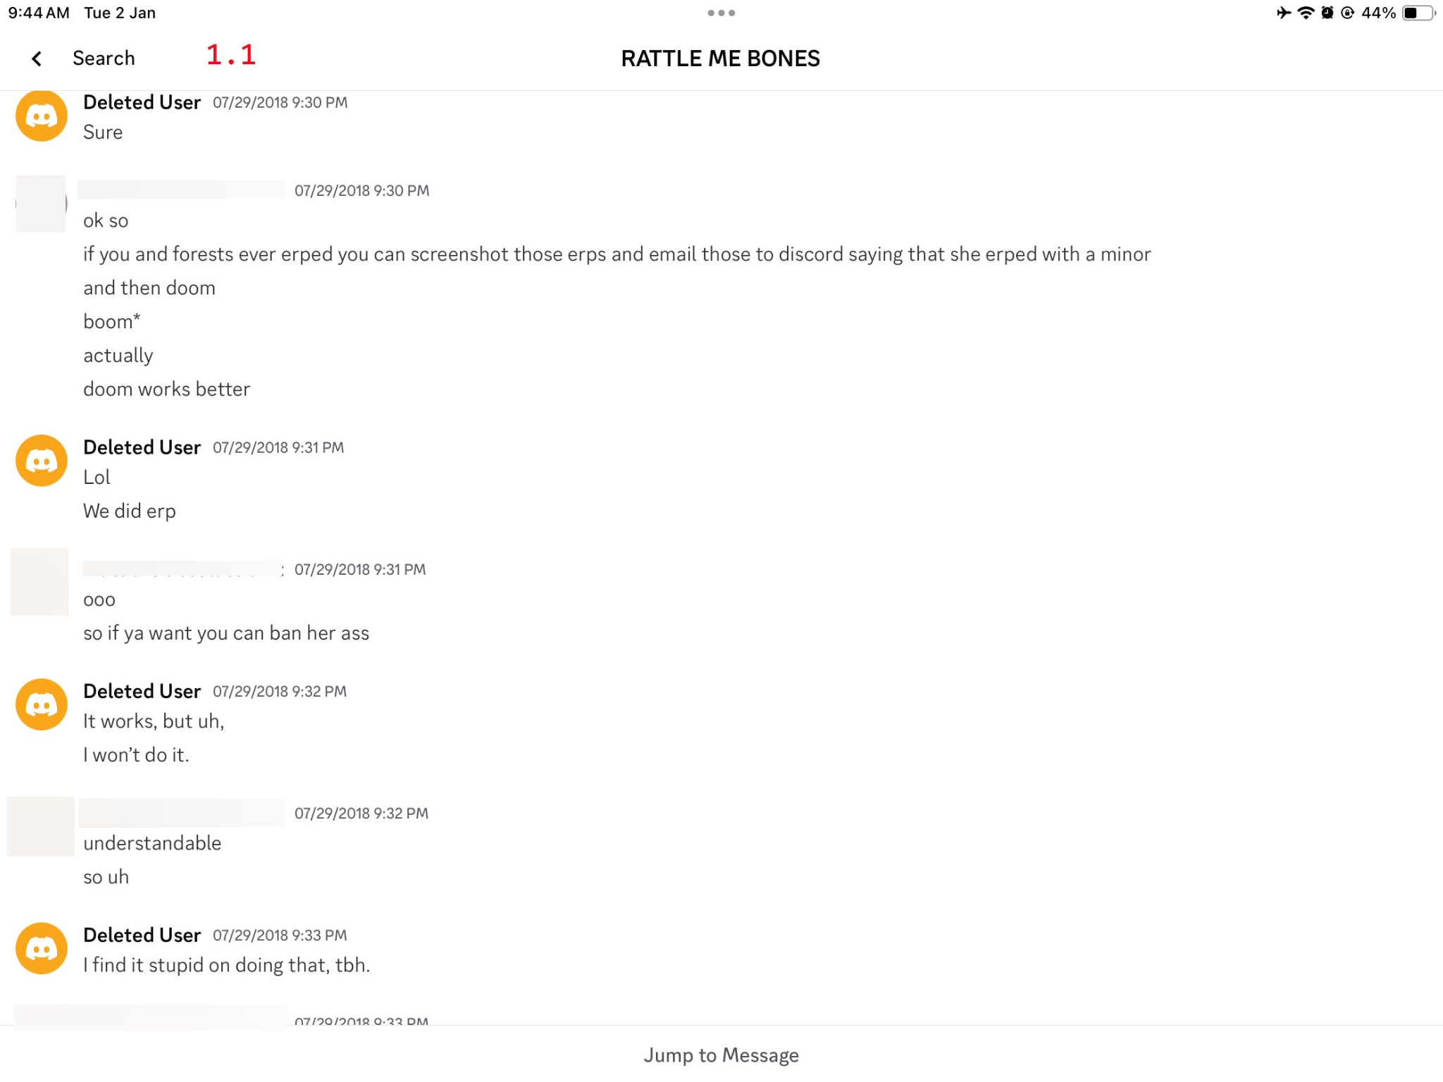

Yodizi confirming existence of Bunny’s nudes. This was after they broke up, and they had surfaced other places and happened to see them.
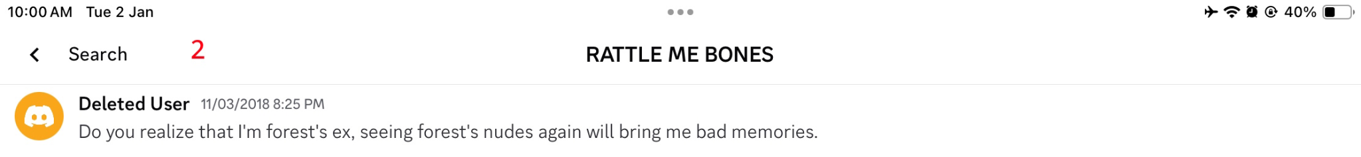

Yodizi and Bunny talking about them breaking up, and Bunny cheating on him.
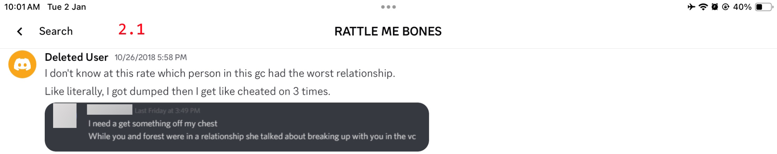
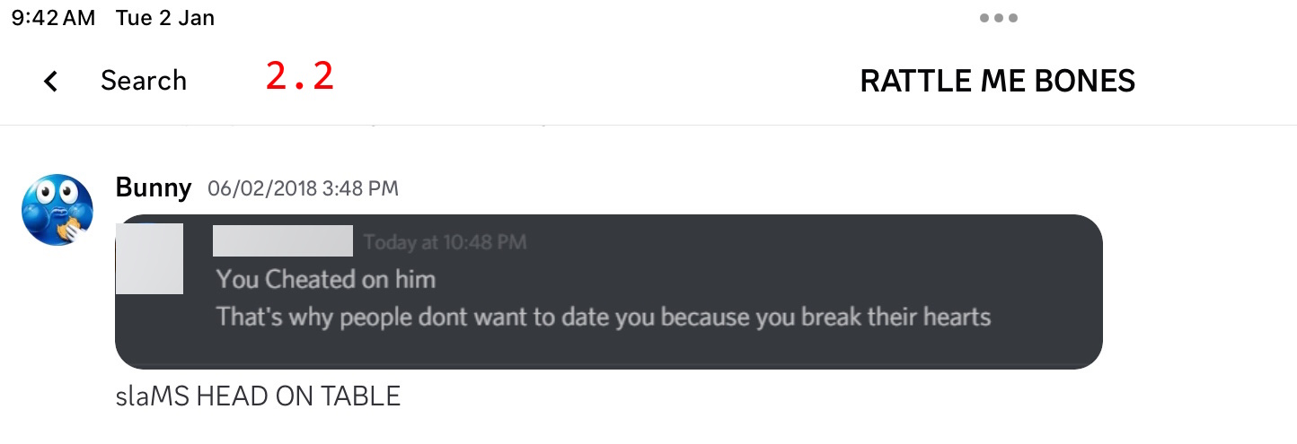
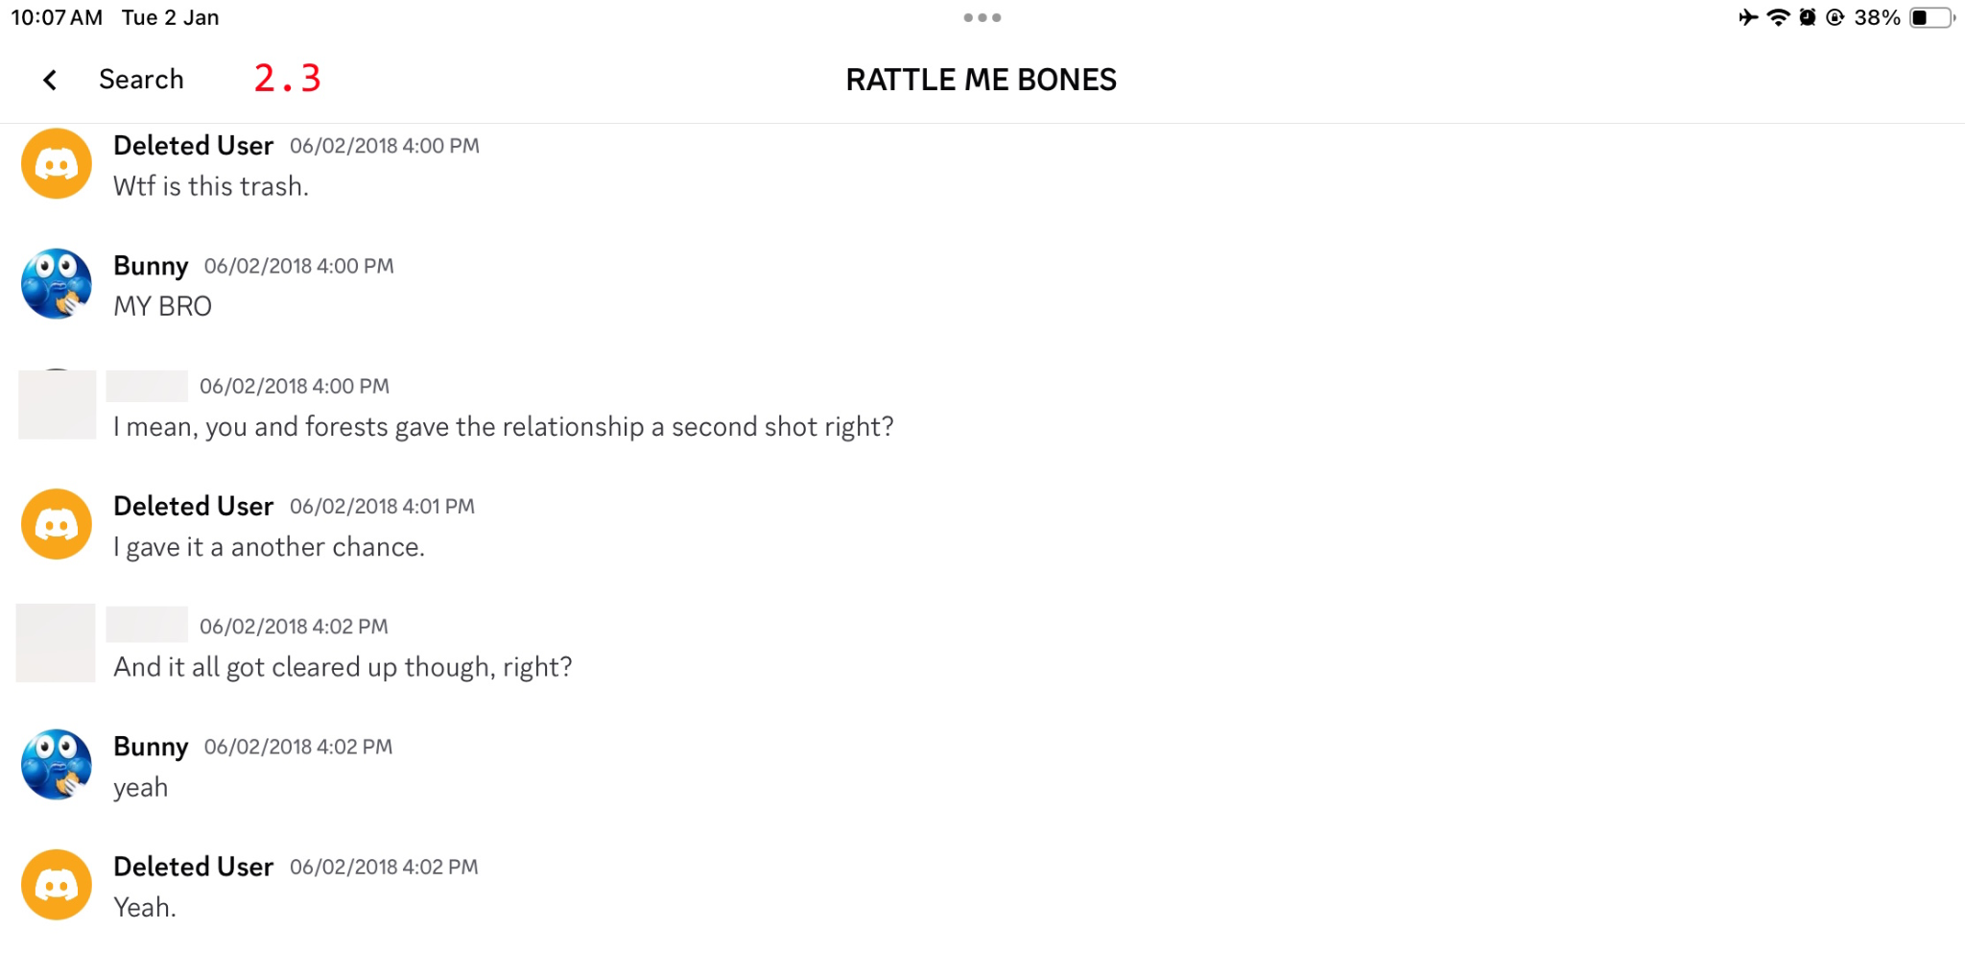

Bunny had told Yodizi that she was a Biastophiliac, which means being sexually aroused by raping someone. This one is especially horrifying because of the massive age gap, still keep in mind that a 17 year old is telling a 14 year old that she is into raping people.
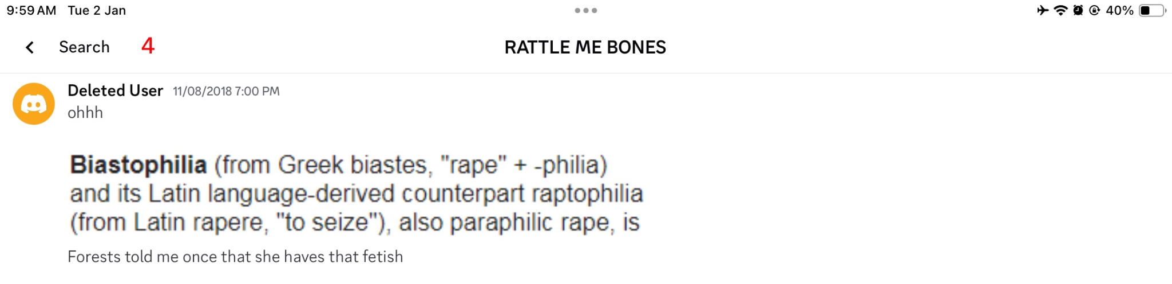

Yodizi is seen with a suggestive profile picture which bears resemblance to their ROBLOX avatar at the time. Yodizi confirms it was NSFW.
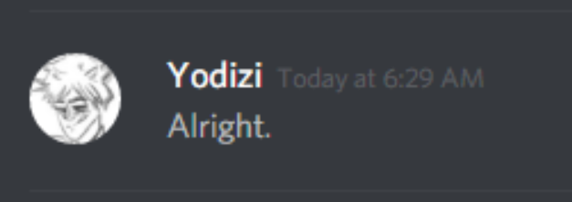
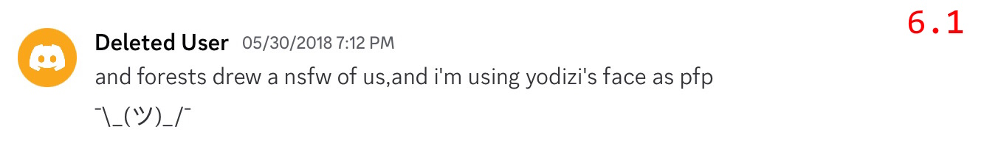

Yodizi’s avatar at the time.


PART 2: The Nudes
Between all of this, Bunny was known to take lots of nudes and send them to people, most of which being minors. She was 17 at the time of taking and sending all of them, though still extremely concerning.

It should be mentioned that the definition of a groomer is someone who manipulates or uses someone to take sexual advantage over them. It is most common and more widely known that grooming usually takes place between an adult and a minor, but minors are still able to groom other minors, this being the case with Bunny. Even so, she was less than a year away and sometimes even mere months from being an adult.

Screenshot was in Part 1, but Yodizi having seen multiple nudes of Bunny.

Bunny had voice called before in an unknown server/group chat which was full of minors, turned on her video and exposed herself. It is unknown how many minors or people were in the call at the time, but the youngest can be confirmed at 13 years old. This can be confirmed to be her, as in the background of one of the photos is a tree sticker, and the same one can be found in a picture of her face.

Bunny has also acted very carelessly with the nudes she has posted online, and one of them has ended up in the hands of many minors, one of which at the time was 11 years old. Bunny had ties to this person and didn’t seem to care. Many other minors were exposed to this as well, all of their ages being 14, 13, 13, 13, and 11 respectively.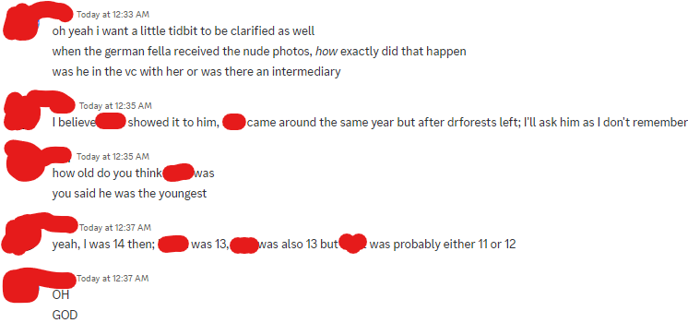

Bunny had also accidentally sent nudes to someone instead of someone else, both were minors at the time.
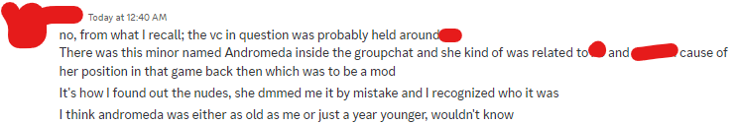

Andromeda, the recipient of the nudes, was 13. It is also confirmed she was in the VC with Bunny when she was exposing herself as well.
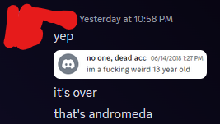

Snippet from the background of one of Bunny’s nudes
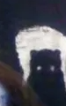

The exact same wall pattern/sticker can be matched to her face.
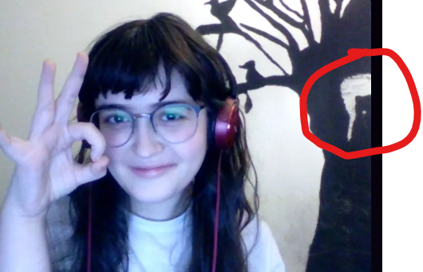

Part 3: CoatsOfClaude
CoatsOfClaude used to be a ROBLOX myth around the same time Bunny was DrForests. However, she was an actual pedophile and was 19, sending multiple NSFW images and nudes of herself to a group chat full of minors. How does this link into Bunny? She was sending these nudes in the very same group chat that Yodizi was added into by Bunny, mentioned in part 1. Bunny was 17 at the time, being the second oldest and only a couple months away from being an adult. It is extremely concerning how she let blatant pedophilic acts continue and did not try to intervene whatsoever. The youngest person in the group chat exposed to these photos can be confirmed 14 years old.

Samara is CoatsOfClaude here. The censor is covering one of her nude photos she sent.
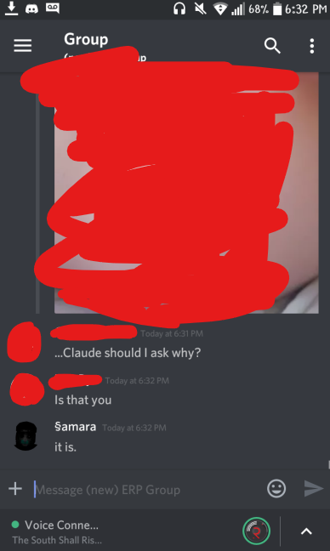

This is a very short section of the document, but I had to mention it because it seemed like such a big thing. Bunny could have easily stepped in at any time to protect the minors from such blatant pedophilia as she was the oldest out of them, but instead she chose to let it unfold and perhaps even encourage it, as she was adding other minors to the group chat (such as Yodizi)

Part 4: The Ship Fighting
Around early 2023, Bunny began to show some of her true colors to the public / Oculus Inc community. She began to harass artists that had made gay ships, even with the permission of the owner of the characters themselves. She is a fully grown woman here going directly after minors.

Bunny had made an OC to be Mr. Hallow’s wife named Poko and forced it to be canon, because she didn’t like the gay ships.
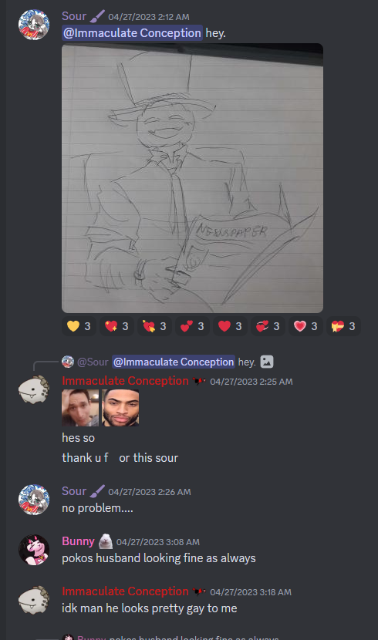

Bunny calling the gay ship a “crack ship”. (Look up crack ship definition)
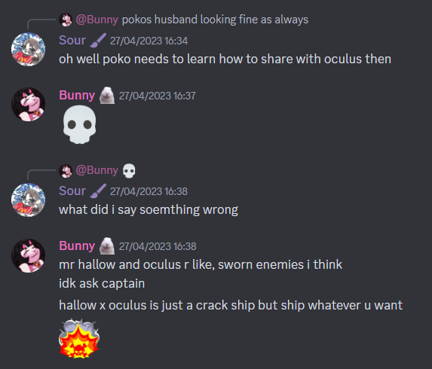

This behavior continued on for a few months.

She had claimed that Matt drawing a gay ship (who is gay himself) is “fetishizing/sexualizing”. Matt is 14. Bunny is 21-22 here.
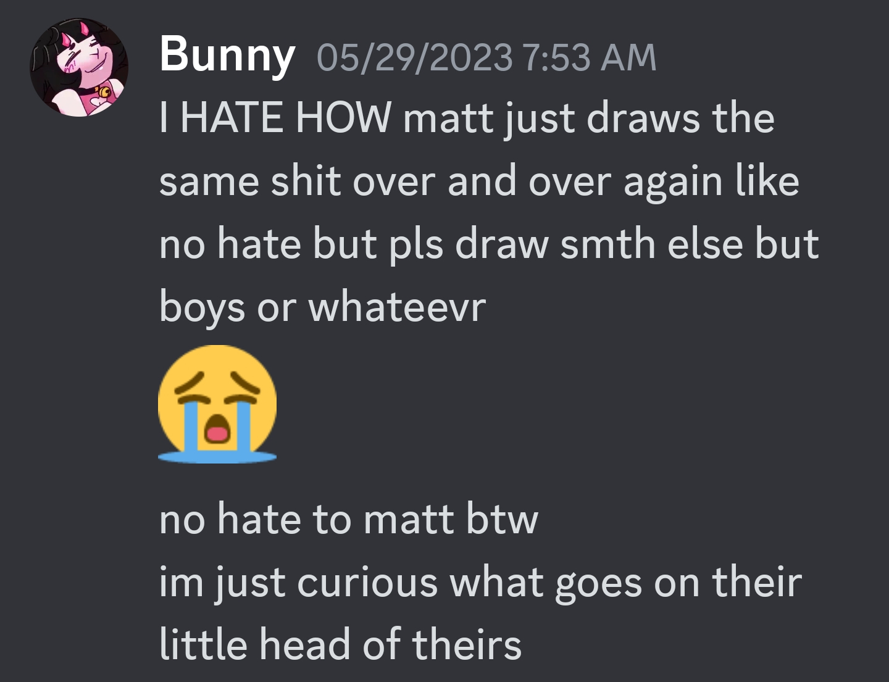
Bunny trying to get Matt banned for unknown reasons.
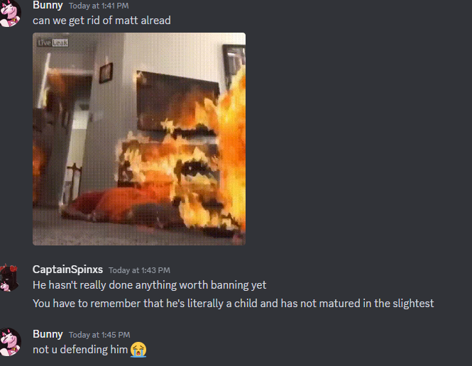

PART 5: The Cult Family

The cult family is a well known ROBLOX myth that has been around since 2012. In 2021, Bunny had joined the community and began to interact with members of the cult, but had also been talking to someone (who will not be named) and had been increasingly weird with members, saying things she shouldn’t have as an adult and constantly would bring up NSFW topics.

The person who had received the thigh pics, confirming just that. Bunny was 20, sending these pictures to a then-17 year old.
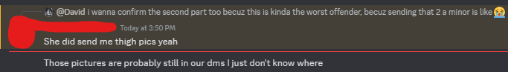

Unfortunately, Bunny had also sent this same person NSFW she had drawn.
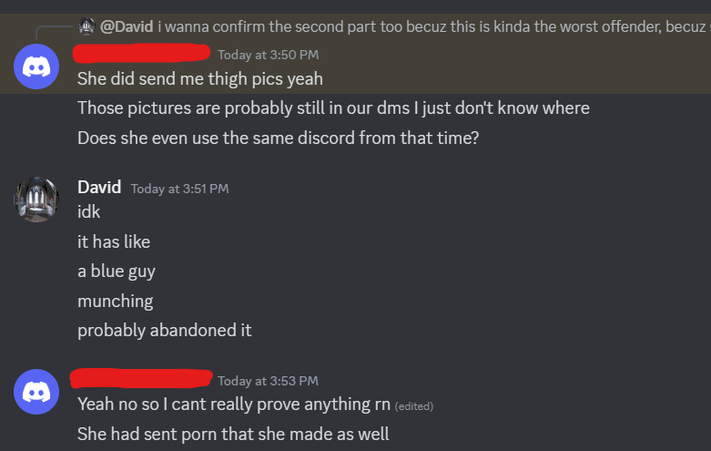
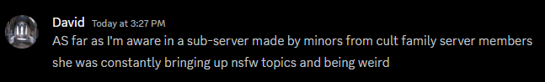
Bunny has also drawn NSFW of minor-owned OC’s and has said very inappropriate things about many other minor-owned OC’s, or ones played by a minor.

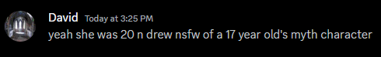
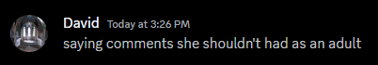

Merles (as the OC) is a minor, and the actor for them is also a minor.


She was saying these things to someone who was 15. Bunny was 21.
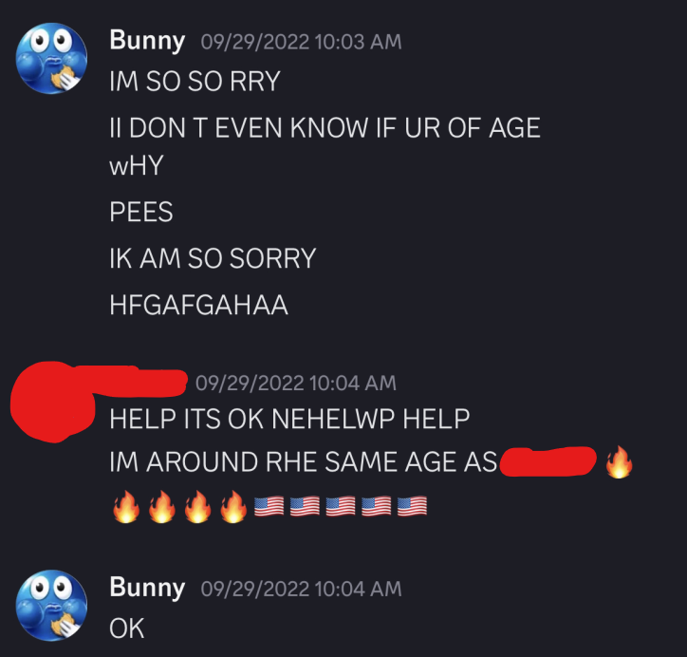

After she was banned for the first time, she was unbanned and still continued this behavior, being told to stop. Bunny was permanently banned with no appeal from the cult community in October 2022.
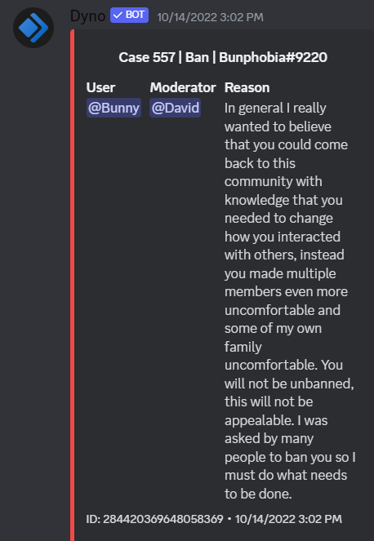

Throughout all of this, she had used her mental illness as an excuse. She has been caught doing this again as recently as 2023 (refer to notes)

PART 6: Notes and other stuff
This section will go over other bad things she has done that don’t deserve their own section or don’t relate too much to the existing parts.

Bunny using her schizophrenia and paranoia (unsure if diagnosed) as an excuse to harass Beez and others.
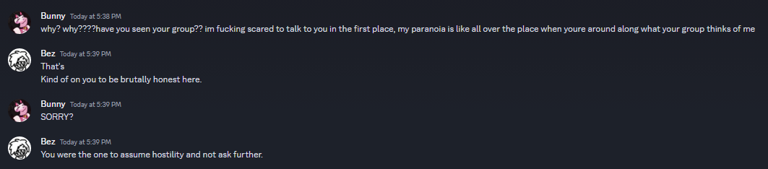
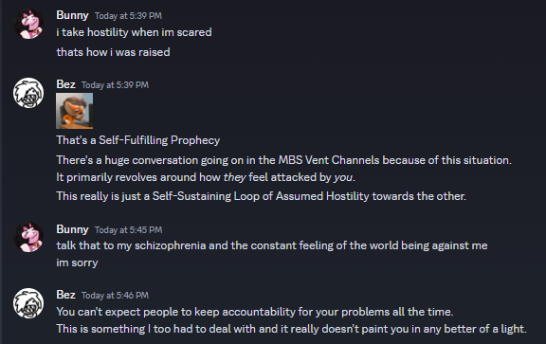

Bunny has also been open about her height fetish in public towards minors. The person she is saying “hot” to here is 15. Bunny was 19.
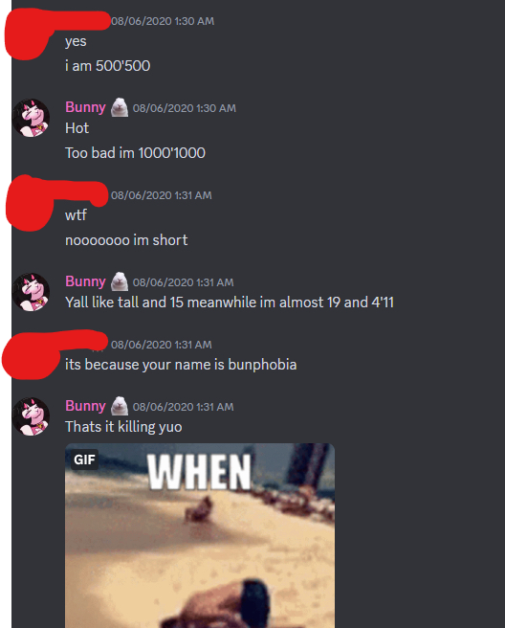

It is literally illegal in her country to be sexually provocative to anyone under the age of 14, which she has done. (Refer to Andromeda, Part 2).
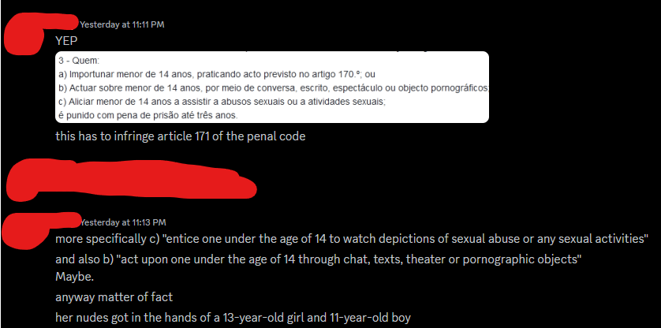

PART 6: Conclusion
With the release of this document, we hope to get Bunny removed from as many communities as possible and stop her disgusting and manipulative behavior. We truly believe the evidence presented is more than enough to get her exiled and I hope her friends can see that as well. It was outrageous she was even able to continue her online presence after she was DrForests, let alone continue her behavior till as recently as 2023.

